1.write short notes on ISDN Network ?

a) ISDN is a circuit-switched telephone network system, which also provides access to packet switched networks, designed to allow digital transmission of voice and data over ordinary telephone copper wires, resulting in potentially better voice quality than an analog phone can provide. It offers circuit-switched connections (for either voice or data), and packet-switched connections (for data), in increments of 64 kilobit/s. In some countries, ISDN found major market application for Internet access, in which ISDN typically provides a maximum of 128 kbit/s bandwidth in both upstream and downstream directions. Channel bonding can achieve a greater data rate; typically the ISDN B-channels of three or four BRIs (six to eight 64 kbit/s channels) are bonded.

ISDN is employed as the network, data-link and physical layers in the context of the OSI model, or could be considered a suite of digital services existing on layers 1, 2, and 3 of the OSI model.

2. State the difference between circuit switching and packet switching network.

a)

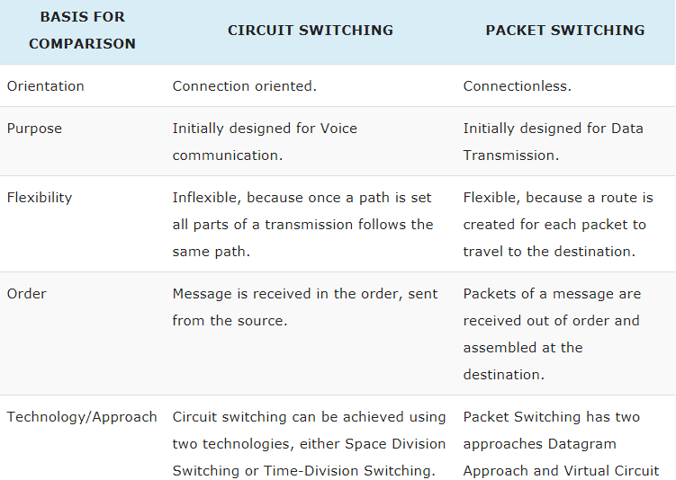

3. Discuss about various topology of **Local Area Network** [LAN].

a) **Bus Topology**

Connects each node in a line - cable runs from one PC to the next and from there to the next, etc.Actually there are two variations of the Bus topology:

In small networks, cable is run from one NIC to the next on each node - the "Tee" is attached to the NIC.In larger networks, a single bus, or backbone cable runs through an entire building and the nodes are cabled to a BNC connector on a wall plate - the "Tee" is behind the wall plate.The Bus topology's disadvantage is that a break in the backbone takes down the entire network, although the malfunctioning of a single node does not affect the network as long as the integrity of the cable is maintained.

**Star or Hub Topology**

Connects all nodes to a centralized hub. Most popular topology for Ethernet.

If all of a hub's ports are in use then it can simply be connected to another hub.

**Advantages :**

Inexpensive cable (UTP)

Offers greater flexibility in wiring than Bus

If cable to one node breaks, the rest of the network still works

**Disadvantages :**

Because each node gets connected to the hub it uses a lot of cable

Requires a hub

**Ring Topology :**

Although the Ring looks a lot like the Star because each node is connected to a central device, the two work very differently.Packets are (attached to a token and) sent around the ring and examined by each node.Difficult to maintain because just one down node breaks the chain.

4.Classify ISDN services

a) There are two levels of service: the Basic Rate Interface (BRI), intended for the home and small enterprise, and the Primary Rate Interface (PRI), for larger users. Both rates divide their capacity across a number of channels:

B-channels carry payloads (e.g., data or voice streams)

D-channels carry control and signaling information.

A BRI connection consists of two 64 Kbps B-channels and one 16 Kbps D-channel. Thus, a BRI delivers up to 128 Kbps of data.

In the United States, a PRI connection consists of 23 B-channels (1,472 Kbps total) and one 64 Kbps D-channel. In Europe a PRI connection consists of 30 B-channels (1,920 Kbps total) and 1 D-channel.

ISDN was slow to achieve standardization and was rapidly overtaken and surpassed in both speeds possible and breadth of deployment by packet-switched technologies.

Broadband ISDN (BISDN) extends the integration throughout the rest of an end-to-end path at higher data rates -- for example, using fiber optic or radio media. ISDN can combine both analog/voice data and digital data on the same network link. Most video conferencing services used in the 1990s and early 2000s were delivered primarily via ISDN services.

5. Write a short note on centralized store program control

a) Centralized control

In centralized control, all control equipment is replaced a central processing unit. It must be able to process 10 to 100 calls per second, depending on the load to the system. Multiprocessor configurations are commonplace and may operate in various modes, such as in load-sharing configuration, in synchronous duplex-mode, or one processor may be in stand-by mode.

Standby mode

Standby mode of operation is the simplest of a dual-processor configuration. Normally one processor is in standby mode. The standby processor is brought online only when the active processor fails. An important requirement of this configuration is ability of standby processor to reconstitute the state of exchange system when it takes over the control; means to determine which of the subscriber lines or trunks are in use.

In small exchanges, this may be possible by scanning the status signals as soon as the standby processor is brought into action. In such a case only the calls which are being established at the time of failure are disturbed. In large exchanges it is not possible to scan all the status signals within a significant time. Here the active processor copies the status of system periodically into secondary storage. When switchover occurs the recent status from the secondary memory is loaded. In this case only the calls which change status between last update and failure are affected. The shared secondary storage need not to be duplicated and simple unit level redundancy would suffice. 1ESS switch was a prominent example.

6. Explain different signaling techniques in telecommunication network.

a) Signals between the subscriber’s plant and the subscriber.

1. signals from the subscriber’s plant: - call/ring off - numbering signal ( DP (Dial Pulse); DTMF ( Dial Tone Multi-Frequency); PBX (DTD (Direct Inward Dialling)

2. signals from telephone plant to the sub scriber’s plant: -metering pulses (that can be got by poling; pulses of 12 or 16 kHz; pulses of 50 Hz);-quality of sounds regarding the call progress: (TD – dial tone; RA-call observe; TO - engage tone; TI- unexisted tone). - call to the called subscriber ( 75 vef/25Hz). - registered messages It is found out that the signals between the telephone plant and the subscriber’s plant can be classified in vocal signallings (numbered DTMF, quality of sounds, registered messages) and signals outside the band of 300 Hz … 3400 Hz.

3. For ISDN lines the signallings outside the vocal band are registered by the common signalling channel D.

7. Write a short note on Link-to Link Layers

a) This layer is the protocol layer that transfers data between adjacent network nodes in a [wide area network](https://en.wikipedia.org/wiki/Wide_area_network) (WAN) or between nodes on the same [local area network](https://en.wikipedia.org/wiki/Local_area_network)(LAN) [segment](https://en.wikipedia.org/wiki/Network_segment).[[1]](https://en.wikipedia.org/wiki/Data_link_layer#cite_note-1) The data link layer provides the functional and procedural means to [transfer](https://en.wikipedia.org/wiki/Transfer_(computing)) data between network entities and might provide the means to detect and possibly correct errors that may occur in the [physical layer](https://en.wikipedia.org/wiki/Physical_layer).

8) Explain the following terms:

i) Unit of traffic ii) Congestion iii) Traffic measurement.

a) i) Unit of traffic: The **erlang** (symbol **E**[[1]](https://en.wikipedia.org/wiki/Erlang_(unit)#cite_note-1)) is a [dimensionless unit](https://en.wikipedia.org/wiki/Dimensionless_unit) that is used in [telephony](https://en.wikipedia.org/wiki/Telephony) as a measure of [offered load](https://en.wikipedia.org/wiki/Offered_load) or carried load on service-providing elements such as telephone circuits or telephone switching equipment. A single [cord circuit](https://en.wikipedia.org/wiki/Cord_circuit) has the capacity to be used for 60 minutes in one hour. Full utilization of that capacity, 60 minutes of traffic, constitutes 1 erlang.

Carried traffic in erlangs is the average number of concurrent calls measured over a given period (often one hour), while offered traffic is the traffic that would be carried if all call-attempts succeeded. How much offered traffic is carried in practice will depend on what happens to unanswered calls when all servers are busy.

ii) congestion : Congestion, in the context of networks, refers to a network state where a node or link carries so much data that it may deteriorate network service quality, resulting in queuing delay, frame or data packet loss and the blocking of new connections. In a congested network, response time slows with reduced network throughput. Congestion occurs when bandwidth is insufficient and network data traffic exceeds capacity.  
  
Data packet loss from congestion is partially countered by aggressive network protocol retransmission, which maintains a network congestion state after reducing the initial data load. This can create two stable states under the same data traffic load - one dealing with the initial load and the other maintaining reduced network throughput.

iii) Traffic Measurements are conducted on a continuous basis and the results compiled into reports for management which are used in management decisions on various time scales. Measurements that are taken every few minutes are used for network management and temporary [routing](https://en.wikipedia.org/wiki/Routing_in_the_PSTN), measurements every few hours, days and weeks are used for maintenance purposes and measurements that are taken over months or even years are used for long-term network deployment, upgrading and extensions.[[2]](https://en.wikipedia.org/wiki/Traffic_measurement_(telecommunications)#cite_note-kennedy-2)

To determine normal reference traffic for a network, the ITU recommends that a network traffic analyst must take measurements for the busiest hour of each day for a whole year.[[2]](https://en.wikipedia.org/wiki/Traffic_measurement_(telecommunications)#cite_note-kennedy-2)The busiest hour is defined as that four consecutive quarter hours whose traffic intensity is the greatest. Measurements taken outside the busy hour can be discarded. The reference intensity of traffic is then calculated by taking the average traffic intensity of the top thirty days in the year.[[2]](https://en.wikipedia.org/wiki/Traffic_measurement_(telecommunications)#cite_note-kennedy-2) Measurements taken on individual days can be discarded. This will give the normal high traffic intensity in the network, allowing network managers to make long-term strategic decisions

9) What is grade of service?

a) **Grade of service** is the [probability](https://en.wikipedia.org/wiki/Probability) of a [call](https://en.wikipedia.org/wiki/Telephone_call) in a circuit *group* being blocked or delayed for more than a specified interval, expressed as a [vulgar fraction](https://en.wikipedia.org/wiki/Vulgar_fraction) or [decimal fraction](https://en.wikipedia.org/wiki/Decimal_fraction). This is always with reference to the [busy hour](https://en.wikipedia.org/wiki/Busy_hour) when the [traffic](https://en.wikipedia.org/wiki/Traffic) intensity is the greatest. Grade of service may be viewed independently from the perspective of incoming versus outgoing calls, and is not necessarily equal in each direction or between different source-destination pairs. "Grade of Service" sometimes means a measure of inbound [call center](https://en.wikipedia.org/wiki/Call_center) traffic to verify adherence to conditions to measure the success of customers served.

10) Explain the operations of a single and multistage cross bar switch.

a) **single crossbar switching**: The simplest concept of a switch fabric is that known as a *crossbar* and is shown schematically in Figure [3](https://www.grotto-networking.com/BBSwitchArch.html#fig:Crossbar). Here we have *N* inputs that could be connected to any one of *N* outputs. For now we can just think of simple port switching but the results and concepts apply to other forms of switching. In a crossbar fabric, to make a "connection" between an input port and and an output port requires the use of "cross point" element (some type of mechanical, electrical, or optical device). When a particular "cross point" element has been enabled we say a "cross connect" has been made.

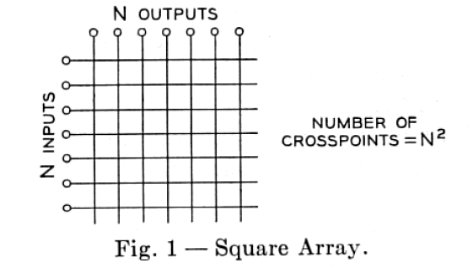

**multistage cross bar switch** :

Multi-Stage Switch Architectures

One approach that is both practical and can be effective is to build a large switch fabric out of a network of smaller sized switch fabrics. However arbitrary arrangements of elements may fail to yield any advantage as the following example shows.

**Example: a 9 x 9 switch created with 3 x 3 elements**

Consider my attempt shown in Figure [5](https://www.grotto-networking.com/BBSwitchArch.html#fig:MSNine) to create a 9x9 switch from 3x3 switching elements. As we can see I built a 9x9 switch out of 3x3 elements. So I managed to create a big switch from smaller packages. Did I reduce the number of cross points needed? A 9x9 switch needs 81 cross points, a 3x3 switch needs only 9 cross points, but I used nine 3x3 switches so ended up using 81 cross points again. Hence my design has no advantage with respect to cross points. Very disappointing so far, but it gets worse.

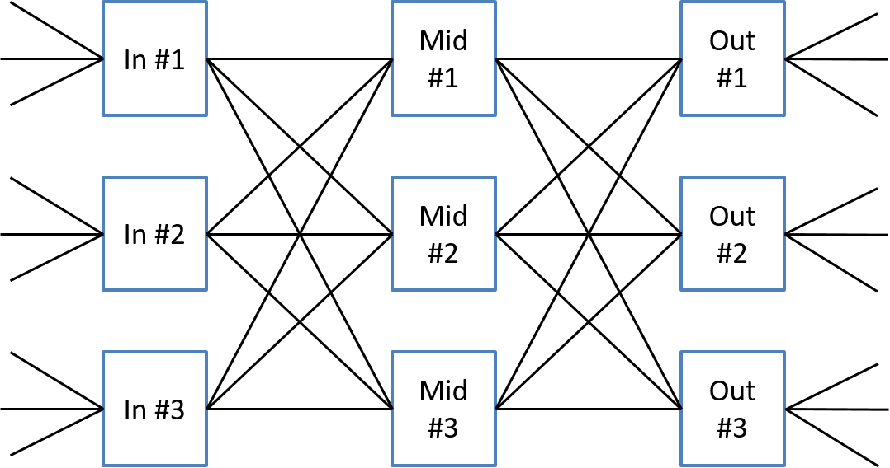Naive attempt at switch fabric construction.

Now let's try to route connections across this multi-stage switch fabric. We denote a particular connection between an input port and an output port by a capital letter such as A, B, C, etc... We will place this letter alongside the respective input and output port to be connected as shown in the figure below. To make use of a multi-stage fabric we need to find a path across the fabric whose links have not been used by another connection. Remember we are thinking in terms of port switching, also known as space switching, right now and each connection between needs its own path and cannot share a path with any other connection.

11) Design a three stage network for connecting 100 incoming trunks to 100 outgoing trunks.

a) Introduction Switching networks realizing one-to-one connections between their inputs and outputs have been studied in depth (see El] for example). However, one can envisage more general interconnection networks for computing. For example, if one wishes to transfer some data from one buffer to several destinations, then one can use networks in which an input can be connected to several outputs, while every output is connected to exactly one input. Such a network is called a multiconnection network. These networks were studied in I-2, 3], with the aim of designing complete multiconnection networks, i.e., multiconnection networks which can realize any possible interconnection of this type between the inputs and outputs.

12) Draw and explain 6*6 cross-bar switching ?

a) A diagrammatic representation of a practical crosspoint switching matrix is shown in Figure. There is an array of horizontal and vertical wires shown by solid lines. A set of vertical and horizontal contact points are connected to these wires. The contact points form pairs, each pair consisting of a bank of three or four horizontal and a corresponding bank of vertical contact points. A contact point pair acts as a cross-point switch and remains separated or open when not in use. The contact points are mechanically mounted (and electrically insulated) on a set of horizontal and vertical bars shown as dotted lines. The bars, in turn, are attached to a set of electromagnets.

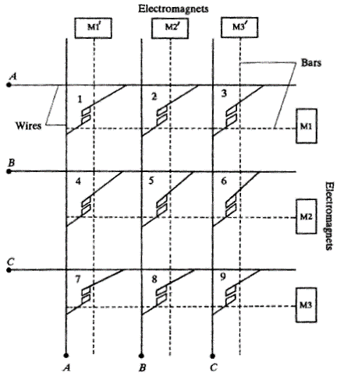

When an electromagnet, say in the horizontal direction, is energised, the bar attached to it slightly rotates in such a way that the contact points attached to the bar move closer to its facing contact points but do not actually make any contact. Now, if an electromagnet in the vertical direction is energised, the corresponding bar rotates causing the contact points at the intersection of the two bars to close. This happens because the contact points move towards each other. **As**an example, if electromagnets M2 and **M3**are energised, a contact is established at the crosspoint 6 such that the subscriber B is connected to the subscriber C.

 In order to fully understand the working of the crossbar switching, let us consider a 6 X 6 crossbar schematic shown in Figure 3.

