# UNIT-4

**MEASUREMENT OF HUMIDITY, FORCE, TORQUE, AND POWER**

**Introduction to Humidity or dampness:**

The amount of water vapour contained in air or gas is called humidity. It plays a vital role in many industrial processes such as chemical, textile, paper, food, leather, pharmaceutical Industries as Well as precision equipment manufacturing.

# Importance of humidity control:

1. Humidity should be measured and controlled to prevent the food products to become dry, spoilage of dried milk, eggs and for successful storage of fruits, meat etc.
2. Humidity should be controlled in order to reduce the affects of surface leakage in electrical installations.
3. It should be controlled to maintain proper environment conditions for human comforts.
4. Textile and paper industries require high humidity conditions. Any variations in humidity may cause the nature, behavior, characteristics of paper pulp and synthetic fibers to change.
5. It should be maintained and controlled in the required levels for proper drying process. If the humidity increases beyond the desired level (upper limit) the dry process may get retarded.

If it decreases below the lower limit the surface of the material becomes over dry.

Hence, the humidity is a very important process variable that should be controlled within the desired limits.

“Before going into the details of measuring of humidity it is important to known some terms related to humidity measurement”.

# Terminology:

1. **Humidity:** The amount of Water vapour contained in air or gas is called humidity.
2. **Dry Air:** When there is no Water vapour contained in the atmosphere, it is called dry air.
3. **Moist Air:** When their is water vapour contained in the atmosphere, then the air is called moist air.
4. **Saturated Air:** Saturated air is the moist air where the partial pressure of water - vapour equals the saturation pressure of steam corresponding to the temperature of air.
5. **Humidity Ratio or Specific Humidity or Absolute Humidity or Moisture Content:** It is defined as the ratio of the mass of water vapour to the mass of dry air in a given volume of the mixture and is denoted by w

Humidity ratio =

mass of water vapour

𝑚𝑎𝑠𝑠 𝑜𝑓 𝑑𝑟𝑦 𝑎𝑖𝑟

1. **Relative Humidity:** It is defined as the ratio of the mass of water vapour in a certain volume of moist air at a given temperature to the mass of water vapour in the same volume of saturated air at the same temperature and is denoted by RH or ∅.

(Water vapour actually present)

Relative humidity = (Water vapour required for saturation) (At a given temperature)

Here a comparison is made between the humidity of air and the humidity of saturated air at the same temperature and pressure. It is to be noted that if relative humidity is 100 % it is saturated air, i.e., the air contains all the moisture it can hold.

It should also be noted that the degree of saturation (percentage of relative humidity ) of air keeps on changing with temperature.

1. **Dew Point Temperature:** By continuous cooling at constant pressure if the temperature of air is reduced, the water - vapour in the air will start to condense at; particular temperature. The temperature at which the water vapour starts condensing is called as dew point temperature.
2. **Dry Bulb Temperature:** When a thermometer bulb is directly exposed to an air -water vapour mixture, the temperature indicated by the thermometer is the dry –bull temperature.

This dry- bulb temperate is not affected by the moisture present in the air i.e. the temperature of air is measured in a normal way by the thermometer.

1. **Wet Bulb Temperature:** When a thermometer bulb is covered by a wet wick, and if the bulb covered by the wet wick is exposed to air, water vapour mixture, the temperature indicated by the thermometer is the wet bulb temperature. When air passed on the wet wick present on the bulb of the thermometer, the moisture present in the wick starts evaporating and this creates a cooling effect at the bulb. The bulb now measures the thermodynamic equilibrium temperature reached between then cooling affected by the evaporation of water and heating by convection.
2. **Wet - Bulb Depression:** Wet - bulb depression = (Dry - bulb temperature) - (Wet bulb temperature ) Always dry - bulb temperature is higher than the wet bulb temperature.

i.e., (Dry - bulb temperature > Wet bulb temperature)

1. Percentage Humidity: It is defined as ratio of weight of water vapour in a unit weight of air to weight of water vapour in the same weight of air if the air were completely saturated at the same temperature.

(Weight of water vapour in a unit weight of air)

Percentage humidity =

Weight of water vapour in the same weight of air if the air were completely saturated at the same temperature.

# LIST OF INSTRUMENTS USED TO MEASURE HUMIDITY:

The three main instruments used for measuring humidity are….

1. Sling psychrometer
2. Absorption hygrometer.
3. Mechanical humidity sensing absorption hygrometer.
4. Electrical humidity sensing absorption hygrometer.
5. Dew point meter.

# Sling psychrometer:-

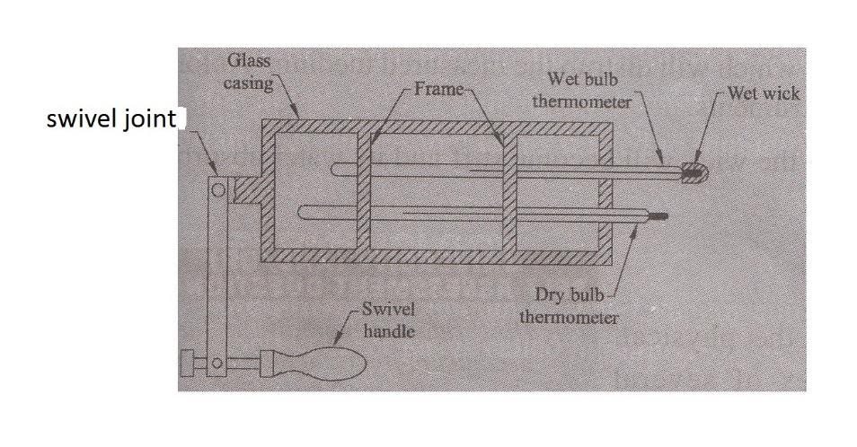

**Principle:** This instrument is used to measure both the dry bulb and wet bulb temperatures at a time with these temperatures we can measure the humidity content in air.

**Description:** The main parts of the instrument are

A frame holding two thermometers to measure dry & wet bulb temperatures as shown fig. Two mercury in glass thermometers, one to measure dry - bulb temperatures and the other to measure Wet-bulb temperature.

The frame carrying the thermometers is covered by a glass casing. A swivel handle is attached to the frame - glass casing - thermometer arrangement to ensure that the air at the wet bulb is always in immediate contact with the wet wick.

**Operation:** Accurate measurement of wet bulb temperature is obtained only if air moves with a velocity around the wet wick.

In order to measure wet bulb temperature, the psychrometer frame 4 glass covering thermometer arrangement is rotated at 5 m/ s to 10 m/ s to get the necessary air motion. The thermometer whose bulb is bare (Without wick) contacts the air and indicates the dry bulb temperature. At the same time, the thermometer whose bulb is covered with the wet wick comes in contact with the air and when this air passes on the wet Wick, the moisture present in the wick starts evaporating and a cooling effect is produced at the bulb. This temperature is the wet bulb temperature, which will be naturally less than the dry bulb temperature.

# Applications:

* It is used for checking humidity level in air conditioned rooms and installations.
* This is used for setting & checking hair hygrometers.
* It is used in the measurement range of 0 to lO0 % RH and can measure Wet bulb temperatures between 0° C to 180° C.
* It is used for measuring wet bulb temperatures between 0° C to 180° C.

# Limitations:

* Continuous recording of humidity is not possible. The evaporation process at the wet bulb will add moisture to the air, which will distrub the measured medium. Antomation is not possible with this instruments.
* If the wick is covered with dirt, the wick will become stiff and its water absorbing capacity will reduce.

# Absorption hygrometer:

Principle: Humidity changes the physical, chemical and electrical properties of several materials. This property is used in transducers that are designed and calibrated to read relative humidity directly.

There are two types of absorption hygrometers namely; (a). Mechanical humidity sensing absorption hygrometer. (b). Electrical humidity sensing absorption hygrometer.

# (a) . Mechanical Humidity Sensing Absorption Hygrometer:

**Principle:**

Hygroscopic materials such as human hair, animal membranes, Wood, paper etc, under go changes in linear dimensions when they absorb moisture form their surrounding air. This change in linear dimension is used for the measurement of humidity present in air. A hair hygrometer has been shown in fig.

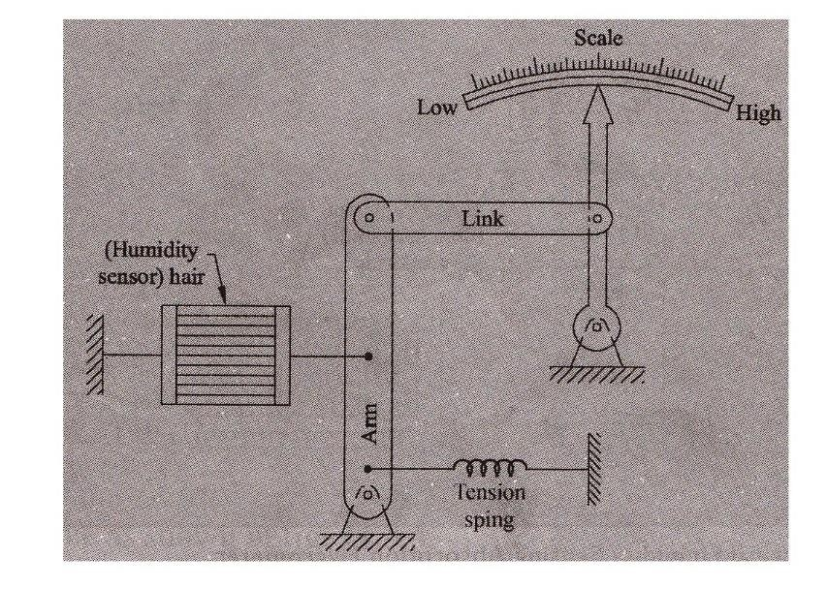

# Description:

The main parts of the mechanical hair hygrometer type are:

1. Human hair as the humidity sensor. The hair is arranged in parallel beam and they are separated from one another to expose them to the surrounding air. Number of hairs are placed in parallel to increase mechanical strength as shown in fig.
2. The hair arrangement is subjected to light tension by the use of a tension spring to ensure proper functioning.
3. The hair arrangement is connected to an arm and a link arrangement and link in turn is attached to a pointer, pivoted at one end. The pointer sweeps on a humidity calibrated scale.

**Operation:** When the humidity of air is to be measured, the hair arrangement is exposed to the air medium and this absorbs the humidity from the surrounding air and expands or contracts in the linear direction.

This expansion or contraction of the arrangement moves the arm & link and thus the pointer on the calibrated scale, indicating the humidity present in the atmosphere. These hygrometers are called membrance hygrometers when the sensing element is a membrance.

# Applications:

* Temperature range of these hygrometers is 0 to 75°C
* RH (Relative humidity) range is 30 to 95 %.

# Limitations:

* Response time is slow
* Calibration tends to change if is it used continuously

# (b) . Electrical Humidity sensing Absorption Hygrometer:

**Principle:**

Humidity changes the resistance of some material. This change in resistance is taker as a measure of humidity

# Description:

The main parts of this arrangement are:

1. The two metal electrodes, which are coated and separated by a humidity sensing hygroscopic salt (lithium chloride) as shown in fig.
2. The leads of the electrodes are connected to a null balance Wheatstone bridge

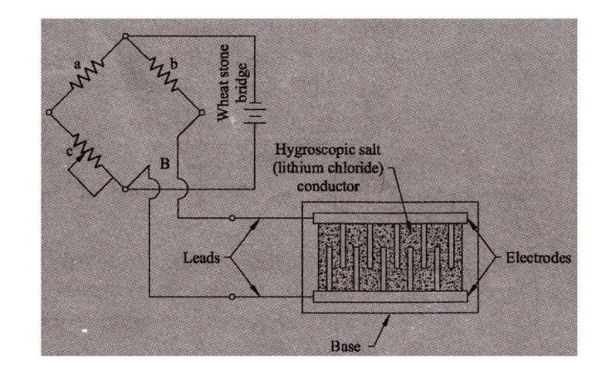

# Operation:

The electrodes coated with lithium chloride are exposed to atmosphere, whose humidity is to be measured.

Humidity variation causes the resistance of lithium chloride to change. i.e., the chemical absorbs or loses moisture and causes a change in resistance.

Higher the humidity ( RH) in the atmosphere, more will be the humidity absorbed by lithium chloride and lower will be the resistance and higher will be the resistance in case of lesser humidity.

The change in resistance is measured using a Wheatstone bridge which becomes a measure of humidity (RH) present in the atmosphere.

# Applications:

-These are used under constant temperature conditions.

-The accuracy of this instrument is ± 25%

-The response is very fast, of the order of few seconds.

# Limitations:

This instrument should not be exposed to 100 % humidity as this makes chemical absorb all the humidity and damage the instrument.

Temperature corrections must be made if they are not used at constant temperature conditions.

# Dew point meter:-

**Principle:** At constant pressure if the temperature of air is reduced, the water vapour in the will start to condense at a particular temperature. This temperature is called dew point temperature.

# Description:

The main parts of the arrangement are:

1. A shiny mirror surface fixed with a thermocouple as shown in fig.
2. A nozzle to provide a jet of air on the mirror.
3. A light source focused constantly on the mirror.
4. A photo cell to detect the amount of light reflected from the mirror.

# Operation:

-The mirror is constantly cooled by a cooling medium, which is maintained at a constant temperature.

-A thermocouple is attached to this mirror, whose leads are connected, to a milli voltmeter.

-Constantly a light is made to fall at an angle on the mirror and the amount of reflected light is sensed by a photo cell as shown in fig.

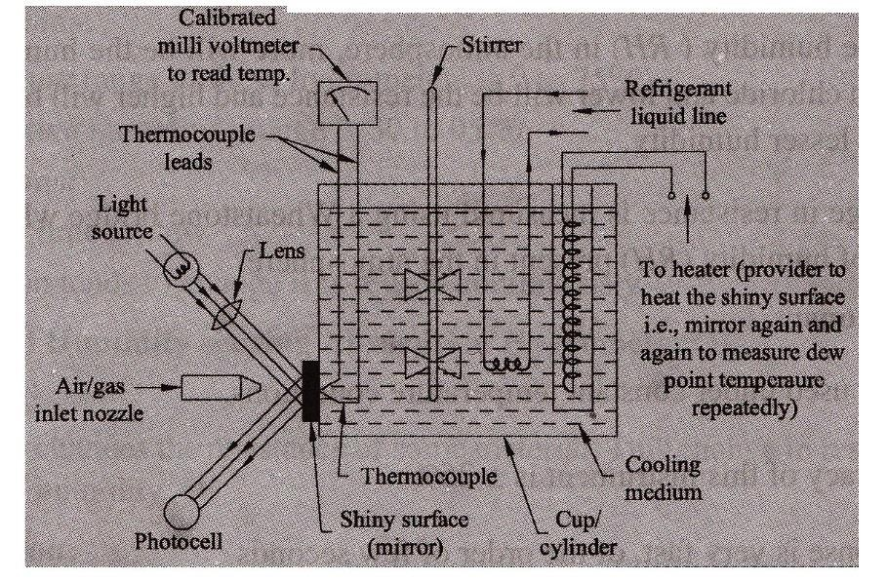

-Now an air jet is made to fall on the mirror and the water- vapour (moisture) contained in the air starts condensing on the mirror and they appear as small drops (dews) or the mirror.

-This moisture formed on the mirror reduces the amount of light reflected, which is detected by the photocell. When for the first time, there is a change in the amount of transmitted light, it becomes an indication of dew formation. At this instance i.e., the temperature indicated by the thermocouple attached to the mirror becomes the dew-point temperature.

-This instrument is used to know the time at which the dew appears for the first time and to know the dew point temperature.

# Applications:

-Cargoes can be protected from condensation damage by this instrument by maintaining the dew point of air in holds lower than the cargo temperature.

-Used in industries for determining dew point.

# Limitations:

-Effective light measurement is not possible.

-Limitations is cooling fluids exists.

# Explain one method of measurement of moisture content of gases:

A hygrometer based on the quartz crystal oscillator is used to measure the moisture content of gases such as ethylene, hydrogen, refrigerants and natural gas.

When a quartz crystal coated with a layer of hygroscopic materials (the materials which exhibit a change in their dimensions when they absorb moisture) is subjected to gas sample, the weight of the crystal increases as the hygroscopic materials absorbs the moisture. As the ‘weight of the crystal increases, its frequency changes. An oscillator employing quart crystal coated with hygroscopic material and used for the measurement of humidity (or moisture) is shown in figure given below,

In the above arrangement, two crystals are used. The two crystals are alternately subjected to two different gases for a period of about 30 seconds, so that their contaminations become same and a stable frequency output is obtained.

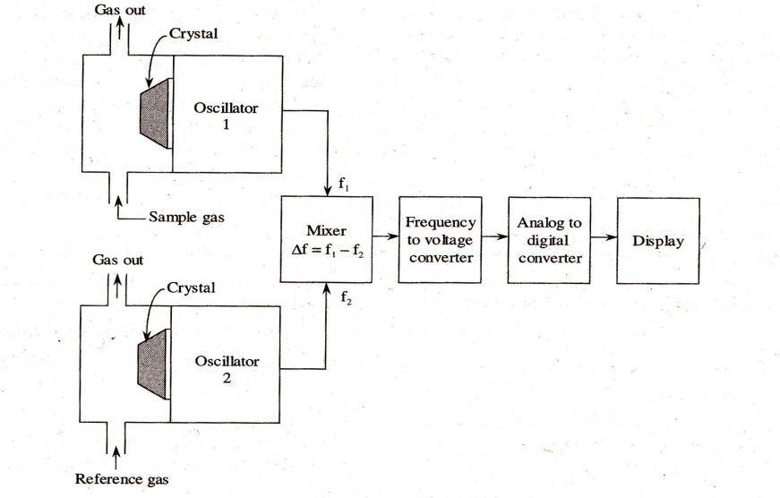

The frequency shifts of the crystal due to the change of its weight fin the presence of moisture of sample gas are measured electronically and the difference in frequency is determined. This frequency difference is converted into signal, which is then converted into digital form and displayed. Thus, quartz crystal hygrometer can measure humidity or moisture content of gases ranging from 1Vppm to 30Vppm.

# MEASUREMENT OF FORCE, TORQUE AND POWER:-

An engineer is concerned not only with the generation of power by a prime-mover but is also required to measure the useful output. That helps the engineer to know how well prime-mover is doing its job in relation to the energy supplied to it. The terms related to engine output are:

1. **Force:** Force represents the mechanical quantity which changes or tends to change the relative motion or shape of the body on which it acts. Force is vector quantity specified completely by its magnitude, point of application, line of action and direction.

The relationship between motion and force is provided by the laws of dynamics. Newton’s second low of motion states that force is proportional to the rate of change of momentum. That is



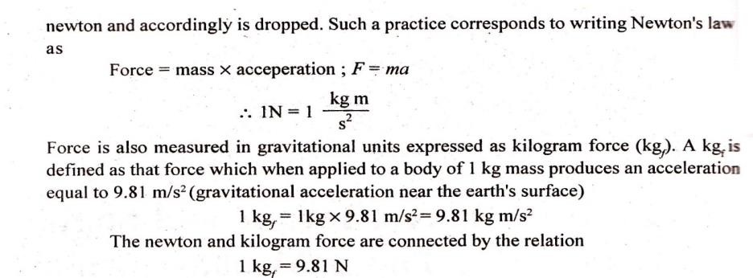

1. **Work:** Work represents the product of force and the displacement measured in the direction of force.

Work done = force × displacement; W= F s

The unit of work is joule (J) which is defined as the work done by a constant force of one newton acting on a body and moving it through a distance of one metre in its direction.

1 J = 1 N m

1. **Torque:** It represents the amount of twisting effort, and numerically it equals the product of force and the moment arm or the perpendicular distance from the point of rotation (fulcrum) to the point of application of force. Consider a wheel rotated by the force F applied at radius r. Torque or twisting moment is then given by

T = F × r

Thus measurement of torque is intimately related to force measurement.

1. **Power:** Power is the rate of doing work and is obtained by dividing the work done by time. The unit of power is watt (W), kilowatt (kW) or megawatt (MW). Watt represents a work equivalent of one joule done per second.

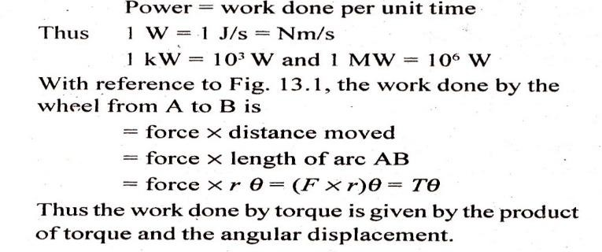

In one rotation 𝜃 =2 𝜋. If the wheel thus N revolutions per minute, then the angular displacement per second is 2𝜋𝑁/60.



# Force Measurement:

A measure of the unknown force may be accomplished by the methods incorporating following principles:-

1. Balancing the force against a known gravitational force on a standard mass (scales balances)
2. Translating the force to a fluid pressure and then measuring the resulting pressure and pneumatic load cells)
3. Applying the force to some elastic member and then measuring the resulting (proving ring)
4. Applying the force to a known mass and then measuring the resulting acceleration
5. Balancing the force against a magnetic force developed by interaction of a magnet current carrying coil.

# Scales and balances:

Force or weight is indicated by making a comparison the force due to gravity acting on a standard mass and the force due to gravity on the unknown mass.

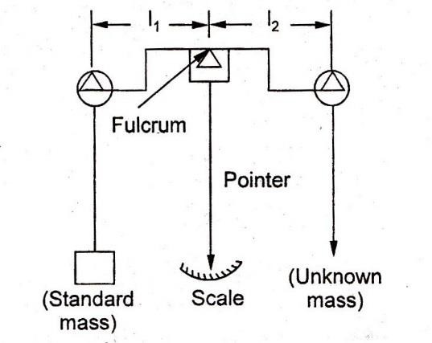

An equal-arm beam balance of a beam pivoted on a knife-edge fulcrum the centre. Attached to the centre of the beam a pointer which points vertically downwards the beam is in equilibrium. The equilibrium exist when the clockwise rotating equals the anti-clockwise rotating moment i.e., 𝑚1 𝑙1=

𝑚2𝑙2. Since the two arms of the beam equal; the beam would be in equilibrium again 𝑚1= 𝑚2. Further for a given location, the attraction acts equally on both the masses therefore at the equilibrium conditions 𝑊1= 𝑊2 , i. e., the unknown force or weights equal known force or weights.

# PROVING (STRESS) RING:

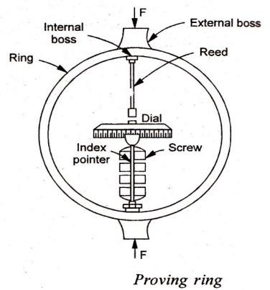

The proving (stress) ring is a ring of known physical dimensions and mechanical properties. When an external compressive or tensile load is applied to the lugs or external bosses, the ring changes in its diameter; the change being proportional to the applied force. The amount of ring deflection is measured by means of a micrometer screw and a vibrating reed which are attached to the internal bosses. During use, the micrometer tip is advanced and its contact with the reed is indicated by considerable damping of the reed vibration. The difference in the micrometer reading taken before and after the application of load is the measure of the amount of the elongation or compression of the ring. The proving ring deflection can also be picked by LVDT, resulting in a proportional voltage change. The device gives precise results when properly calibrated and corrected for temperature variations.

Instead of deflection, strain in an elastic member may be measured by a strain gauge, and then correlated to the applied force.

**Mechanical load cells:** The term load cell is used to describe a variety of force transducers which may utilize the deflection or strain of elastic member, or the increase in pressure of enclosed fluids. The resulting fluid pressure is transmitted to some form of pressure sensing device such as a manometer or a bourdon tube pressure gauge. The gauge reading is identified and calibrated in units of force.

# Hydraulic load cell:

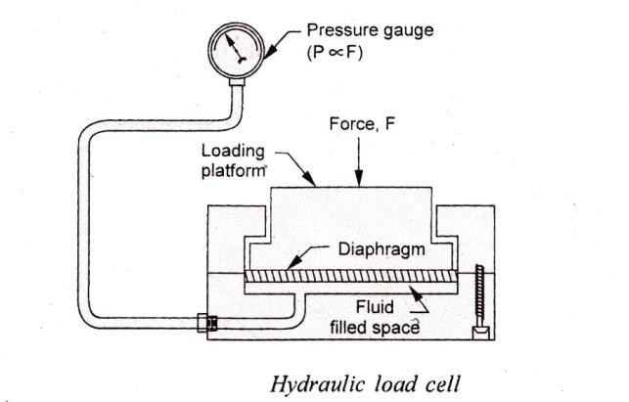

In a hydraulic load cell the force variable is impressed upon a diaphragm which deflects and there by transmits the force to a liquid. The liquid medium, contained in a confined space, has a preload pressure of the order of 2 bar. Application of force increases the liquid pressure; it equals the force magnitude divided by the effective area of the diaphragm. The pressure is transmitted to and read on an accurate pressure gauge calibrated directly in force units. The system has a good dynamic response; the diaphragm deflection being less than 0.05 mm under full load. This is because the diaphragm has a low modulus and substantially all the force is transmitted to the liquid. These cells have been to measure loads up to about 2.5 MN with an accuracy of the order of 0. I percent of full scale; resolution is about

0.02 percent.

# pneumatic load cell:

A pneumatic load cell operates on the force-balance principle and employs a nozzle-flapper transducer similar to the conventional relay system. A variable downward force is balanced by an upward force of air pressure against the effective area of a diaphragm. Application of force causes the flapper to come closer to the nozzle, and the diaphragm to deflect downwards. The nozzle opening is nearly shut-off and

this results into an increased back pressure in the system. The increased pressure acts on the diaphragm, produces an effective upward force which tends to return the diaphragm to its preload position.

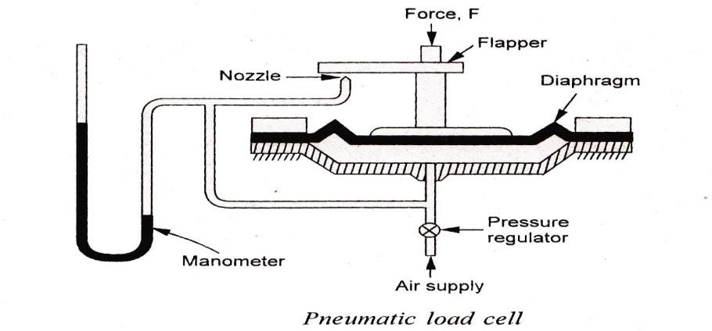

For any constant applied force, the system attains equilibrium at a specific nozzle opening and a corresponding pressure is indicated by the height of mercury column in a manometer. Since the maximum pressure in the system is limited to the air-supply pressure, the range of 'M unit can be extended only by using a larger diameter diaphragm. The commercially available load cells operating on this principle can measure loads up to 250 KN with an accuracy of 0.5 percent of full scale. The air consumption is of the order of 0.17 𝑚3/hr of free air.

# Strain gauge load cell:

The strain gauge load cell converts weight or force into electrical outputs which are provided by the strain gauges; these outputs can be connected to various measuring instruments for indicating, recording and controlling the weight or force.

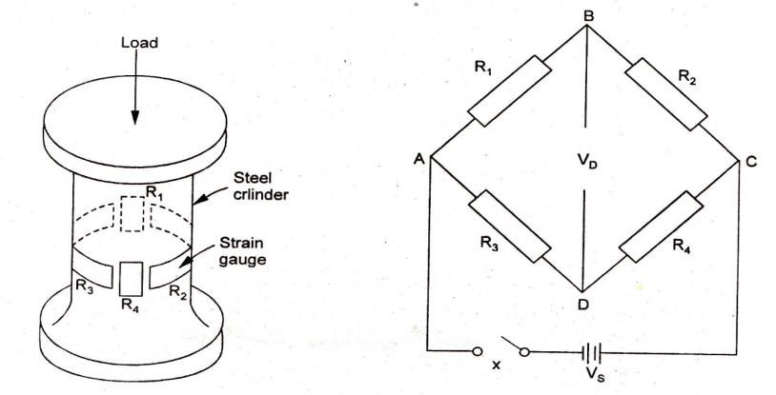

A simple load cell consists of a steel cylinder which has four identical strain gauges mounted upon it; the gauges 𝑅1 and 𝑅4 are along the direction of applied load and the gauges 𝑅2 and 𝑅3 are attached circumferentially at right angles to gauges 𝑅1 and 𝑅4. These four gauges are connected electrically to the four limbs of a Wheatstone bridge circuit. When there is no load on the cell, all the four gauges have the same resistance. Evidently then the terminals B and D are at the same potential; the bridge is balanced and the output voltage is zero

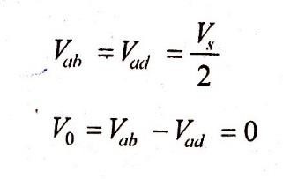

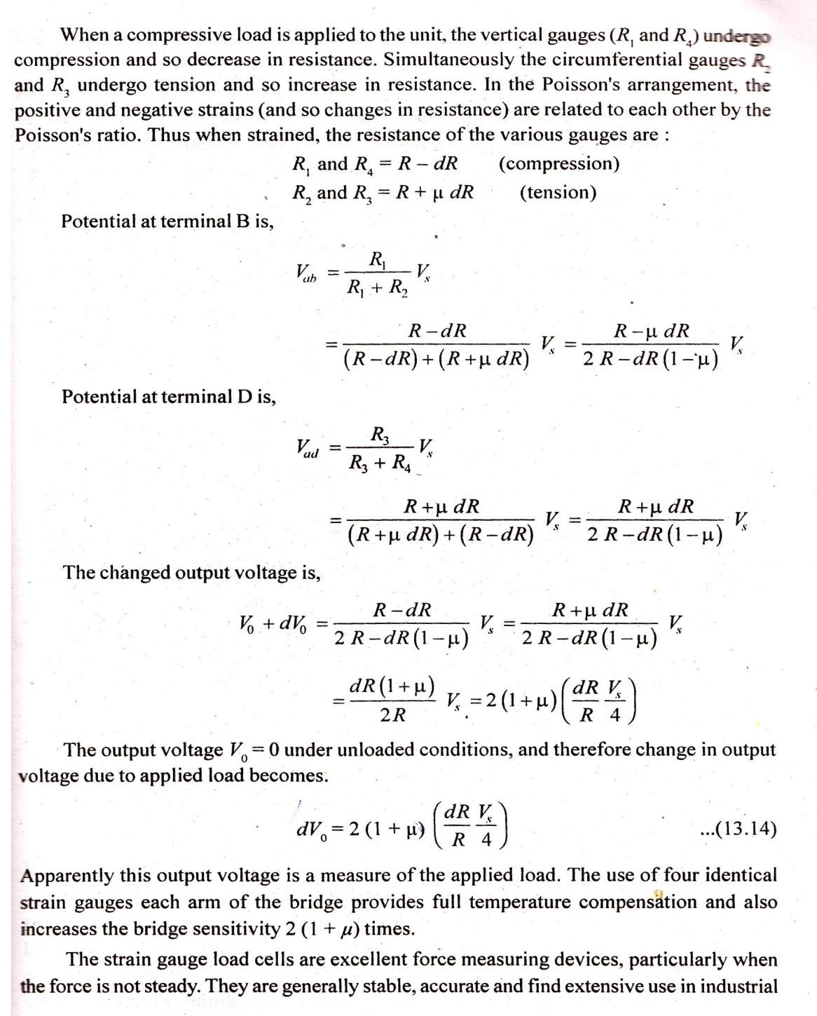

applications such as draw-bar and tool-force dynamometers, crane load monitoring, and road vehicle weighing device etc.

# Problem:

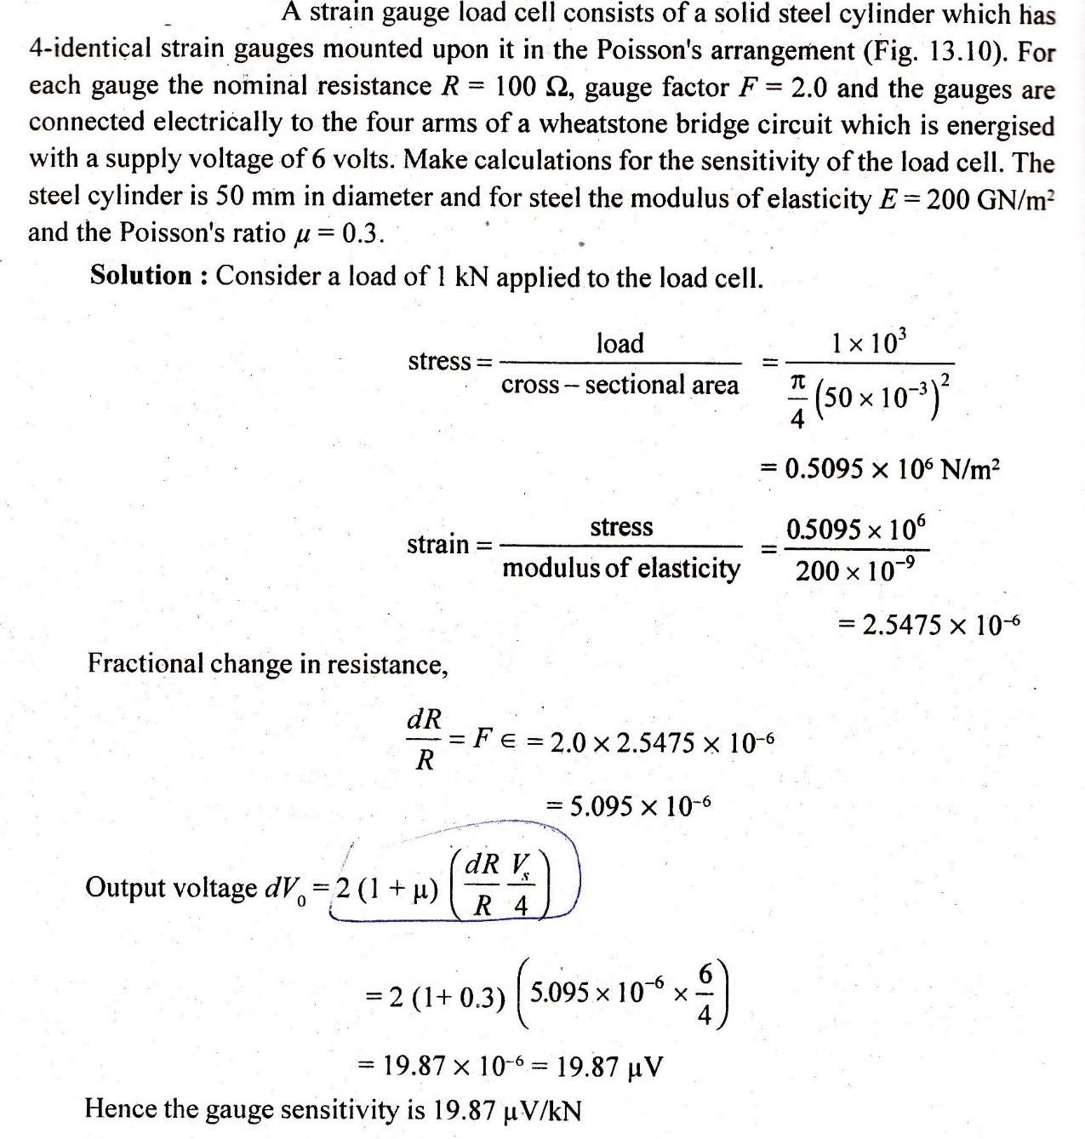

**Torques measurement:**

The main purpose of torque measurement is to determine the mechanical power required or developed by a machine. Torque measurement also helps in obtaining load information necessary for stress or strain analysis. In some cases other variables are determined by measuring torque. For example, in the case of rotating cylinder viscometer, measurement of torque developed at the fixed end of the stationary cylinder help in determining the viscosity of the fluid between the movable and stationary cylinder.

# Mechanical torsion meter:

Figure shows the schematics of an elastic torsion bar meter wherein angular deflection of a parallel length of shaft is used to measure torque. The angular twist over fixed length of the bar is observed on a calibrated disk (attached to the rotating shaft) by using the stroboscope effect of intermittent viewing and the persistence of vision. The system gives a varying angle of twist between the driving engine and the driven load as the torque changes.

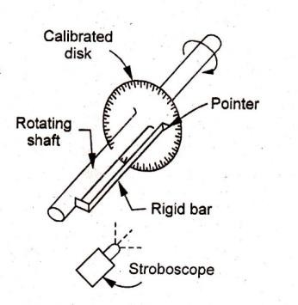

**Optical torsion meter:** The meter uses an optical method to detect the angular twist of a rotating shaft.

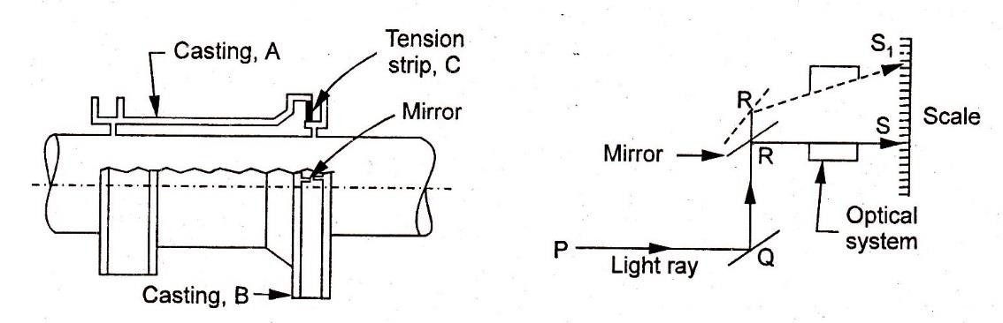

The unit comprises two castings A and B which are fitted to the shaft at a known distance apart. These castings are attached to each other by a tension strip C which transmits torsion but has little resistance to bending. When the shaft is transmitting a torque, there occurs a relative movement between the castings which results in partial inclination between the two mirrors attached to the castings. The mirrors are made to reflect a light beam onto a graduated scale; angular deflection of the light ray is then proportional to the twist of, and hence the torque in, the shaft. For constant torque measurements from a steam turbine, the two mirrors are arranged back to back and there occurs a reflection from each mirror during every half revolution. A second system of mirrors giving four reflections per revolution is desirable when used with a reciprocating engine whose torque varies during a revolution.

**Electrical torsion meter:** A system using two magnetic or photoelectric transducers, as shown in Fig, involves two sets of measurements.

1. a count of the impulse from either slotted wheel. This count gives the frequency or shaft speed.

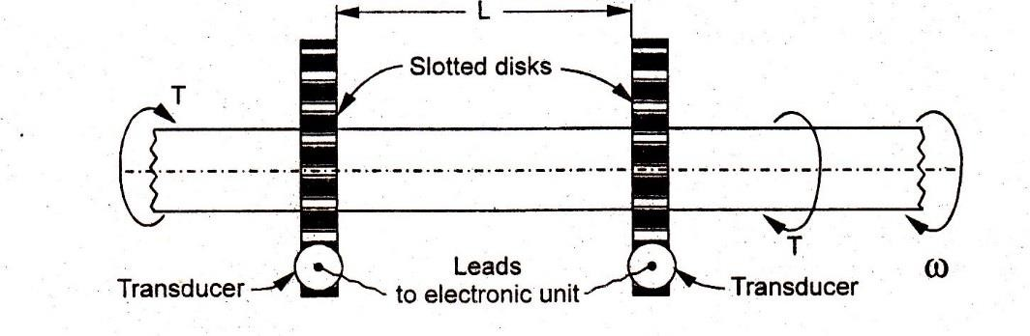

1. a measure of the time between pulses from the two wheels. This signal is proportional to the twist 6 of, and hence torque T in the shaft.

These two signals, T and 𝜔, can be combined to estimate the power being transmitted by the shaft.

**Strain- gauge torsion meter:** A general configuration of a strain gauge bridge circuit widely employed for torque measurement from a rotating shaft is shown in Fig.

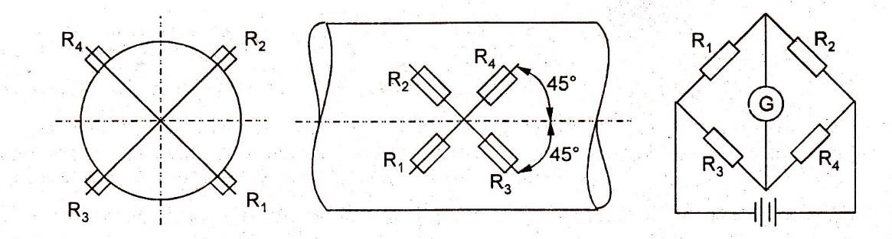

Four bonded-wire strain gauges are mounted on a 45' helix with the axis of the rotation and are placed in pairs diametrically opposite, If the gauges are accurately placed and have matched characteristics, the system is temperature compensated and insensitive to bending and thrust or pull effects. Any .change in the gauge circuit then results only from torsional deflection. When the shaft is under torsion, gauges I and 4 will elongate as a result of the tensile component of a pure shear stress on one diagonal axis, while gauges 2 and 3 will contract owing to compressive component on the other diagonal axis. These tensile and compressive principal strains can be measured, and the shaft torque can be calculated

A main problem of the system is carrying connections from the strain gauges (mounted on the rotating shaft) to a bridge circuit which is stationary. For slow shaft rotations, the connecting wires are simply wrapped around the shaft. For continuous and fast shaft rotations, leads from the four junctions of the gauges are led along the shaft to the slip rings. Contact with the slip rings is made with the brushes through which connections can be made to the measuring instrument.

Commercial-strain-gauge torque sensors are available with built-in slip rings and speed sensors. A family of such devices covers the range 6 Nm to 1000 kNm with full-scale output of about 40 mV.

# SHAFT POWER MEASUREMENT (DYNAMOMETERS):-

The dynamometer is a device used to measure the torque being exerted along a rotating shaft so as to determine the shaft power input or output of power-generating, transmitting, and absorbing machinery. Dynamometers are generally classified into:

1. **Absorption dynamometers** in which the energy is converted into heat by friction whilst being measured. The heat is dissipated to the surroundings where it generally serves no useful purpose. Absorption dynamometers are used when the test-machine is a power generator such as an engine, turbine and an electric motor. The types commonly used include Prony brakes, hydraulic or fluid friction brakes, fan brakes and eddy current dynamometers.
2. **Transmission dynamometers** in which the energy being transmitted either to or from dynamometer is not absorbed or dissipated. After measurement, the energy is conveyed to the surroundings in a useful mechanical or electrical form. A small amount of power ma). However, be lost by friction at the joints of the dynamometer. The type includes torsion and belt dynamometers, and strain gauge dynamometers.
3. **Driving dynamometer** which may be coupled to either power-absorbing or power generating devices since it may operate either a motor or a generator. These instruments measure power and also supply energy to operate the tested devices. They are essentially useful in determining performance characteristics of such machines as pumps and compressors. Electric cradled dynamometer is a typical example of the driving dynamometer.

**Mechanical brakes:** The Prony and the rope brakes are the two types of mechanical brakes chiefly employed for power measurement. The prony brake has two common arrangements in the block type and the band type. Whereas the block type is employed to high speed shafts with a small pulley, the band type measures the power of low speed shafts having a relatively large pulley.

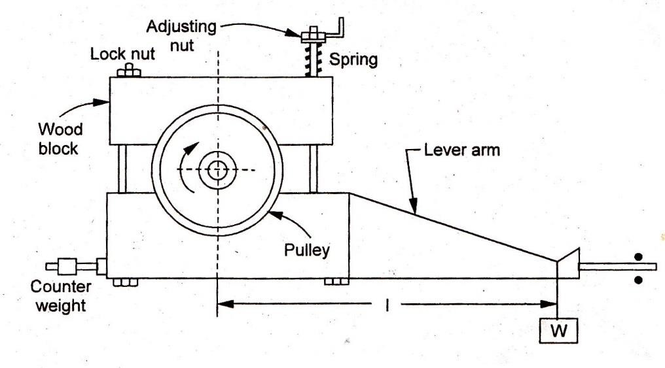

The block type prony brake consists of two blocks of wood each of which embraces rather less than one half of the pulley rim. One block carries a lever arm to the end of which a pull can be applied by means of a dead weight or spring balance. A second arm projects from the block in the opposite direction and carries a counter-weight to balance the brake when unloaded. When operating, friction between the blocks and the pulley tends to rotate the blocks in the direction of the rotation of the shaft. This tendency is prevented by adding weights at the extremity of the lever arm so that it remains horizontal in a position of equilibrium.

Let W be the weight in newton, I be the effective length of the lever arm in meter, and N be the revolutions of the crankshalt per minute. Then:



# Rope brake dynamometers:

A rope brake dynamometers consists of one or more ropes wrapped around the fly wheel of an engine whose power is to be measured. The ropes are spaced evenly across the width of the rim by means of U- shaped wooden blocks' located at different points of the rim of the flywheel. The upward ends of the rope are connected together and attached to a spring balance, and the downward ends are kept in place by a dead weight. The rotation of flywheel produces frictional force and the rope tightens. Consequently a force is induced in the spring balance. Generation of heat is enormous and that necessitates a cooling arrangement for the brake. The rim is made trough shaped internally. Water is run into the trough and kept in place by the centrifugal force.

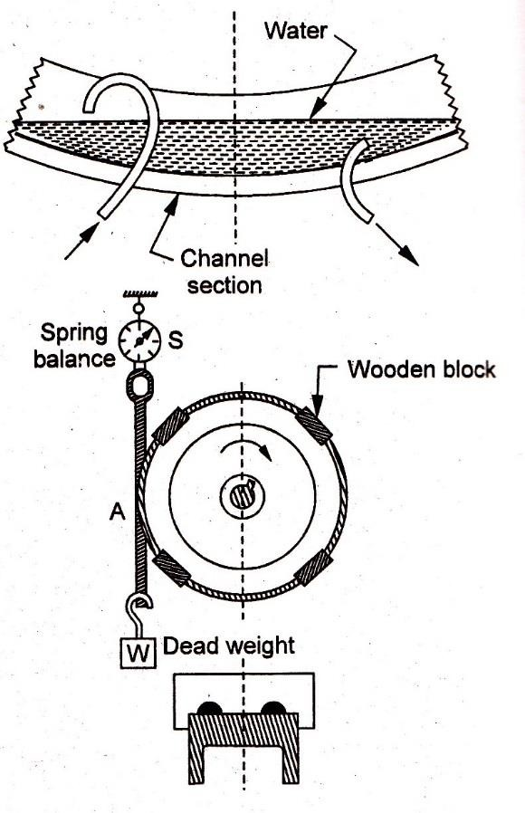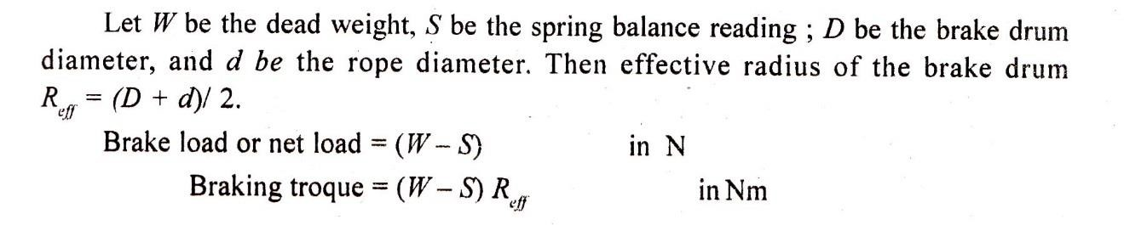

# Hydraulic dynamometer:-

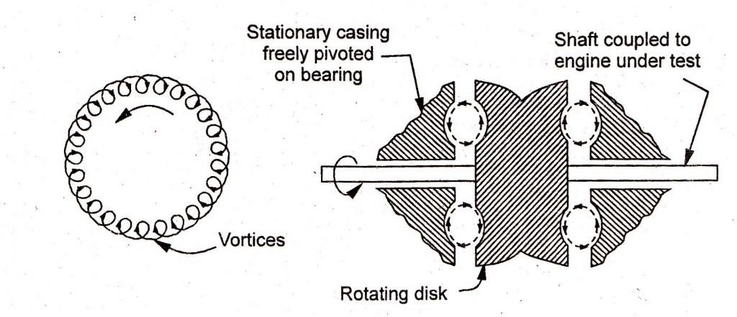

A hydraulic dynamometer uses fluid-friction rather than dry friction for dissipating -the input energy. The unit consists essentially of two elements namely a rotating disk and stationary casing. The rotating disk is keyed to the driving shaft of the prime-mover and it resolves inside the stationary casing. The casing is mounted on antifriction (trunnion) bearings and has a brake arm and a balance system attached to it. Such bearings allow the casing to rotate freely except for the restraint imposed by the brake arm. Further, the casing is in two-halves; one of which is placed on either side of the rotating disk. Semi-elliptical recesses in the casing match with the corresponding grooves inside the rotating disk to form chambers through which a stream of water flow is maintained. When brake is operating, the water follows a helical path in the chamber. Vortices and eddy-currents are set-up in the water and these tend to turn the dynamometer casing .in the direction of rotation of the engine shaft. This tendency is resisted by the brake arm balance system that measure the torque.

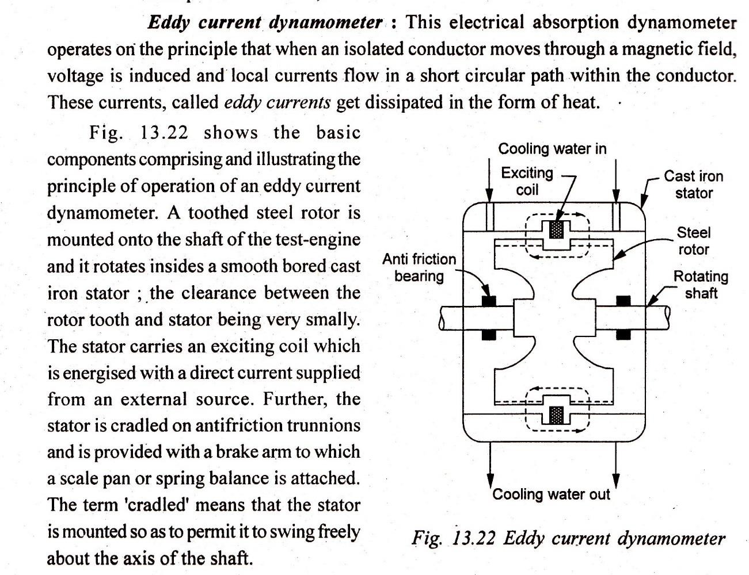

***************THE END***********