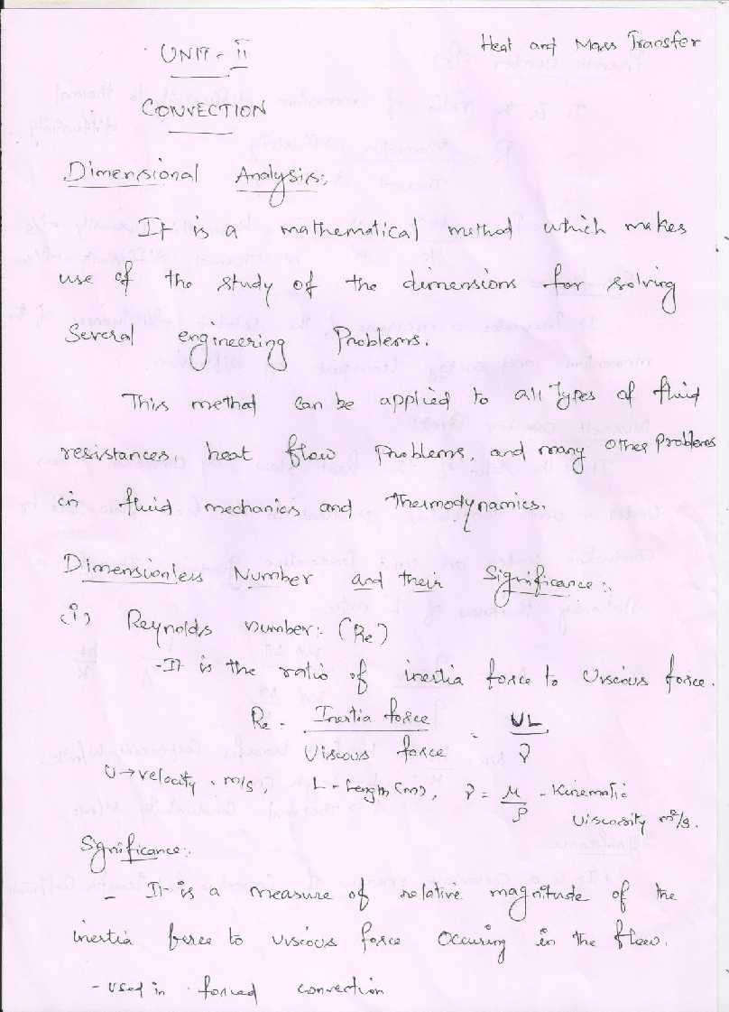

[www.studentsfocus.com](http://www.studentsfocus.com/)

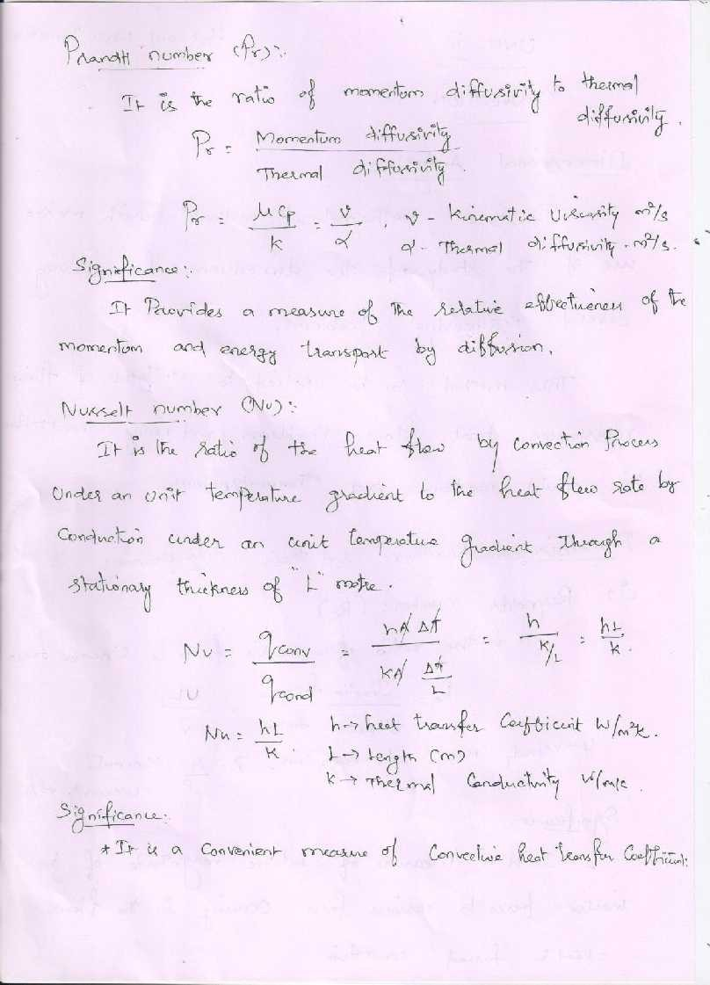

[www.studentsfocus.com](http://www.studentsfocus.com/)

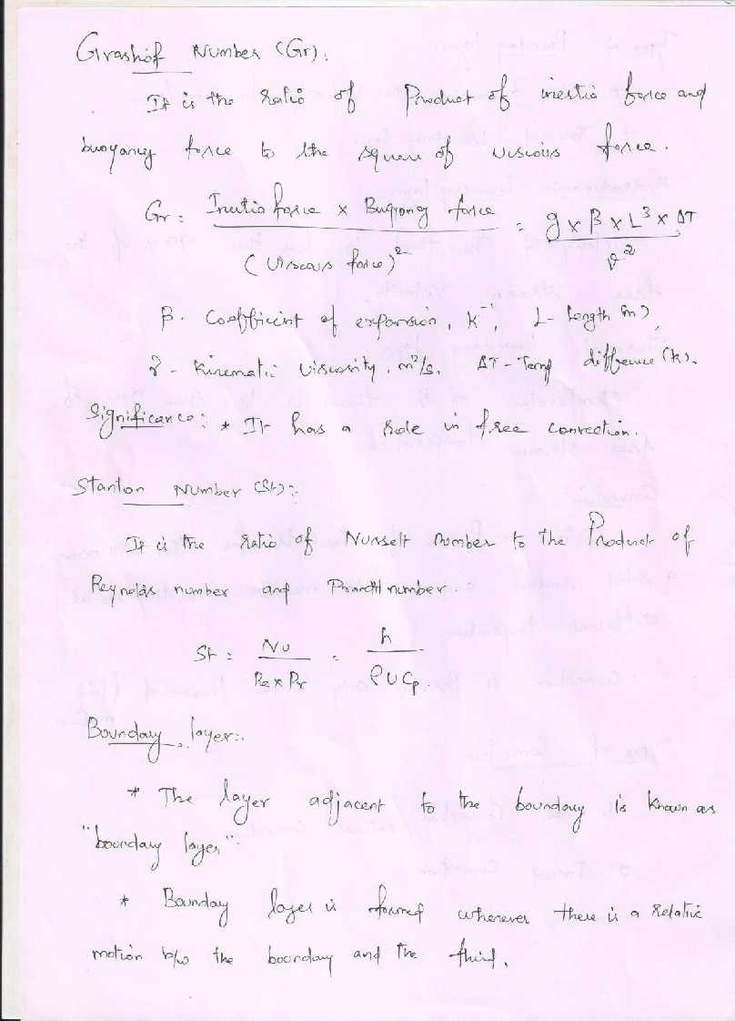

[www.studentsfocus.com](http://www.studentsfocus.com/)

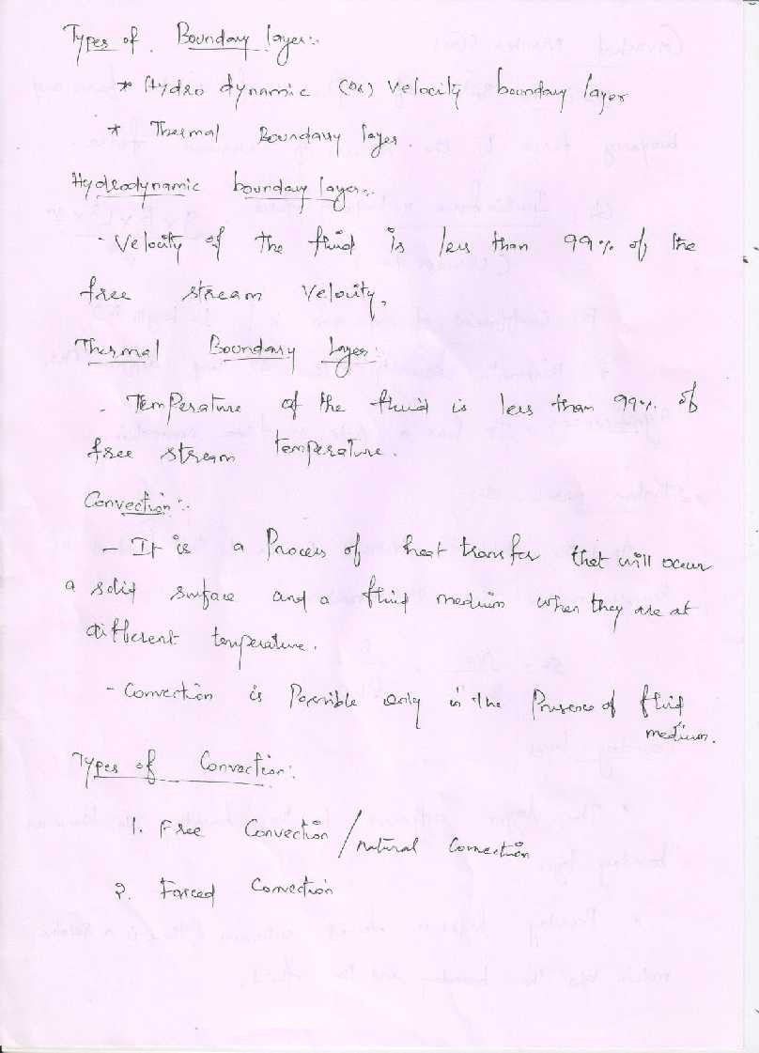

[www.studentsfocus.com](http://www.studentsfocus.com/)

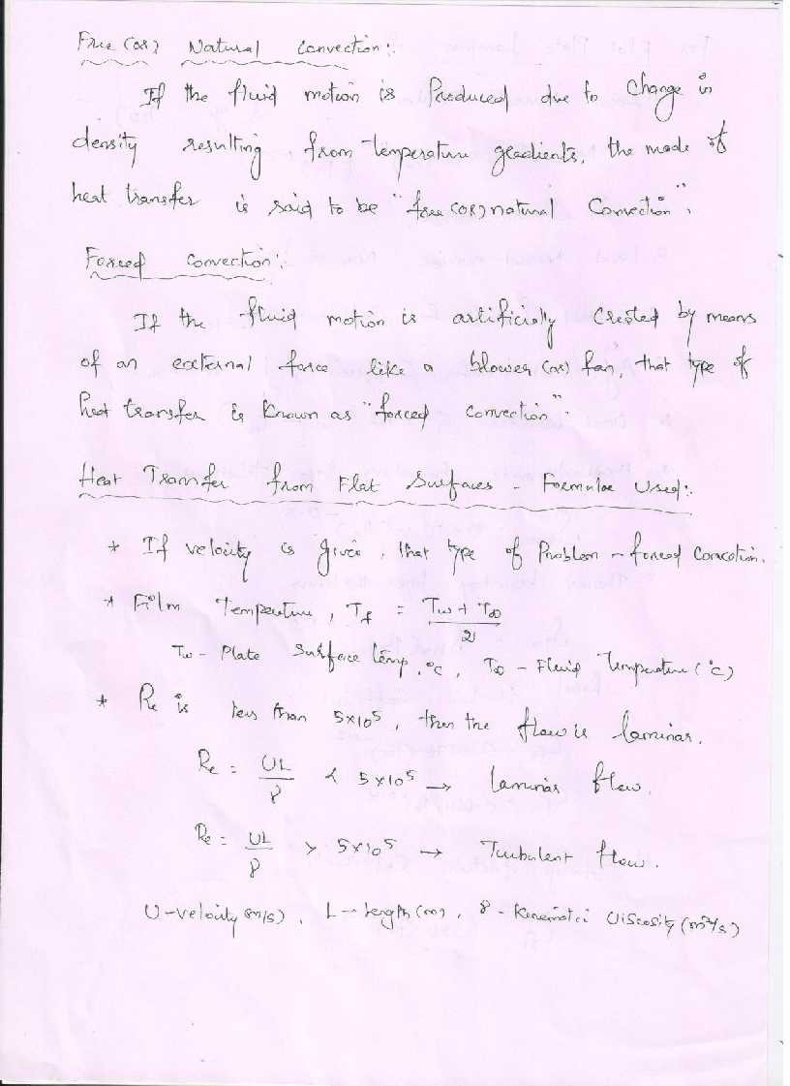

[www.studentsfocus.com](http://www.studentsfocus.com/)

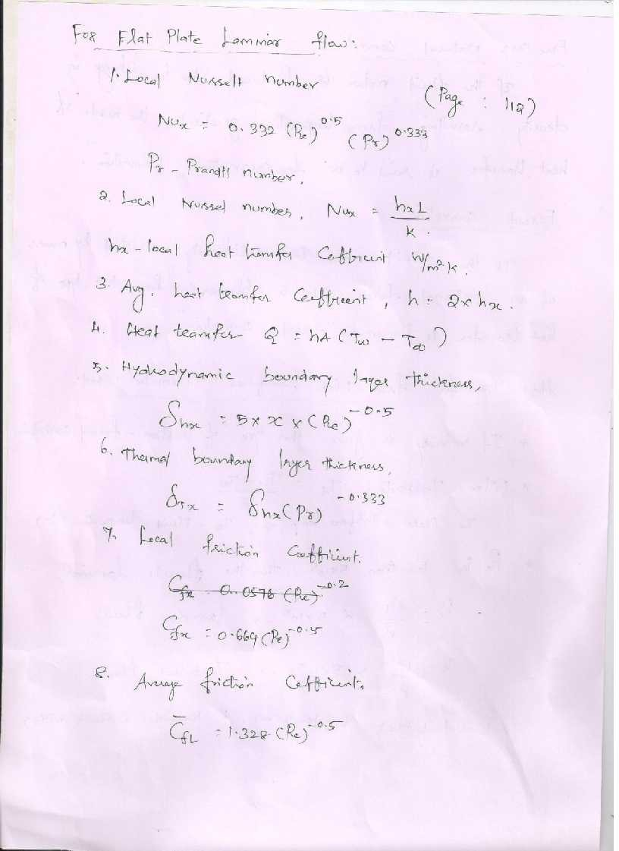

[www.studentsfocus.com](http://www.studentsfocus.com/)

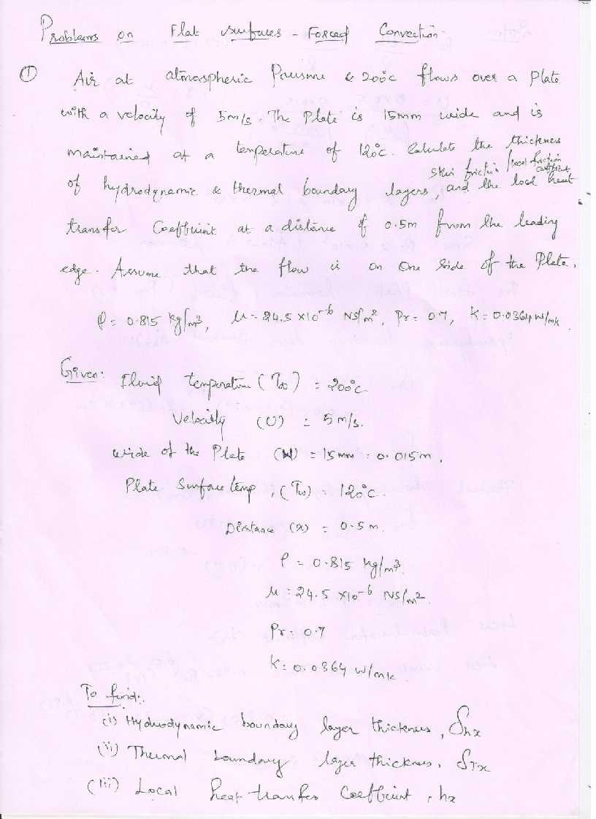

[www.studentsfocus.com](http://www.studentsfocus.com/)

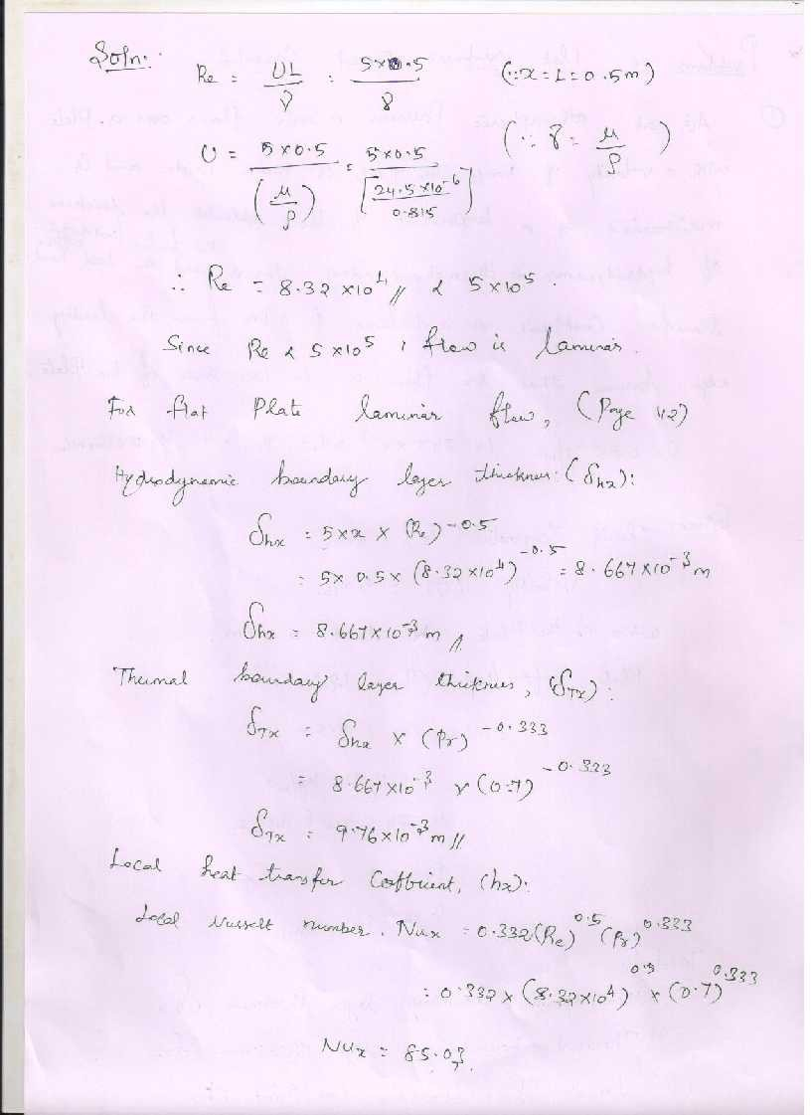

[www.studentsfocus.com](http://www.studentsfocus.com/)

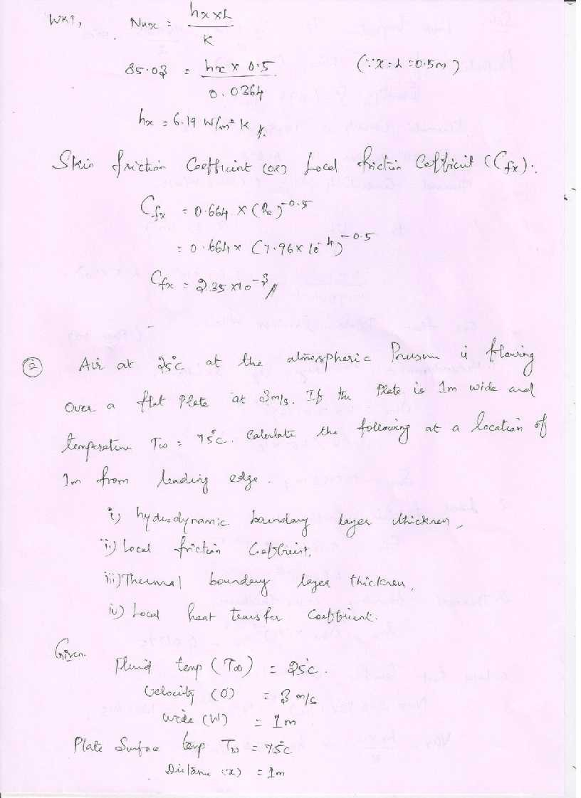

[www.studentsfocus.com](http://www.studentsfocus.com/)

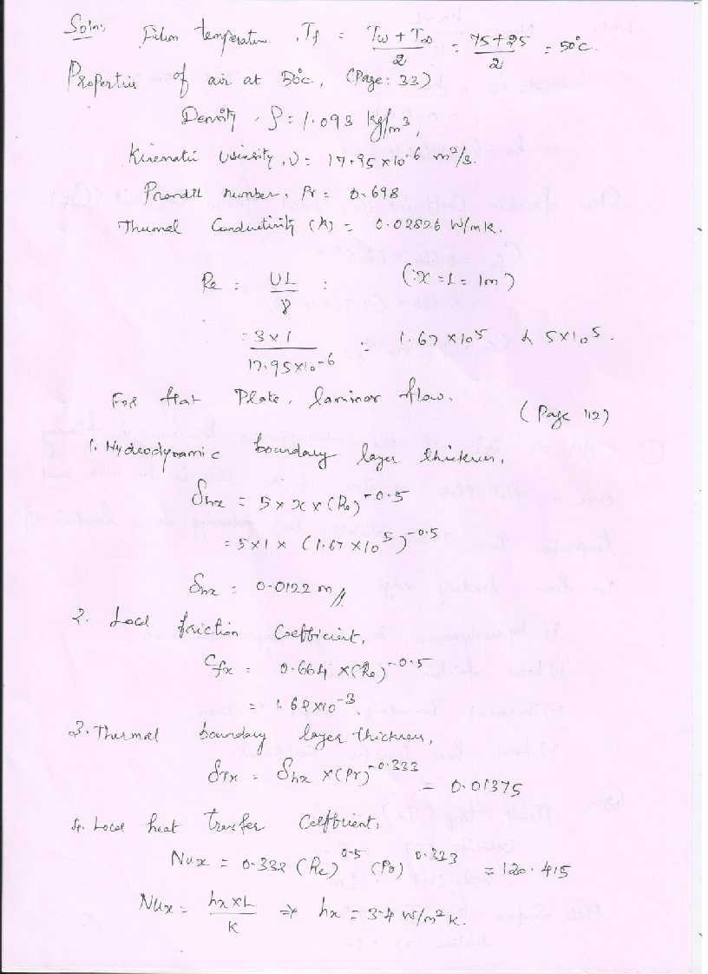

[www.studentsfocus.com](http://www.studentsfocus.com/)

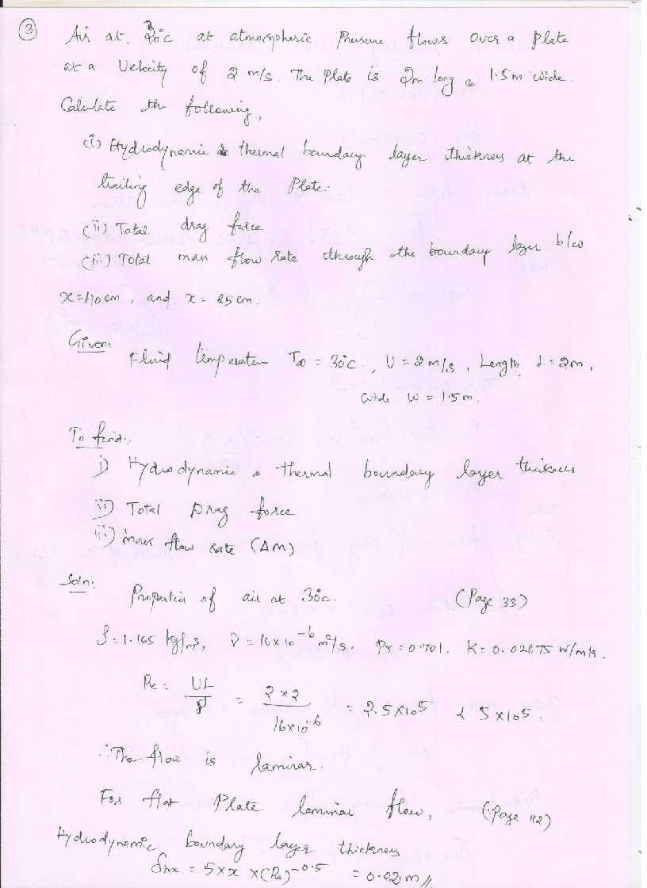

[www.studentsfocus.com](http://www.studentsfocus.com/)

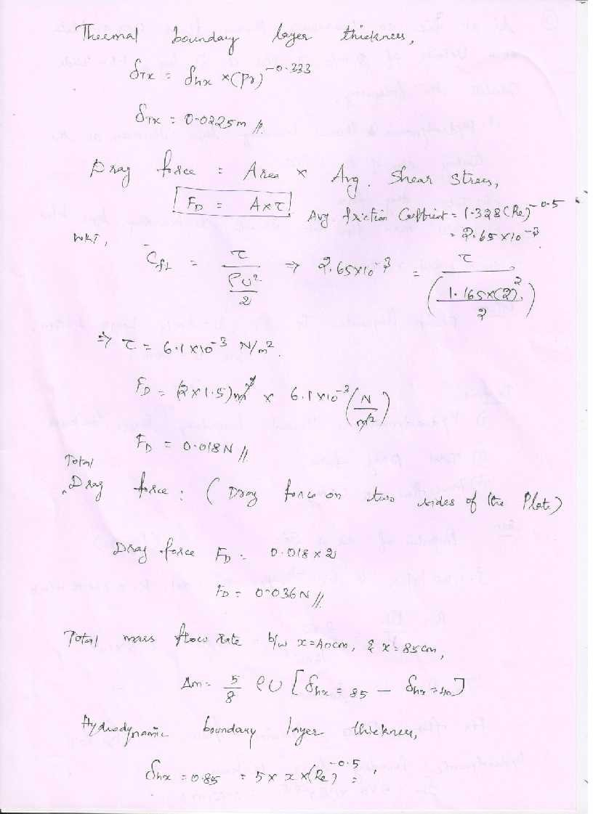

[www.studentsfocus.com](http://www.studentsfocus.com/)

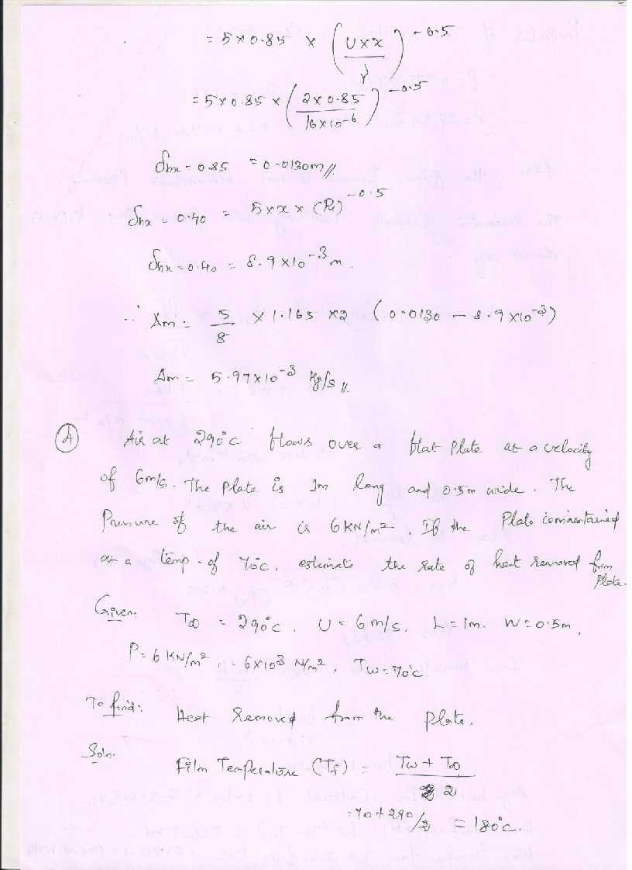

[www.studentsfocus.com](http://www.studentsfocus.com/)

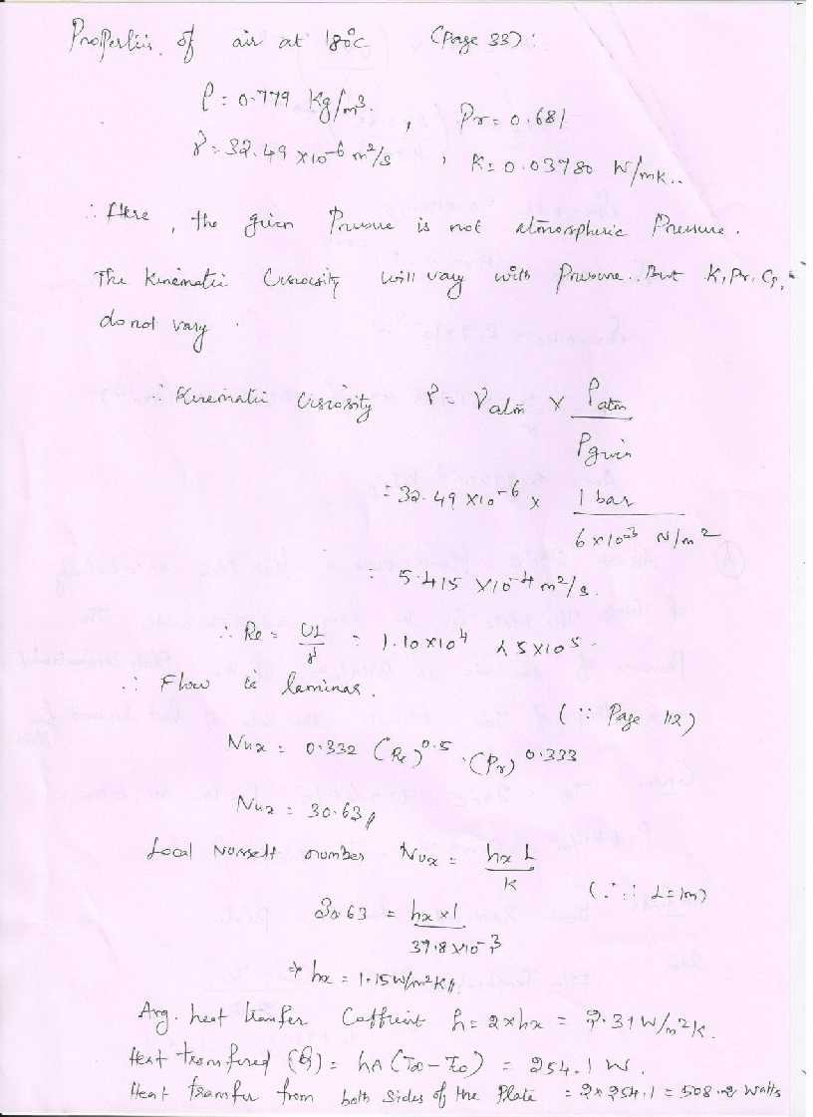

[www.studentsfocus.com](http://www.studentsfocus.com/)

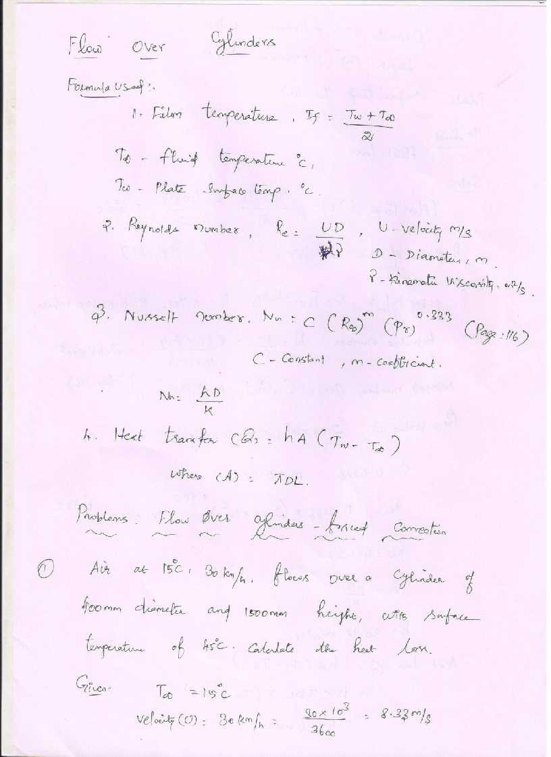

[www.studentsfocus.com](http://www.studentsfocus.com/)

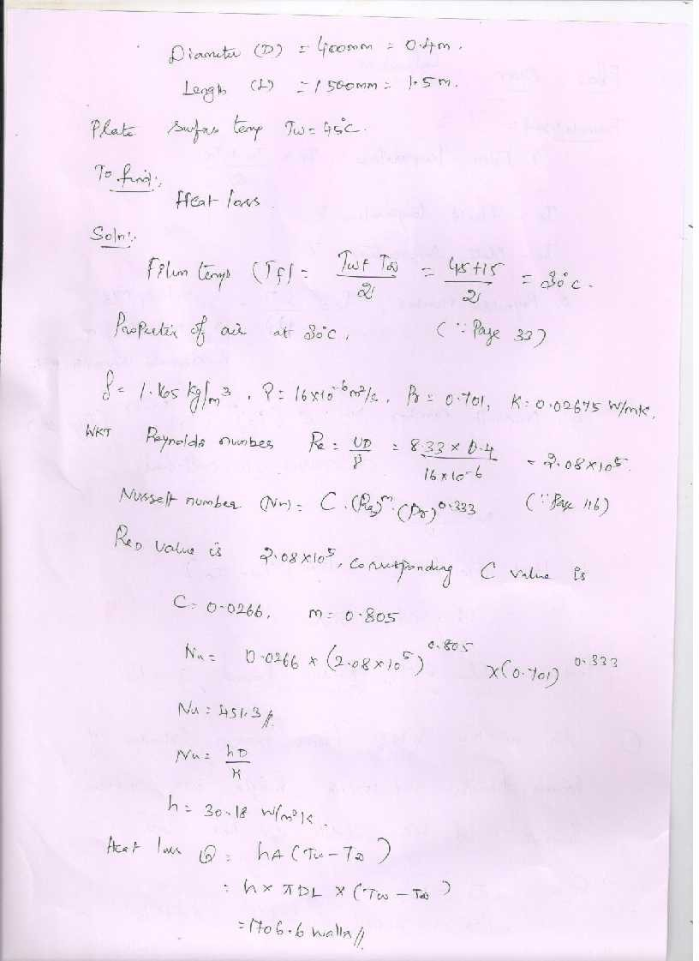

[www.studentsfocus.com](http://www.studentsfocus.com/)

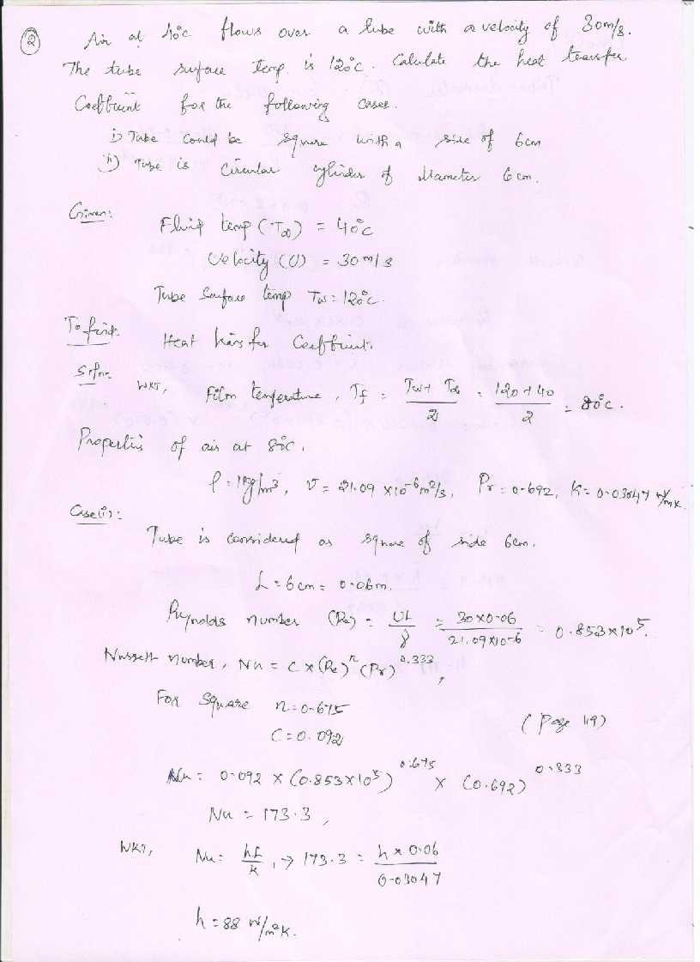

[www.studentsfocus.com](http://www.studentsfocus.com/)

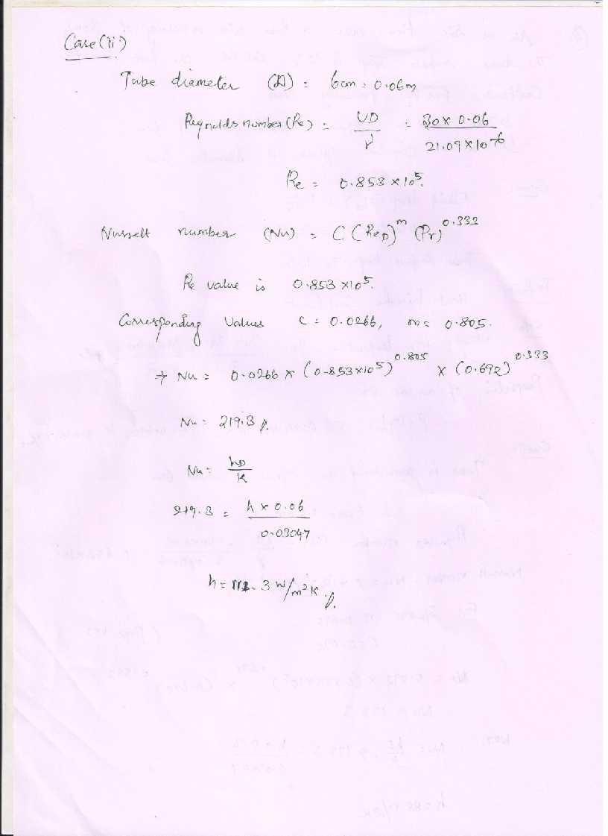

[www.studentsfocus.com](http://www.studentsfocus.com/)

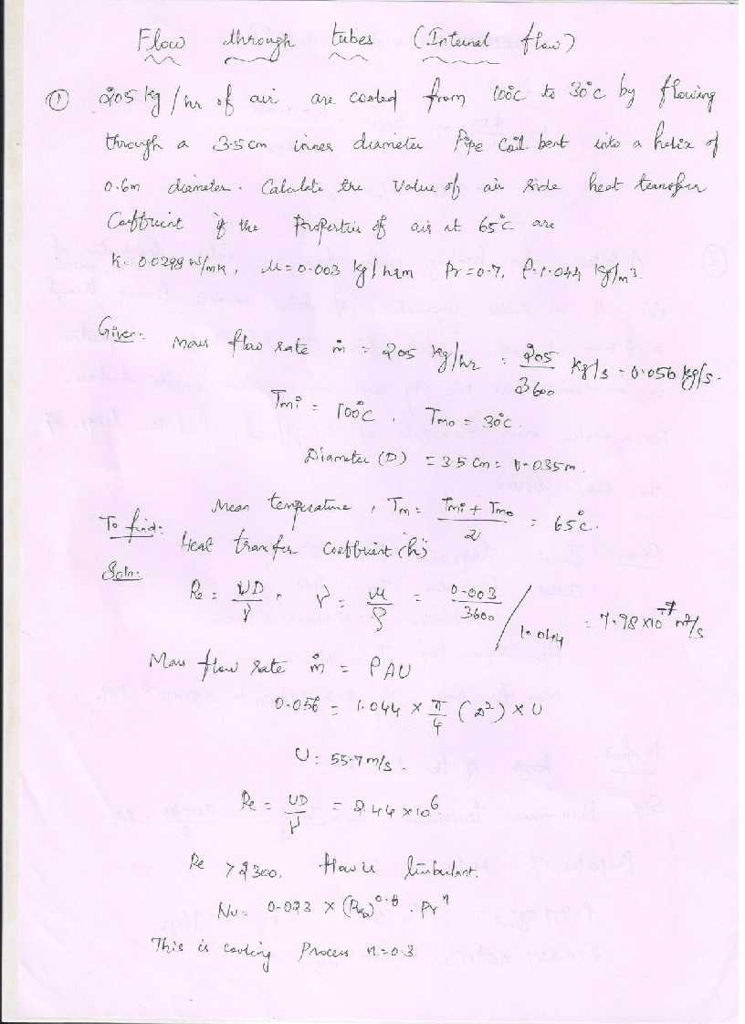

[www.studentsfocus.com](http://www.studentsfocus.com/)

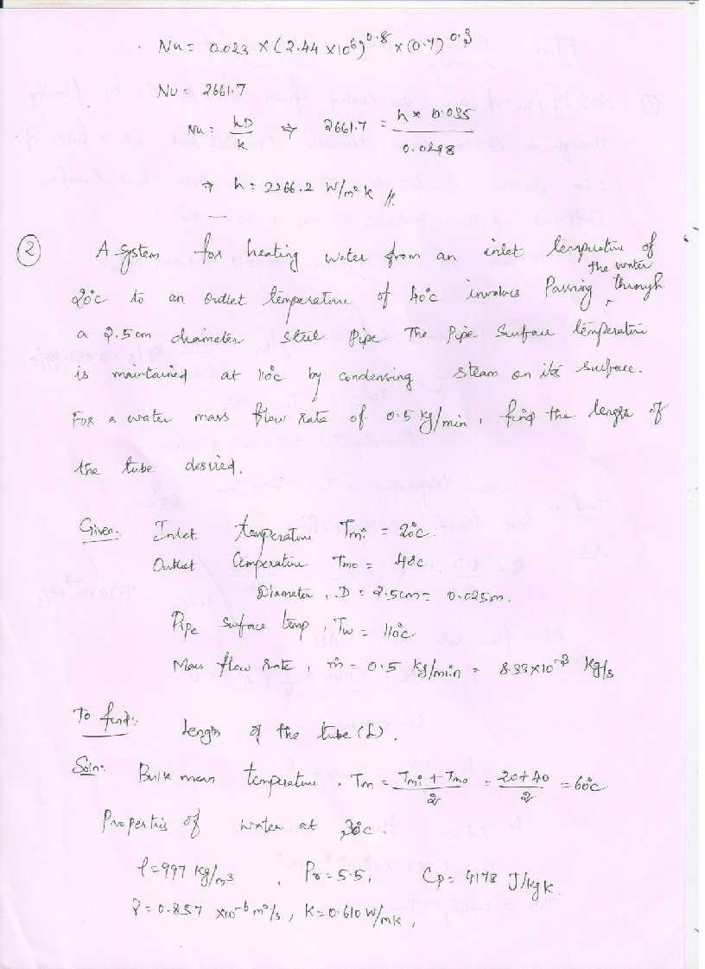

[www.studentsfocus.com](http://www.studentsfocus.com/)

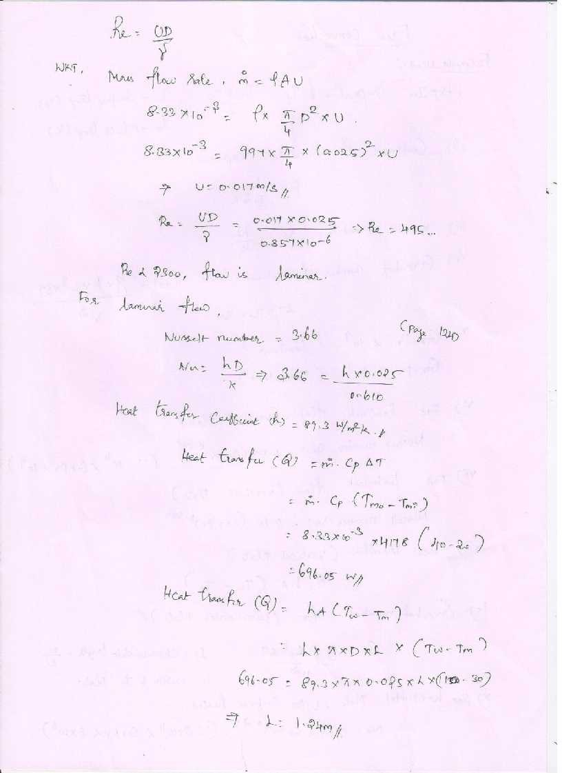

[www.studentsfocus.com](http://www.studentsfocus.com/)

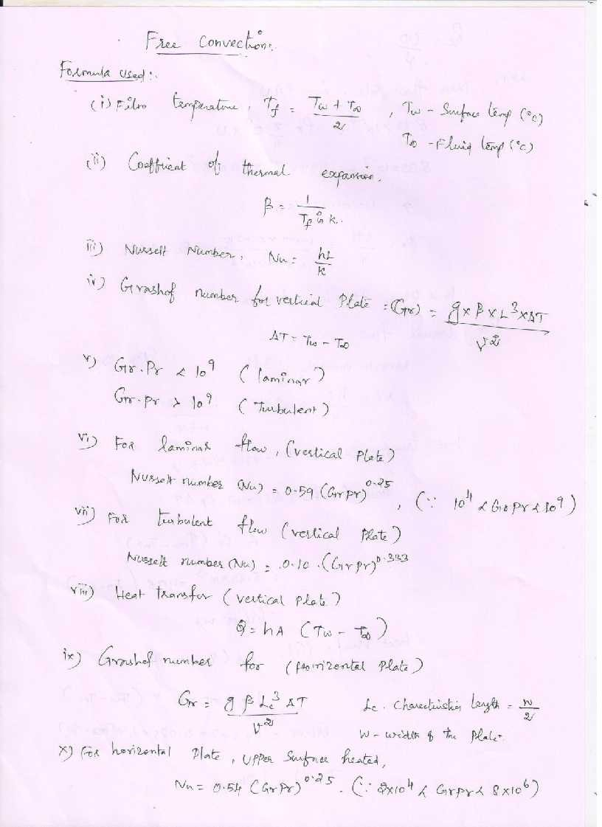

[www.studentsfocus.com](http://www.studentsfocus.com/)

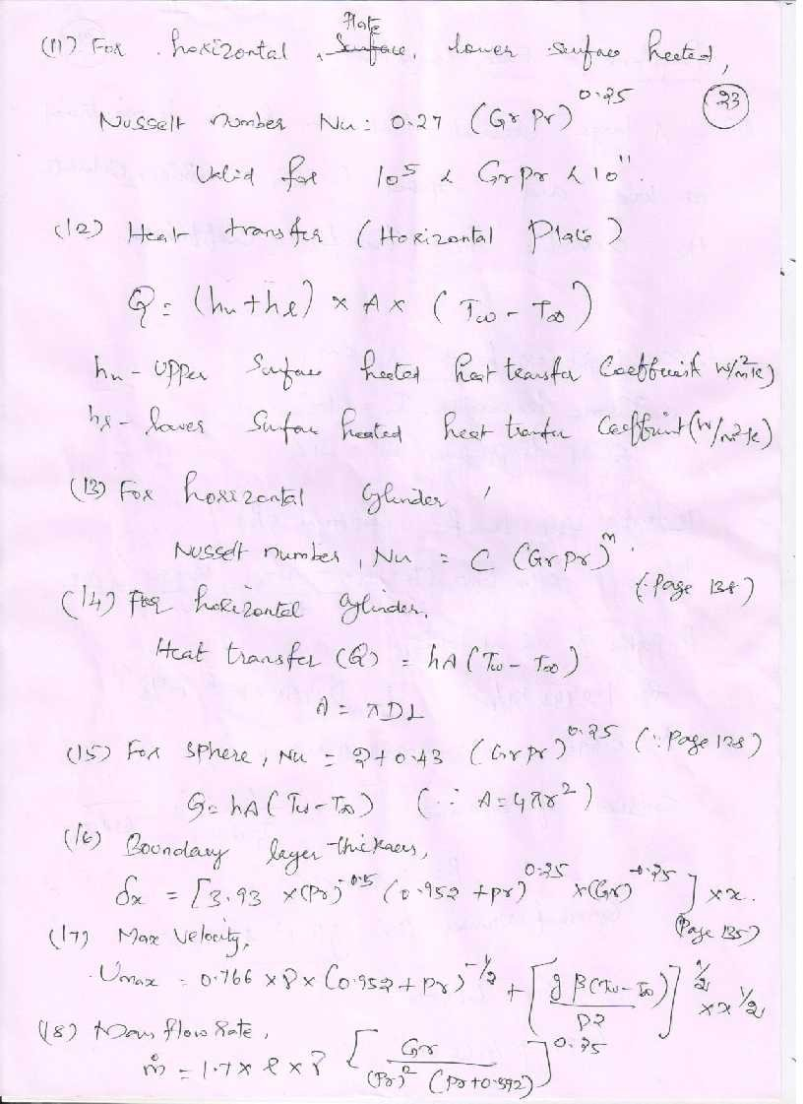

[www.studentsfocus.com](http://www.studentsfocus.com/)

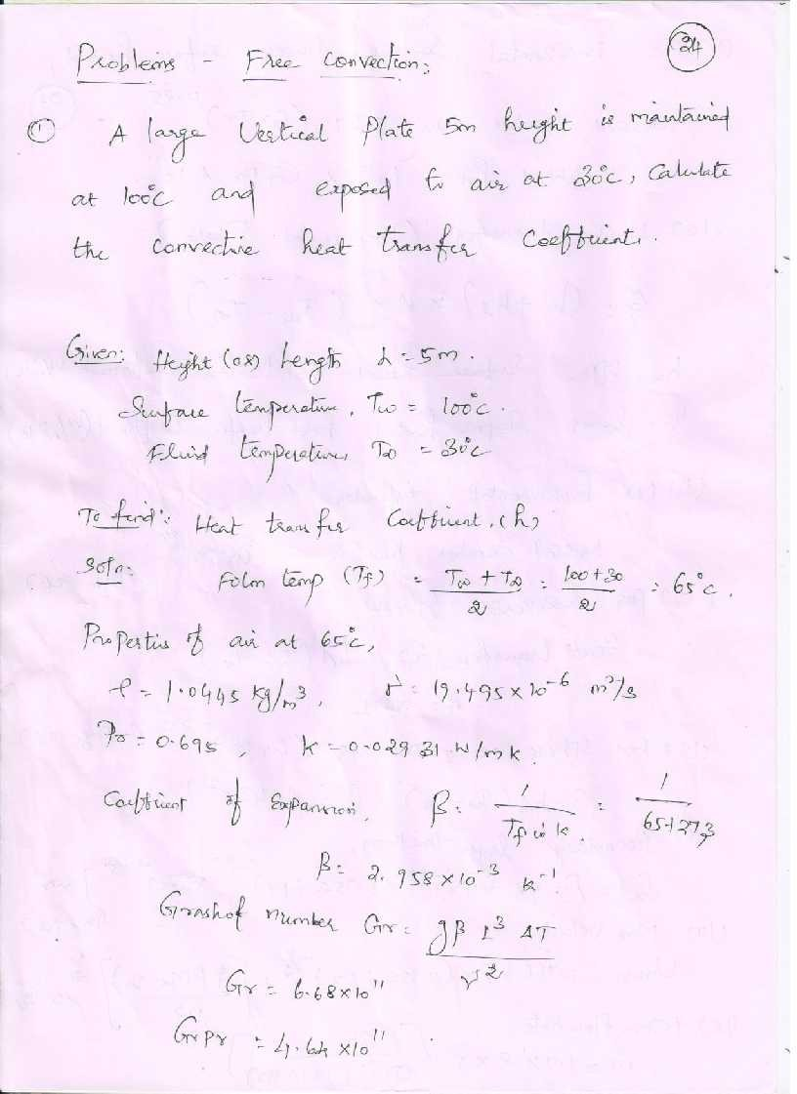

[www.studentsfocus.com](http://www.studentsfocus.com/)

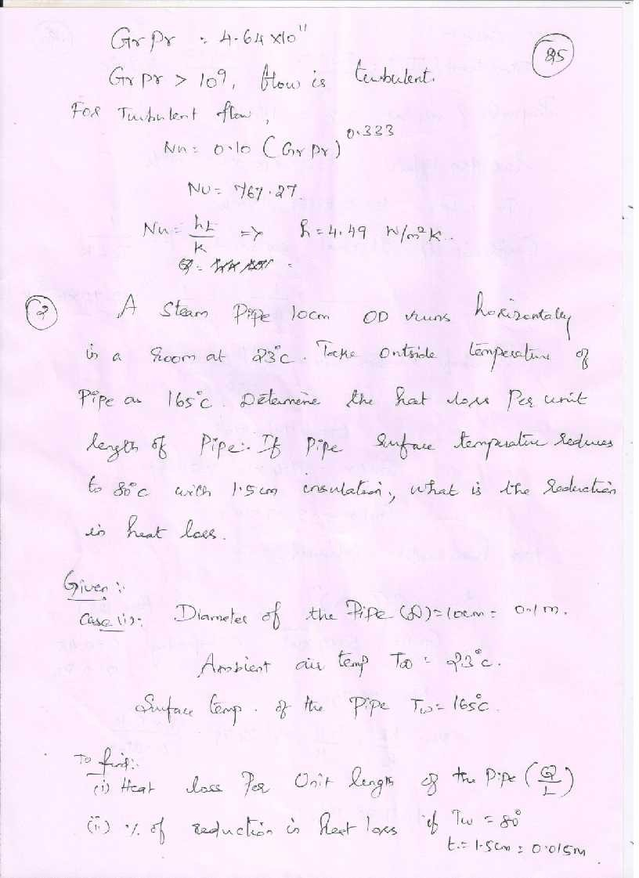

[www.studentsfocus.com](http://www.studentsfocus.com/)

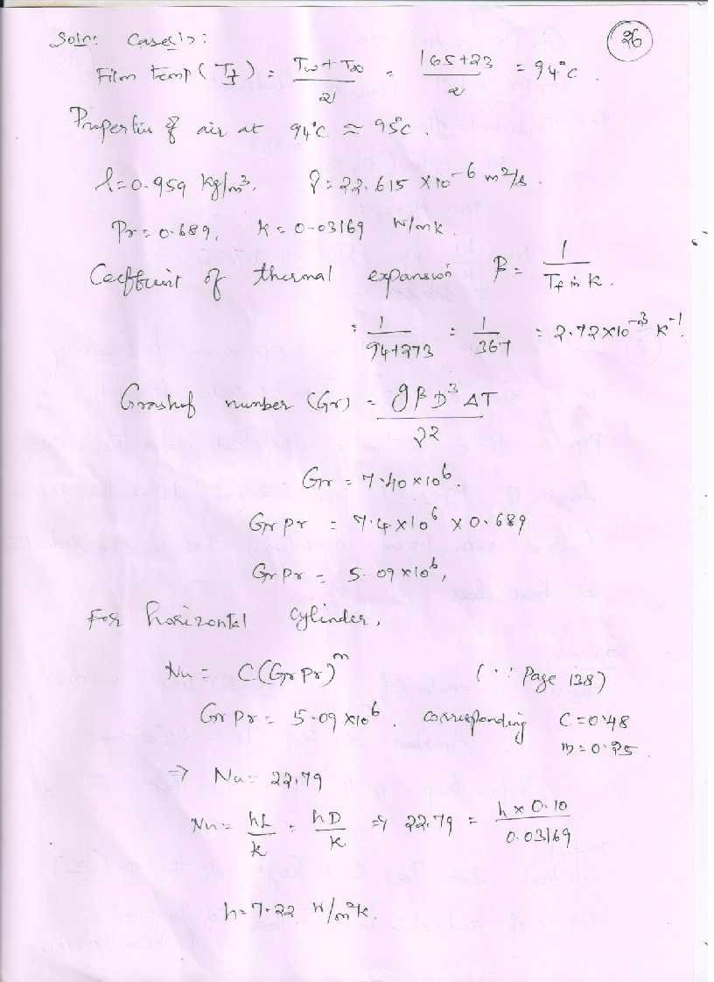

[www.studentsfocus.com](http://www.studentsfocus.com/)

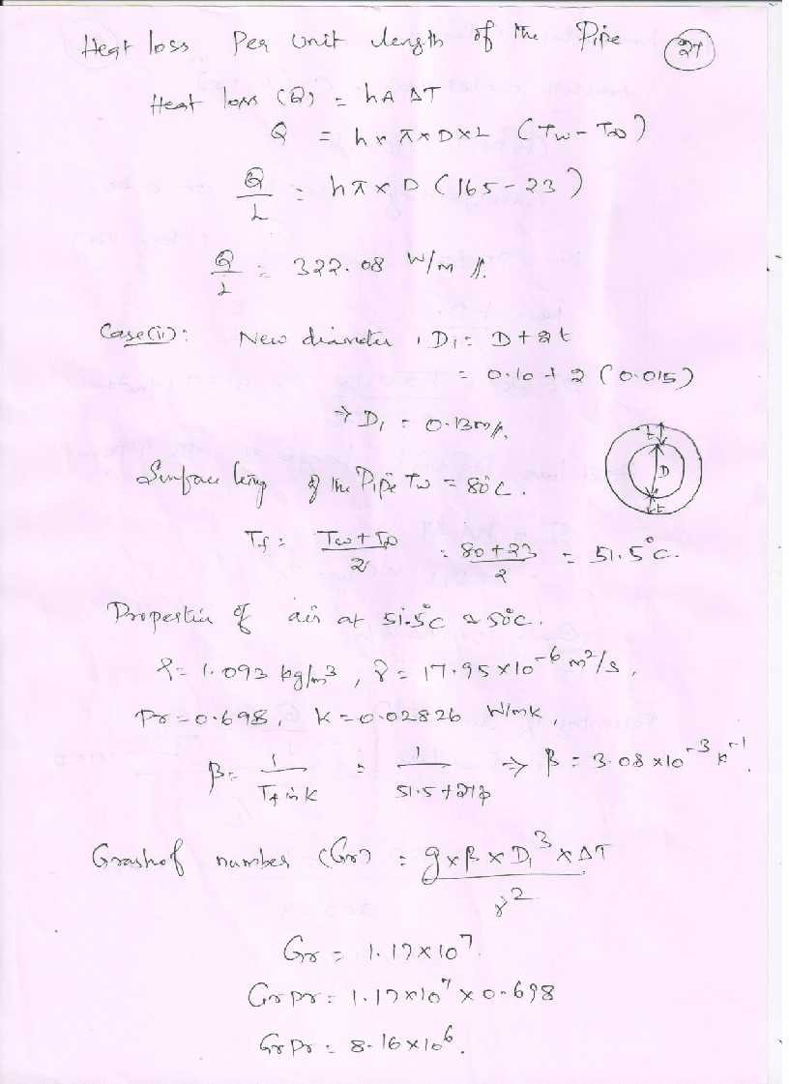

[www.studentsfocus.com](http://www.studentsfocus.com/)

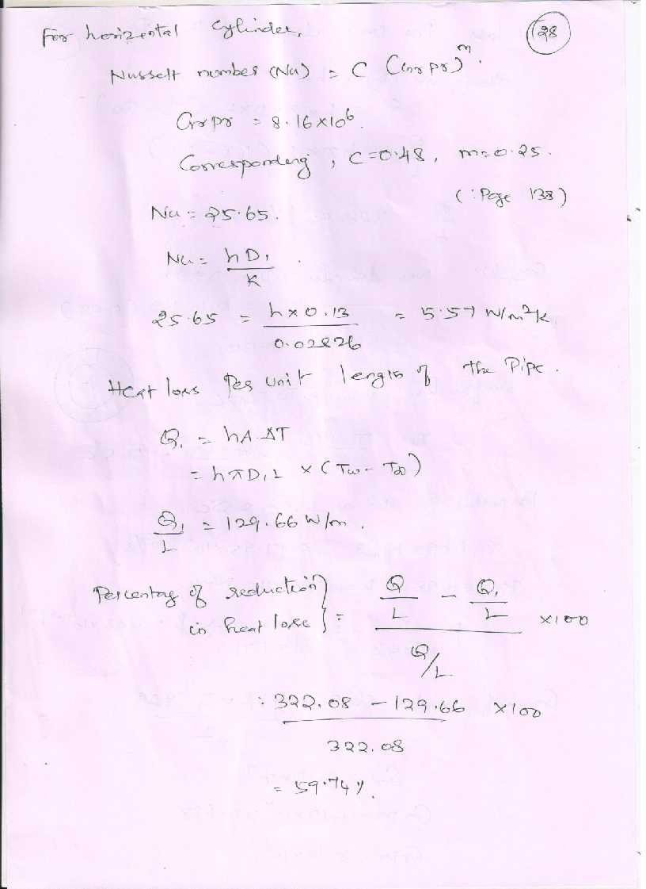

[www.studentsfocus.com](http://www.studentsfocus.com/)

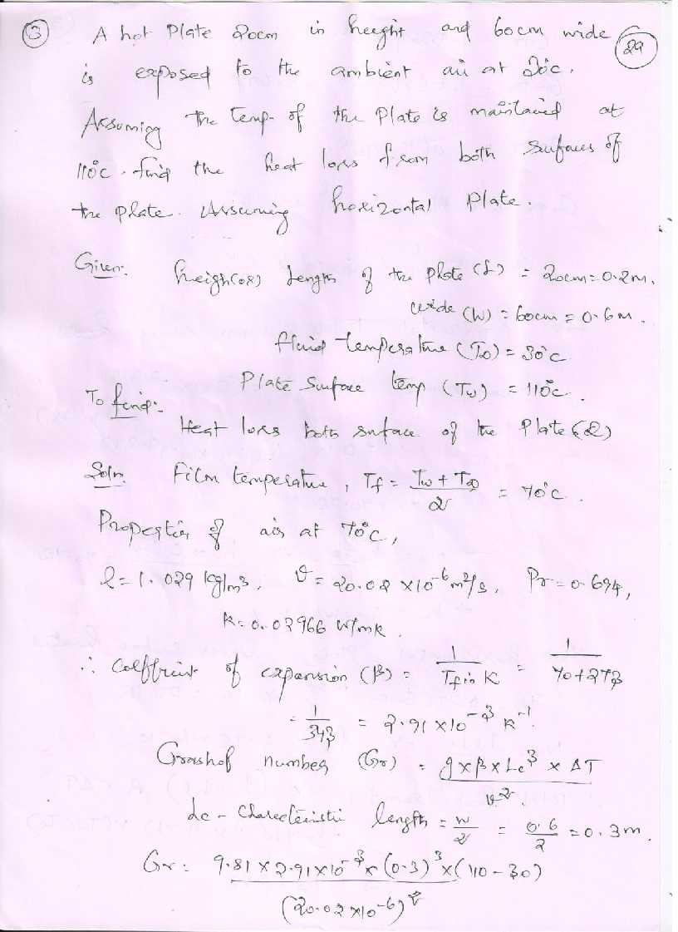

[www.studentsfocus.com](http://www.studentsfocus.com/)

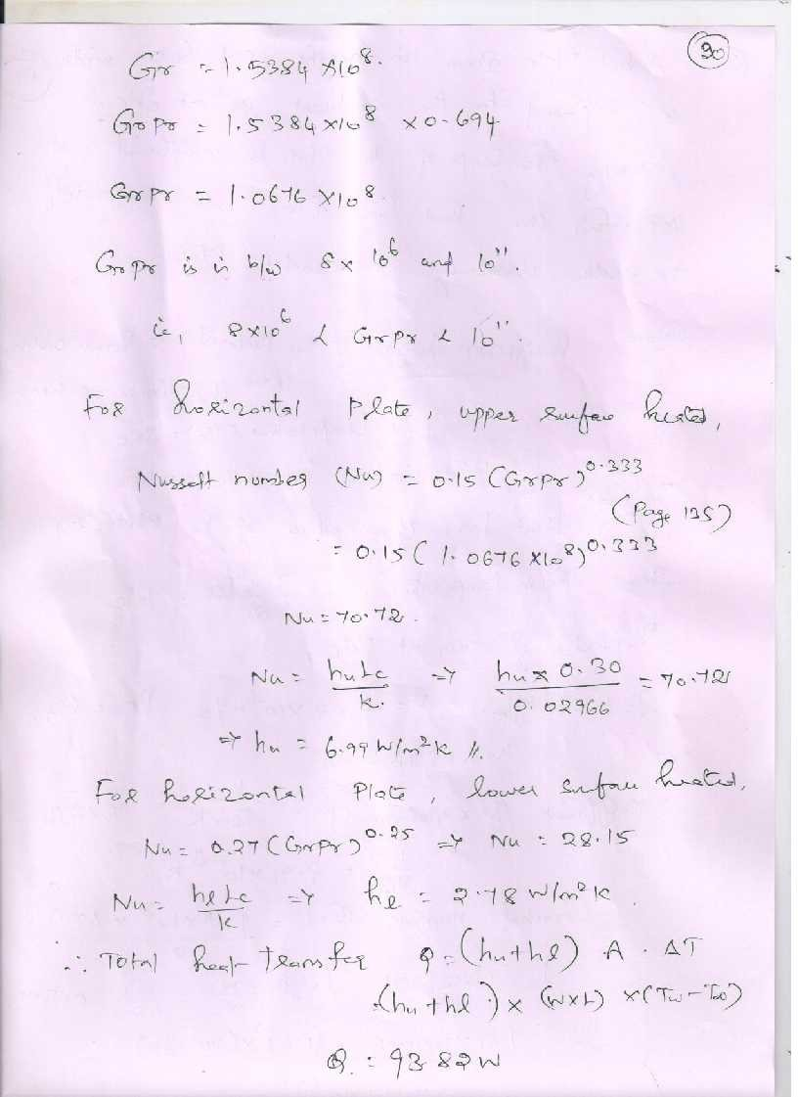

[www.studentsfocus.com](http://www.studentsfocus.com/)

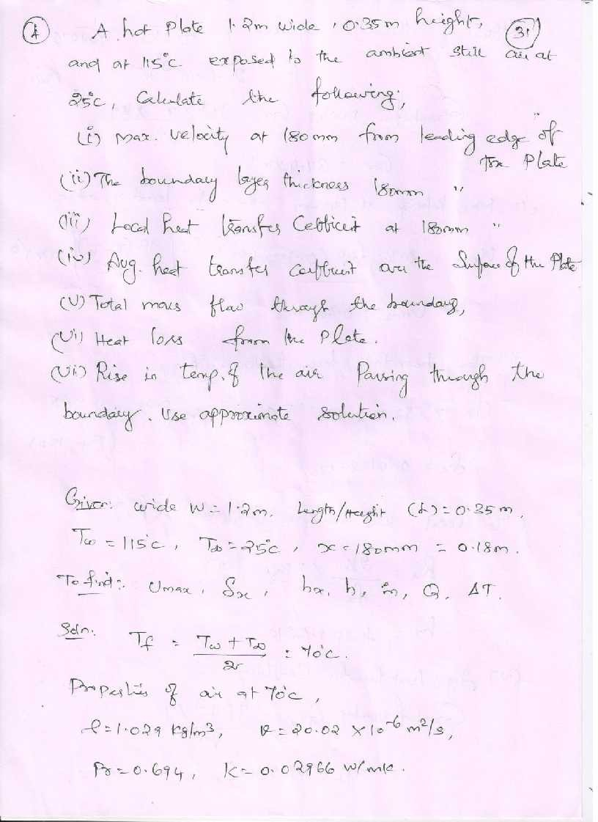

[www.studentsfocus.com](http://www.studentsfocus.com/)

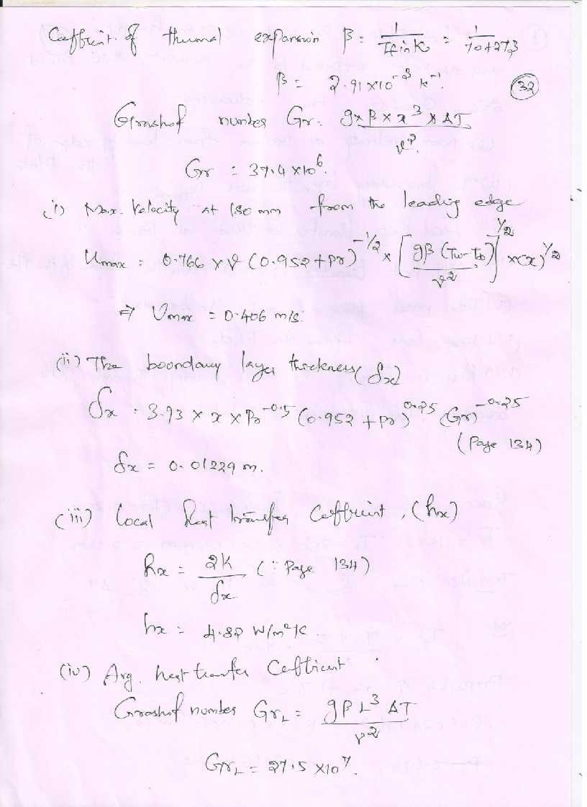

[www.studentsfocus.com](http://www.studentsfocus.com/)

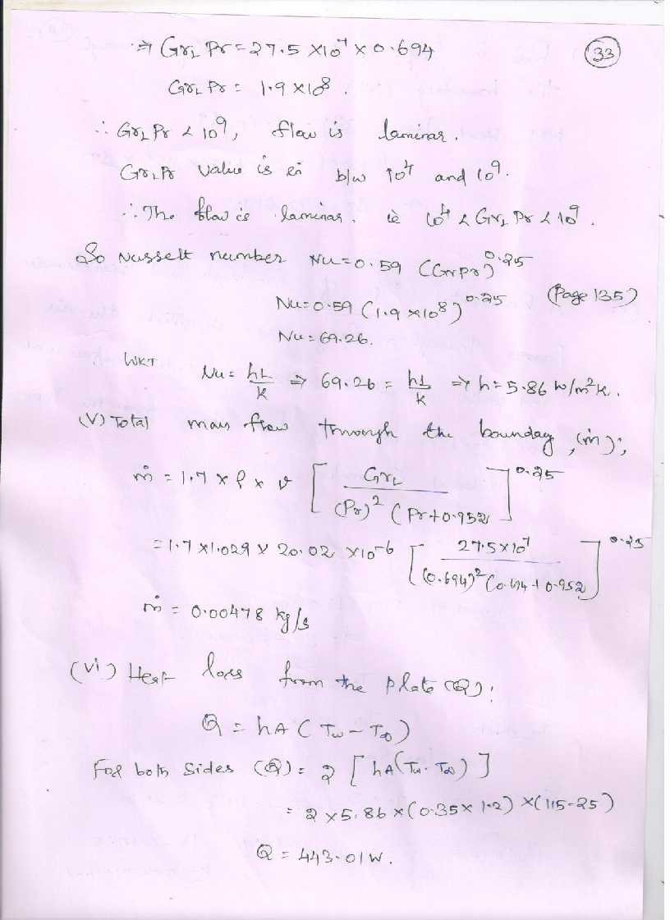

[www.studentsfocus.com](http://www.studentsfocus.com/)

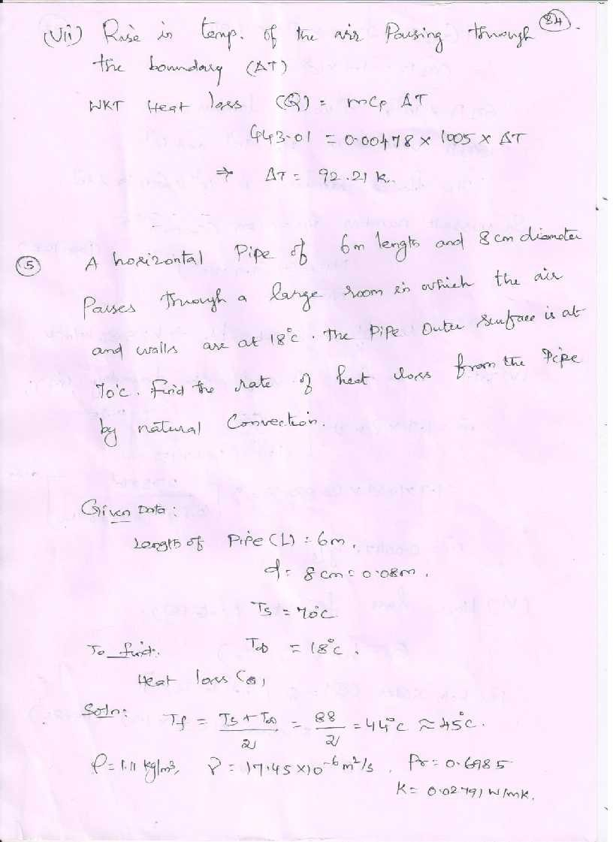

[www.studentsfocus.com](http://www.studentsfocus.com/)

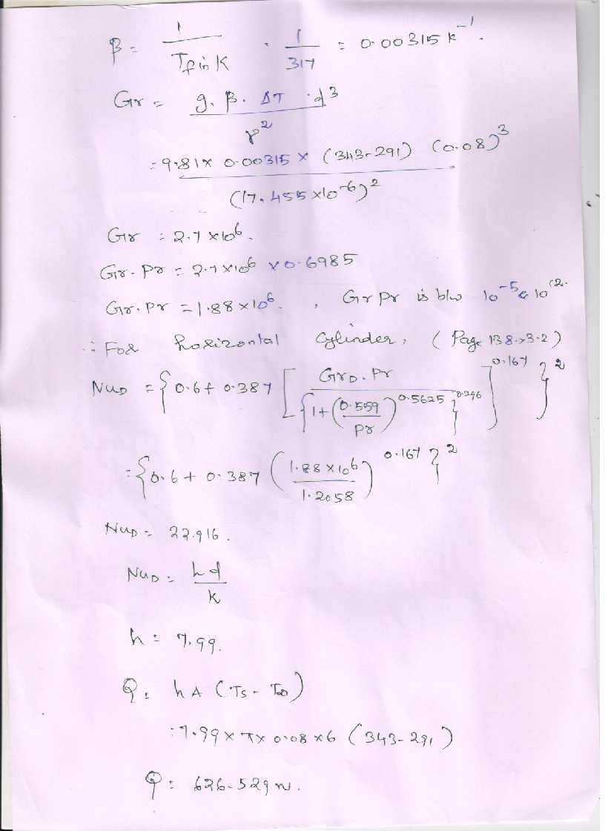

[www.studentsfocus.com](http://www.studentsfocus.com/)