# 

Sub C ode: ME35

UNIT I Basics of Mechanisms SYLLABUS

### Introduction:

Definitions : Link or Element, Pairing of Elements with degrees of freedom, Grubler’s criterion (without derivation), Kinematic chain, Mechanism, Mobility of Mechanism, Inversions, Machine.

### Kinematic Chains and Inversions :

Kinematic chain with three lower pairs, Four bar chain, Single slider crank chain and Double slider crank chain and their inversions.

### Mechanisms:

* 1. Quick returns motion mechanisms – Drag link mechanism, Whitworth mechanism and C rank and slotted lever mechanism
  2. Straight line motion mechanisms – Peacelier’s mechanism and Robert’s mechanism.
  3. Intermittent motion mechanisms – Geneva mechanism and Ratchet & Pawl mechanism.
  4. Toggle mechanism, Pantograph, Hooke’s joint and Ackerman Steering gear mechanism.

### What is Kinematics?

Kinematics is the study of motion (position, velocity, acceleration). A major goal of understanding kinematics is to develop the ability to design a system that will satisfy specified motion requirements. T his will be the emphasis of this class.

### What is Kinetics?

Kinetics is the study of effect of forces on moving bodies. Good kinematic design should produce good kinetics.

### Definitions Link:

A link is defined as a member or a combination of members of a mechanism connecting other members and having relative motion between them. T he link may consist of one or more resistant bodies. A link may be called as kinematic link or element. Eg: Reciprocating steam engine.

Sub C ode: ME35

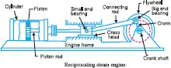

C lassification of link is binary, ternary and quarternary.

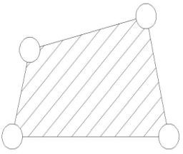

**Joint:** A connection between two links that allows motion between the links. T he motion allowed may be rotational (revolute joint), translational (sliding or prismatic joint), or a combination of the two (roll-slide joint).

### Kinematic pair:

Kinematic pair is a joint of two links having relative motion between them. T he types of kinematic pair are classified according to

* Nature of contact ( lower pair, Higher pair)
* Nature of mechanical contact ( C losed pair, unclosed pair)
* Nature of relative motion ( Sliding pair, turning pair, rolling pair, screw pair, spherical pair)

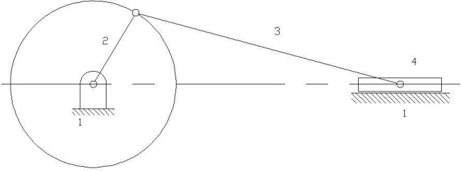

In the above given Slider crank mechanism, link 2 rotates relative to link 1 and constitutes a revolute or turning pair. Similarly, links 2, 3 and 3, 4 constitute turning pairs. Link 4 (Slider) reciprocates relative to link 1 and its a sliding pair.

### Kinematic chain:

Sub C ode: ME35

When the kinematic pairs are coupled in such a way that the last link is joined to the first link to transmit definite motion it is called a kinematic chain.

Eg: T he crank shaft of an engine forms a kinematic pair with the bearings which are fixed in a pair, the connecting rod with the crank forms a second kinematic pair, the piston with the connecting rod forms a third pair and the piston with the cylinder forms the fourth pair. T he total combination of these links is a kinematic chain. Eg: Lawn mover

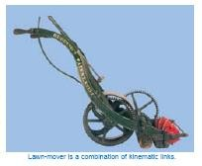

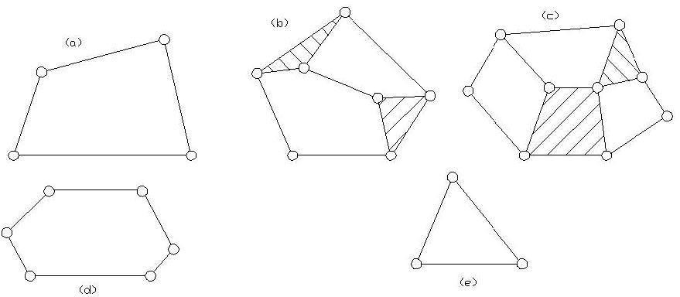

Here, we had to check whether the given link is a kinematic chain We can use two formulas

1. l = 2p-4

2. j= (3/2)l – 2

Exercise: C heck 3 links, 4 links, 5 link arrangements is a kinematic chain.

Page 4 of 65

©Einstein C ollege of Engineering

### Mechanism

Sub C ode: ME35

If motion of any of the movable links results in definite motions of the others the linkage is known as mechanism

### Machine

When a mechanism is required to transmit power or to do some particular type of work it then becomes a machine.

### Degrees of Freedom

It is defined as the number of input parameters which must be independently controlled in order to bring the mechanism in to useful engineering purposes.

It is also defined as the number of independent relative motions, both translational and rotational, a pair can have.

Degrees of freedom = 6 – no. of restraints.

T o find the number of degrees of freedom for a plane mechanism we have **Grubler’s equation**

### F = 3 (n – 1) – 2 j1 – j2

F = Mobility or number of degrees of freedom n = Number of links including frame.

j1 = Joints with single (one) degree of freedom. J2 = Joints with two degrees of freedom.

F > 0, results in a mechanism with ‘F’ degrees of freedom. F = 0, results in a statically determinate structure.

F < 0, results in a statically indeterminate structure.

### MOBILITY- Kutzbach criterion, Grashoff's law

**Mobility: Kutzbach criterion:**

**Fundamental Equation for 2-D Mechanisms:** M = 3(L – 1) – 2J1 – J2 Here we solve, the following problems

Page 5 of 65

©Einstein C ollege of Engineering

* If you pin one end of the link to the plane, how many degrees of freedom does it now have?

Sub C ode: ME35

* Add a second link to the picture so that you have one link pinned to the plane and one free to move in the plane. How many degrees of freedom exist between the two links? (4 is the correct answer)
* Pin the second link to the free end of the first link. How many degrees of freedom do you now have?
* How many degrees of freedom do you have each time you introduce a moving link? How many degrees of freedom do you take away when you add a simple joint? How many degrees of freedom would you take away by adding a half joint? Do the different terms in equation make sense in light of this knowledge?

Here we would also calculate the following:

1. Number of binary links
2. Number of ternary links
3. T he number of quaternary links
4. number of loops
5. number of joints or pairs
6. the number of degrees of freedom
7. Stating whether the given linkages are mechanisms with one degree of freedom.

### Grashoff's law:

* **Grashoff 4-bar linkage:**

A linkage that contains one or more links capable of undergoing a full rotation.

A linkage is Grashoff if: S + L < P + Q

(Where: S = shortest link length, L = longest, P, Q = intermediate length links).

Both joints of the shortest link are capable of 360 degrees of rotation in a Grashoff linkages.

T his gives us 4 possible linkages:

* crank-rocker (input rotates 360
* rocker-crank-rocker (coupler rotates 360)
* rocker-crank (follower)
* double crank (all links rotate 360).

Page 6 of 65

©Einstein C ollege of Engineering

### Problems:

Sub C ode: ME35

* We can also calculate how many unique mechanisms can be obtained from the 8- link kinematic chain.
* We can also calculate degree of freedom and the number of ternary and quaternary links it will have if it has only single turning pairs.

### Inversions of four bar chain mechanism:

T here are three inversions: 1) Beam Engine or C rank and lever mechanism. 2) C oupling rod of locomotive or double crank mechanism. 3) Watt’s straight line mechanism or double lever mechanism.

### Beam Engine:

When the crank AB rotates about A, the link C E pivoted at D makes vertical reciprocating motion at end E. T his is used to convert rotary motion to reciprocating motion and vice versa. It is also known as C rank and lever mechanism. T his mechanism is shown in the figure below.

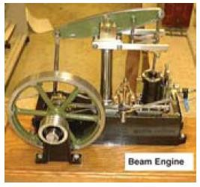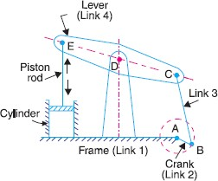

**Coupling rod of locomotive:** In this mechanism the length of link AD = length of link C . Also length of link AB = length of link C D. When AB rotates about A, the crank DC rotates about D. this mechanism is used for coupling locomotive wheels. Since links AB and C D work as cranks, this mechanism is also known as double crank mechanism. T his is shown in the figure below.

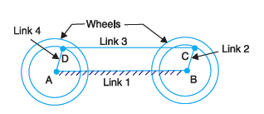

**Watt’s straight line mechanism or Double lever mechanism:** In this mechanism, the links AB & DE act as levers at the ends A & E of these levers are fixed. T he AB & DE are parallel in the mean position of the mechanism and coupling rod BD is perpendicular to the levers AB & DE. On any small displacement of the mechanism the tracing point ‘C’ traces the shape of number

Page 7 of 65

©Einstein C ollege of Engineering

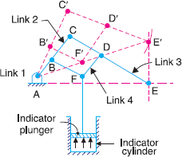‘8’, a portion of which will be approximately straight. Hence this is also an example for the approximate straight line mechanism. T his mechanism is shown below.

### Inversions of Slider crank Chain:

It is a four bar chain having one sliding pair and three turning pairs. It is shown in the figure below the purpose of this mechanism is to convert rotary motion to reciprocating motion and vice versa.

### There are four inversions in a single slider chain mechanism. They are:

st

1. Reciprocating engine mechanism (1

inversion)

nd

1. Oscillating cylinder engine mechanism (2

nd

inversion)

1. C rank and slotted lever mechanism (2

inversion)

rd

1. Whitworth quick return motion mechanism (3

rd

inversion)

1. Rotary engine mechanism (3

th

inversion)

1. Bull engine mechanism (4

th

inversion)

1. Hand Pump (4 inversion)

Page 8 of 65

### Reciprocating engine mechanism:

In the first inversion, the link 1 i.e., the cylinder and the frame is kept fixed. T he fig below shows a reciprocating engine.

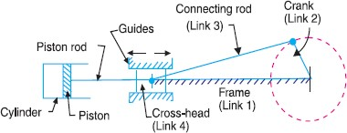

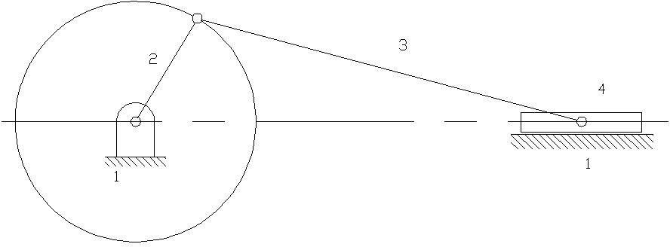

A slotted link 1 is fixed. When the crank 2 rotates about O, the sliding piston 4 reciprocates in the slotted link 1. T his mechanism is used in steam engine, pumps, compressors, I.C . engines, etc.

### Crank and slotted lever mechanism:

It is an application of second inversion. T he crank and slotted lever mechanism is shown in figure below.

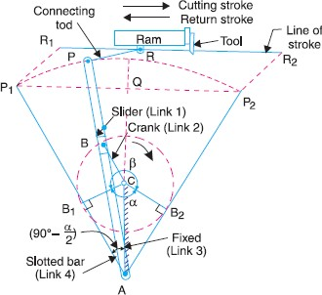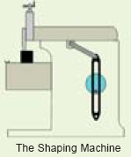

In this mechanism link 3 is fixed. T he slider (link 1) reciprocates in oscillating slotted lever (link

1. and crank (link 2) rotates. Link 5 connects link 4 to the ram (link 6). T he ram with the cutting tool reciprocates perpendicular to the fixed link 3. T he ram with the tool reverses its direction of motion when link 2 is perpendicular to link 4. T hus the cutting stroke is executed during the rotation of the crank through angle α and the return stroke is executed when the crank rotates through angle β or 360 – α. Therefore, when the crank rotates uniformly, we get,

Page 9 of 65

©Einstein C ollege of Engineering

T his mechanism is used in shaping machines, slotting machines and in rotary engines.

### Whitworth quick return motion mechanism:

Sub C ode: ME35

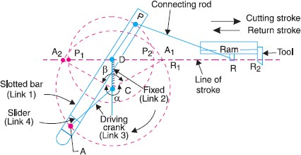

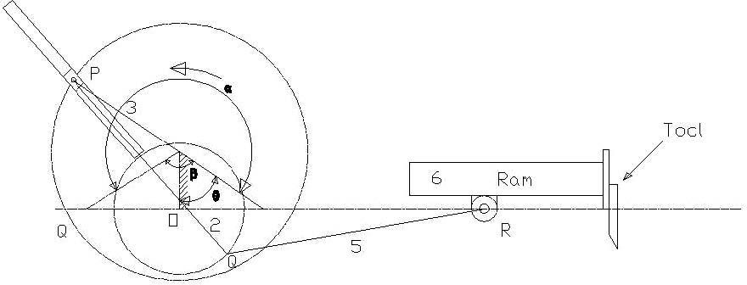

T hird inversion is obtained by fixing the crank i.e. link 2. Whitworth quick return mechanism is an application of third inversion. T his mechanism is shown in the figure below. T he crank OC is fixed and OQ rotates about O. T he slider slides in the slotted link and generates a circle of radius C P. Link 5 connects the extension OQ provided on the opposite side of the link 1 to the ram (link 6). T he rotary motion of P is taken to the ram R which reciprocates. T he quick return motion mechanism is used in shapers and slotting machines. T he angle covered during cutting stroke from P1 to P2 in counter clockwise direction is α or 360 -2θ. During the return stroke, the angle covered is 2θ or β.

### Rotary engine mechanism or Gnome Engine:

Rotary engine mechanism or gnome engine is another application of third inversion. It is a rotary cylinder V – type internal combustion engine used as an aero – engine. But now G nome engine has been replaced by Gas turbines. T he Gnome engine has generally seven cylinders in one plane. T he crank OA is fixed and all the connecting rods from the pistons are connected to A. In

Page 10 of 65

©Einstein C ollege of Engineering

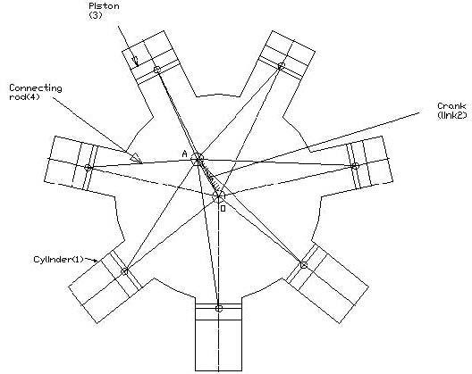this mechanism when the pistons reciprocate in the cylinders, the whole assembly of cylinders, pistons and connecting rods rotate about the axis O, where the entire mechanical power developed, is obtained in the form of rotation of the crank shaft. T his mechanism is shown in the figure below.

### Double Slider Crank Chain:

A four bar chain having two turning and two sliding pairs such that two pairs of the same kind are adjacent is known as double slider crank chain.

### Inversions of Double slider Crank chain:

It consists of two sliding pairs and two turning pairs. T here are three important inversions of double slider crank chain. 1) Elliptical trammel. 2) Scotch yoke mechanism. 3) Oldham’s C oupling.

### Elliptical Trammel:

T his is an instrument for drawing ellipses. Here the slotted link is fixed. T he sliding block P and Q in vertical and horizontal slots respectively. T he end R generates an ellipse with the displacement of sliders P and Q.

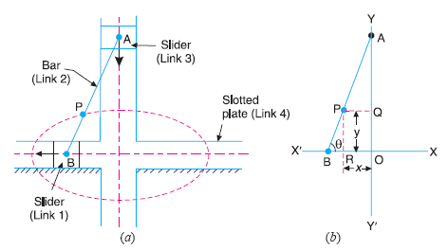

Page 11 of 65

©Einstein C ollege of Engineering

Sub C ode: ME35

Page 12 of 65

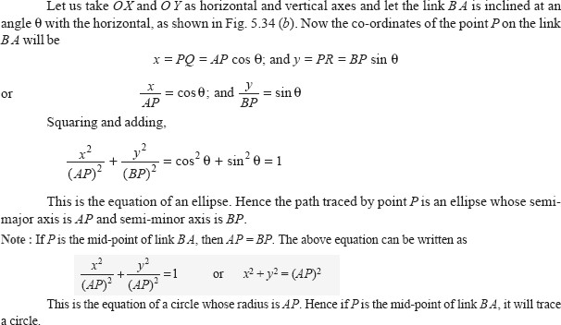

**Scotch yoke mechanism:** T his mechanism is used to convert rotary motion in to reciprocating motion.T he inversion is obtained by fixing either the link 1 or link 3. Link I is fixed. In this mechanism when the link 2 rotates about B as centre, the link 4 reciprocates. T he fixed link 1 guides the frame.

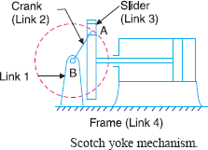

**Oldham’s coupling:** T he third inversion of obtained by fixing the link connecting the 2 blocks P & Q. I f one block is turning through an angle, the frame and the other block will also turn through the same angle. It is shown in the figure below.

Sub C ode: ME35

Page 13 of 65

©Einstein C ollege of Engineering

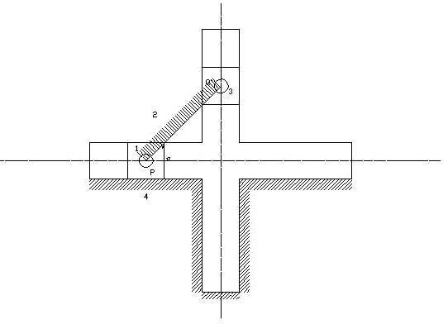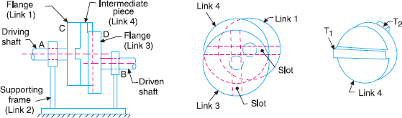

An application of the third inversion of the double slider crank mechanism is Oldham’s coupling shown in the figure. T his coupling is used for connecting two parallel shafts when the distance between the shafts is small. T he two shafts to be connected have flanges at their ends, secured by forging. Slots are cut in the flanges. T hese flanges form 1 and 3. An intermediate disc having tongues at right angles and opposite sides is fitted in between the flanges. T he intermediate piece forms the link 4 which slides or reciprocates in flanges 1 & 3. T he link two is fixed as shown. When flange 1 turns, the intermediate disc 4 must turn through the same angle and whatever angle 4 turns, the flange 3 must turn through the same angle. Hence 1, 4 & 3 must have the same angular velocity at every instant. If the distance between the axis of the shaft is x, it will be the diameter if the circle traced by the centre of the intermediate piece. T he maximum sliding speed of each tongue along its slot is given by v=xω where, ω = angular velocity of each shaft in rad/sec v = linear velocity in m/sec

Sub C ode: ME35

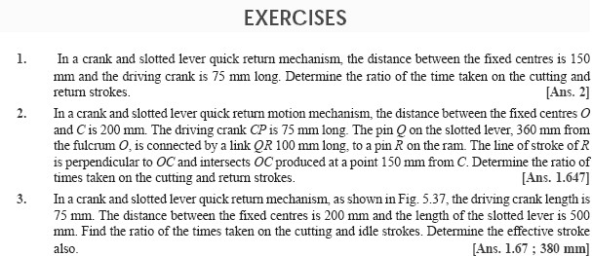

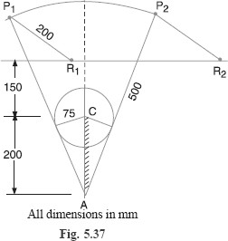

### Mechanical Advantage, Transmission angle:

* + T he mechanical advantage (MA) is defined as the ratio of output torque to the input torque. (Or) ratio of load to output.
  + T ransmission angle.
  + T he extreme values of the transmission angle occur when the crank lies along the line of frame.

Page 14 of 65

©Einstein C ollege of Engineering

T his is four bar mechanism with double crank in which the shortest link is fixed. I f the crank AB

Page 15 of 65

©Einstein C ollege of Engineering

### common mechanisms-Single, Double and offset slider mechanisms - Quick return mechanisms:

Sub C ode: ME35

**Quick Return Motion Mechanisms:**

Many times mechanisms are designed to perform repetitive operations. During these operations for a certain period the mechanisms will be under load known as working stroke and the remaining period is known as the return stroke, the mechanism returns to repeat the operation without load. T he ratio of time of working stroke to that of the return stroke is known a time ratio. Quick return mechanisms are used in machine tools to give a slow cutting stroke and a quick return stroke. T he various quick return mechanisms commonly used are i) Whitworth ii) Drag link. iii) C rank and slotted lever mechanism.

### Whitworth quick return mechanism:

Whitworth quick return mechanism is an application of third inversion of the single slider crank chain. T his mechanism is shown in the figure below. T he crank OC is fixed and OQ rotates about O. T he slider slides in the slotted link and generates a circle of radius C P. Link 5 connects the extension OQ provided on the opposite side of the link 1 to the ram (link 6). T he rotary motion of P is taken to the ram R which reciprocates. T he quick return motion mechanism is used in shapers and slotting machines.

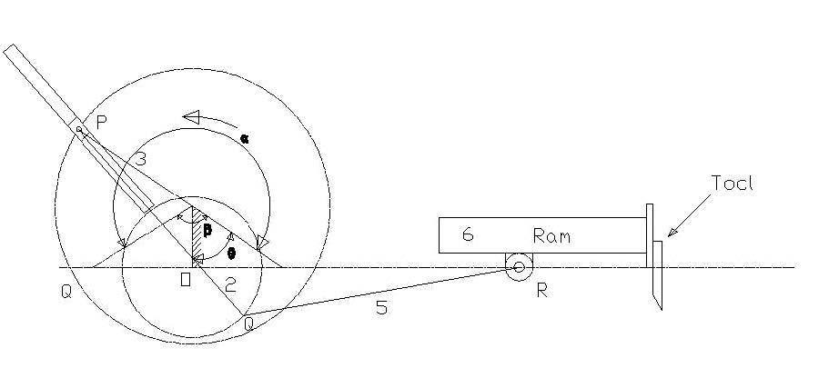

The angle covered during cutting stroke from P1 to P2 in counter clockwise direction is α or 360

-2θ. During the return stroke, the angle covered is 2θ or β.

### Drag link mechanism:

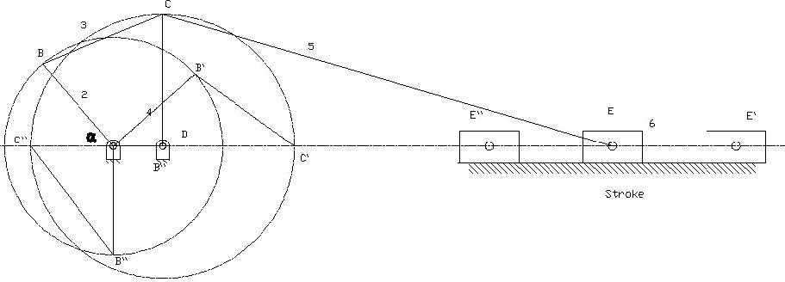

rotates at a uniform speed, the crank C D rotate at a non-uniform speed. T his rotation of link C D is transformed to quick return reciprocity motion of the ram E by the link C E as shown in figure. When the crank AB rotates through an angle α in Counter clockwise direction during working stroke, the link C D rotates through 180. We can observe that / α >/ β. Hence time of working stroke is α /β times more or the return stroke is α /β times quicker. Shortest link is always stationary link. Sum of the shortest and the longest links of the four links 1, 2, 3 and 4 are less than the sum of the other two. It is the necessary condition for the drag link quick return mechanism.

Sub C ode: ME35

### Crank and slotted lever mechanism:

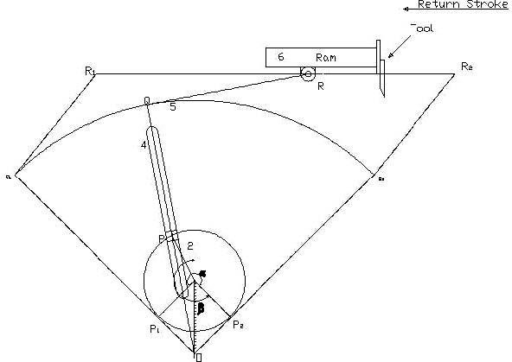It is an application of second inversion. T he crank and slotted lever mechanism is shown in figure below.

In this mechanism link 3 is fixed. T he slider (link 1) reciprocates in oscillating slotted lever (link

4) and crank (link 2) rotates. Link 5 connects link 4 to the ram (link 6). T he ram with the cutting tool reciprocates perpendicular to the fixed link 3. T he ram with the tool reverses its direction of motion when link 2 is perpendicular to link 4. T hus the cutting stroke is executed during the rotation of the crank through angle α and the return stroke is executed when the crank rotates through angle β or 360 – α. Therefore, when the crank rotates uniformly, we get,

T ime to cutting = α = α Time of return β 360 – α

T his mechanism is used in shaping machines, slotting machines and in rotary engines.

### Ratchets and escapements - Indexing Mechanisms - Rocking Mechanisms:

**Intermittent motion mechanism:**

**Ratchet and Pawl mechanism:** T his mechanism is used in producing intermittent rotary motion member. A ratchet and Pawl mechanism consists of a ratchet wheel 2 and a pawl 3 as shown in the figure. When the lever 4 carrying pawl is raised, the ratchet wheel rotates in the counter clock wise direction (driven by pawl). As the pawl lever is lowered the pawl slides over the ratchet teeth. One more pawl 5 is used to prevent the ratchet from reversing. Ratchets are used in feed mechanisms, lifting jacks, clocks, watches and counting devices.

Sub C ode: ME35

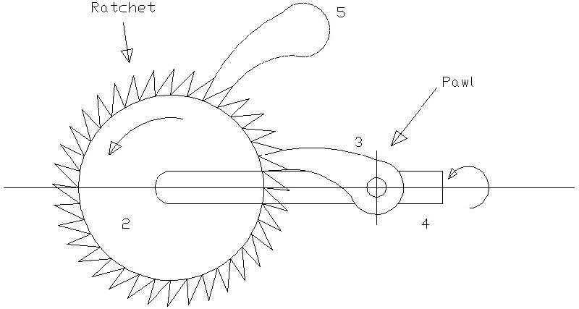

**Geneva mechanism:** Geneva mechanism is an intermittent motion mechanism. It consists of a driving wheel D carrying a pin P which engages in a slot of follower F as shown in figure. During one quarter revolution of the driving plate, the Pin and follower remain in contact and hence the follower is turned by one quarter of a turn. During the remaining time of one revolution of the driver, the follower remains in rest locked in position by the circular arc.

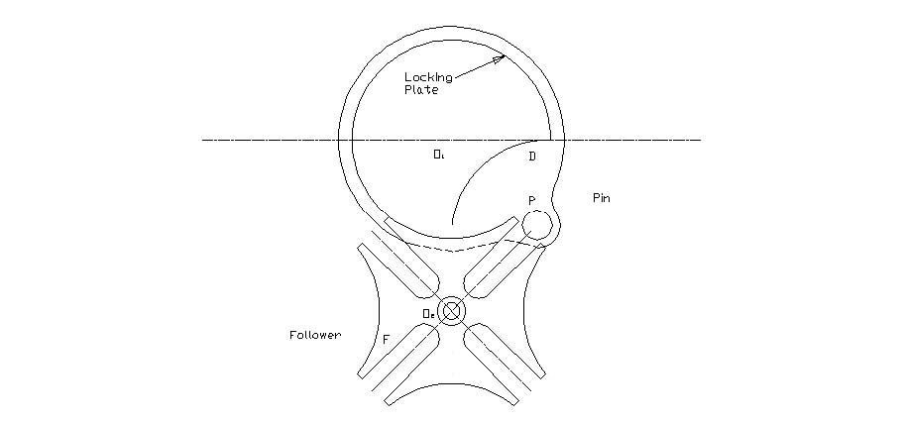

**Pantograph:** Pantograph is used to copy the curves in reduced or enlarged scales. Hence this mechanism finds its use in copying devices such as engraving or profiling machines.

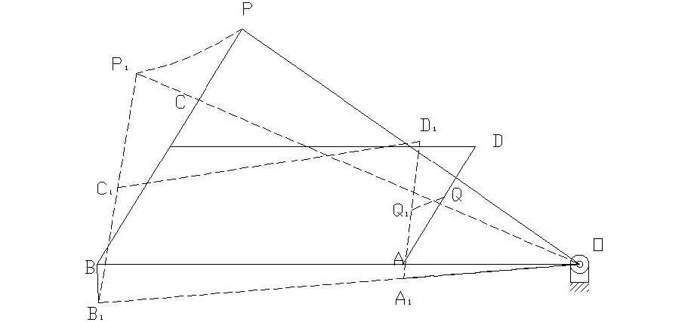

Page 17 of 65

©Einstein C ollege of Engineering

T his is a simple figure of a Pantograph. T he links are pin jointed at A, B, C and D. AB is parallel to DC and AD is parallel to BC . Link BA is extended to fixed pin O. Q is a point on the link AD. If the motion of Q is to be enlarged then the link BC is extended to P such that O, Q and P are in a straight line. T hen it can be shown that the points P and Q always move parallel and similar to each other over any path straight or curved. T heir motions will be proportional to their distance from the fixed point. Let ABC D be the initial position. Suppose if point Q moves to Q1 , then all the links and the joints will move to the new positions (such as A moves to A1 , B moves to Q1, C moves to Q1 , D moves to D1 and P to P1 ) and the new configuration of the mechanism is shown by dotted lines. T he movement of Q (Q Q1) will be enlarged to PP1 in a definite ratio.

Sub C ode: ME35

### Toggle Mechanism:

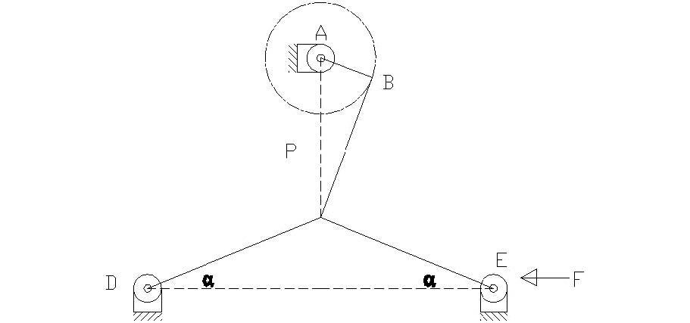

In slider crank mechanism as the crank approaches one of its dead centre position, the slider approaches zero. T he ratio of the crank movement to the slider movement approaching infinity is proportional to the mechanical advantage. T his is the principle used in toggle mechanism. A toggle mechanism is used when large forces act through a short distance is required. T he figure below shows a toggle mechanism. Links C D and C E are of same length. Resolving the forces at C vertically **F Sin α =P Cos α 2**

T herefore, F = P. (because Sin α/Cos α = Tan α) 2 tan α Thus for the given value of P, as the links CD and CE approaches collinear position (αO), the force F rises rapidly.

### Unit II KINEMATICS ANALYSIS

**Graphical method**

Analysis of simple mechanisms- Slider crank mechanism and four bar mechanism- for displacement, velocity and acceleration. Shaping machine mechanism- coincident points- coriolis acceleration

**Analytical method**

Analysis of simple mechanisms- Slider crank mechanism and four bar mechanism- Approximate analytical expression for displacement, velocity and acceleration of piston of reciprocating engine mechanism

**Velocity and Acceleration analysis of mechanisms:**

Velocity and acceleration analysis by vector polygons: Relative velocity and accelerations of particles in a common link, relative velocity and accelerations of coincident particles on separate link, C oriolis component of acceleration.

Velocity and acceleration analysis by complex numbers: Analysis of single slider crank mechanism and four bar mechanism by loop closure equations and complex numbers.

### Displacement, velocity and acceleration analysis in simple mechanisms: Important Concepts in Velocity Analysis

* 1. T he absolute velocity of any point on a mechanism is the velocity of that point with reference to ground.
  2. Relative velocity describes how one point on a mechanism moves relative to another point on the mechanism.
  3. T he velocity of a point on a moving link relative to the pivot of the link is given by the equation: V =  r, where   = angular velocity of the link and r = distance from pivot.

### Acceleration Components

* ***Normal Acceleration:* A**n = 2r. Points toward the center of rotation
* ***Tangential Acceleration:* A**t =  r. In a direction perpendicular to the link
* ***Coriolis Acceleration:* A**c = 2 (dr/dt). In a direction perpendicular to the link
* ***Sliding Acceleration:* A**s = d2r/dt2. In the direction of sliding.

A rotating link will produce normal and tangential acceleration components at any point a distance, r, from the rotational pivot of the link. T he total acceleration of that point is the vector sum of the components.

Page 21 of 65

©Einstein C ollege of Engineering

A slider attached to ground experiences only sliding acceleration.

Sub C ode: ME35

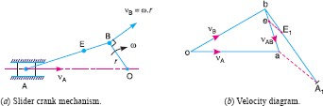

A slider attached to a rotating link (such that the slider is moving in or out along the link as the link rotates) experiences all 4 components of acceleration. Perhaps the most confusing of these is the coriolis acceleration, though the concept of coriolis acceleration is fairly simple. Imagine yourself standing at the center of a merry-go-round as it spins at a constant speed ( ). You begin to walk toward the outer edge of the merry-go-round at a constant speed (dr/dt). Even though you are walking at a constant speed and the merry-go-round is spinning at a constant speed, your total velocity is increasing because you are moving away from the center of rotation (i.e. the edge of the merry-go-round is moving faster than the center). T his is the coriolis acceleration. In what direction did your speed increase? T his is the direction of the coriolis acceleration.

T he total acceleration of a point is the vector sum of all applicable acceleration components:

**A** = **A**n + **A**t + **A**c + **A**s

T hese vectors and the above equation can be broken into x and y components by applying sines and cosines to the vector diagrams to determine the x and y components of each vector. In this way, the x and y components of the total acceleration can be found.

### Graphical Method, Velocity and Acceleration polygons : Graphical velocity analysis:

It is a very short step (using basic trigonometry with sines and cosines) to convert the graphical results into numerical results. T he basic steps are these:

1. Set up a velocity reference plane with a point of zero velocity designated.
2. Use the equation, V =  r, to calculate any known linkage velocities.
3. Plot your known linkage velocities on the velocity plot. A l inkage that is rotating about ground gives an absolute velocity. T his is a vector that originates at the zero velocity point and runs perpendicular to the link to show the direction of motion. T he vector, **V**A, gives the velocity of point A.
4. Plot all other velocity vector directions. A point on a grounded link (such as point B) will produce an absolute velocity vector passing through the zero velocity point and perpendicular to the link. A point on a floating link (such as B relative to point A) will produce a relative velocity vector. T his vector will be perpendicular to the link AB and pass through the reference point (A) on the velocity diagram.

Sub C ode: ME35

1. One should be able to form a closed triangle (for a 4-bar) that shows the vector equation: **V**B = **V**A + **V**B/A where **V**B = absolute velocity of point B, **V**A = absolute velocity of point A, and **V**B/A is the velocity of point B relative to point A.

### Velocity Analysis of Four Bar Mechanisms:

* Problems solving in Four Bar Mechanisms and additional links.

### Velocity Analysis of Slider Crank Mechanisms:

* Problems solving in Slider C rank Mechanisms and additional links.

### Acceleration Analysis of Four Bar Mechanisms:

* Problems solving in Four Bar Mechanisms and additional links.

### Acceleration Analysis of Slider Crank Mechanisms:

* Problems solving in Slider C rank Mechanisms and additional links.

### Kinematic analysis by Complex Algebra methods:

* Analysis of single slider crank mechanism and four bar mechanism by loop closure equations and complex numbers.

### vector Approach:

* Relative velocity and accelerations of particles in a common link, relative velocity and accelerations of coincident particles on separate link

### Computer applications in the kinematic analysis of simple mechanisms:

* C omputer programming for simple mechanisms

### Coincident points, Coriolis Acceleration:

* ***Coriolis Acceleration:* A**c = 2 (dr/dt). In a direction perpendicular to the link. A slider attached to ground experiences only sliding acceleration.

A slider attached to a rotating link (such that the slider is moving in or out along the link as the link rotates) experiences all 4 components of acceleration. Perhaps the most confusing of these is the coriolis acceleration, though the concept of coriolis acceleration is fairly simple. Imagine yourself standing at the center of a merry-go-round as it spins at a constant speed ( ). You begin to walk toward the outer edge of the merry-go-round at a constant speed (dr/dt). Even though you are walking at a constant speed and the merry-go-round is spinning at a constant speed, your total velocity is increasing because you are moving away from the center of rotation (i.e. the edge of the merry-go-round is moving faster than the center). T his is the coriolis acceleration. In what direction did your speed increase? T his is the direction of the coriolis acceleration.

Page 23 of 65

©Einstein C ollege of Engineering

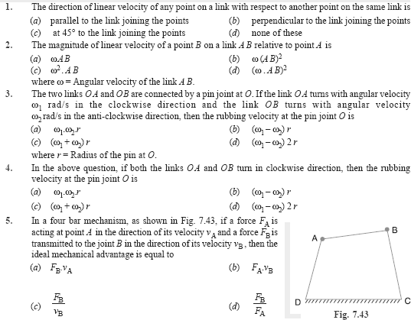



### Question bank – II unit

***Important two questions***

1. **What are the types of motion?**
2. **What is configuration diagram or space diagram?**
3. **Define Coincident points**
4. **Define Coriolis Component**
5. **Write down the expression for Coriolis component of acceleration defining each of terms in**

**the expression.**

1. **What are the types of instantaneous Centres?**
2. Define Kennedy’s theorem.

Page 24 of 65

©Einstein C ollege of Engineering

### Define rubbing velocity at a pin joint.

Sub C ode: ME35

1. **What are the various methods used for finding out velocity of mechanism?**
2. **Define Instantaneous centre.**
3. **Define Angular Velocity ratio theorem.**

***Important descriptive university questions:***

* + **The Crank of a slider crank mechanisms rotates clockwise at a Constant speed of 600 r.p.m. The crank is 125 mm and connecting rod is 500 mm long. Determine 1. Linear velocity and acceleration of the mid Point of the connecting rod, and 2. Angular velocity and angular acceleration of the connecting rod, at a crank angle of 45° from inner dead centre position.**
  + **In a four link mechanism, the dimensions of the links are AB=200 mm, BC=400mm, CD=450 mm and AD=600mm. At the instant when DAB=90°, the link AB has angular velocity of 36 rad/s in the clockwise direction. Determine (i) The velocity of point C, (ii) The velocity of point E on the link BC When BE =200 mm (iii) the angular velocities of links BC and CD, iv) acceleration of link of link BC.**
  + **Derive the expressions for Velocity and acceleration of piston in reciprocating steam engine mechanism with neat sketch**
  + **Derive the expression for Coriolis component of acceleration with neat sketch**
  + **In a slider crank mechanism, the length of the crank and the connecting rod are 100 mm and 400 mm respectively./ The crank [position is 45° from IDC, the crank shaft speed is 600 r.p.m., Clockwise. Using analytical method Determine**

**(1) Velocity and acceleration of the slider, and (2) Angular velocity and angular acceleration of the connecting rod.**

* + **Locate all instantaneous centers of the slider crank mechanism; the length of crank OB and Connecting rod AB are 125 mm and 500 mm respectively. The crank speed is 600 rpm clockwise. When the crank has turned 45° from the IDC,** Determine (i)velocity of slider’ A’ (ii)Angular Velocity of connecting rod ‘AB’.

### References

1. Ambekar A. G., Mecanism and Machine T heory, Prentice Hall of India, New Delhi, 2007.
2. Khurmi R.S., G up., T heory of machines, S. C hand company limited, New Delhi, 2009.

### Web site:

[www.](http://www/) nptel.iitm.ac.in (National programme on technology enhanced learning by IIT , India) <http://www.scribd.com/doc/18424291/Kinematics-of-Machines>

### UNIT-3

### 

### Hooke’s joint:

Hooke’s joint used to connect two parallel intersecting shafts as shown in figure. This can also be used for shaft with angular misalignment where flexible coupling does not serve the purpose. Hence Hooke’s joint is a means of connecting two rotating shafts whose axes lie in the same

plane and their directions making a small angle with each other. It is commonly known as Universal joint. In Europe it is called as C ardan joint.

Sub C ode: ME35

### Ackermann steering gear mechanism:

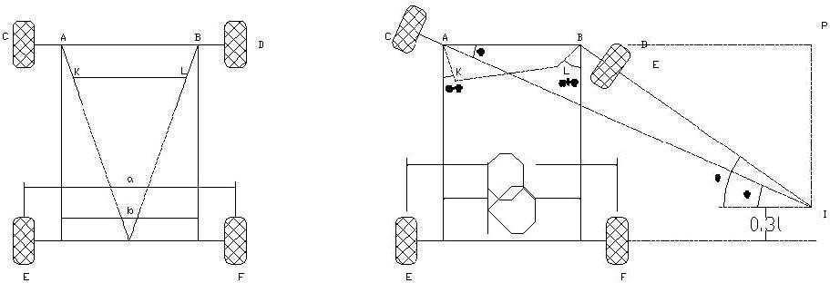

T his mechanism is made of only turning pairs and is made of only turning pairs wear and tear of the parts is less and cheaper in manufacturing. The cross link KL connects two short axles AC and BD of the front wheels through the short links AK and BL which forms bell crank levers C AK and DBL respectively as shown in fig, the longer links AB and KL are parallel and the shorter links AK and BL are inclined at an angle α. When the vehicles steer to the right as shown in the figure, the short link BL is turned so as to increase α, where as the link LK causes the other short link AK to turn so as to reduce α. The fundamental equation for correct steering is, **CotΦ– Cosθ = *b / l****.* In the above arrangement it is clear that the angle Φ through which AK turns is less than the angle θ through which the BL turns and therefore the left front axle turns through a smaller angle than the right front axle. For different angle of turn θ, the corresponding value of Φ and (Cot Φ – Cos θ) are noted. This is done by actually drawing the mechanism to a scale or by calculations. T herefore for different value of the corresponding value of and are tabulated. Approximate value of b/l for correct steering should be between 0.4 and 0.5. In an Ackermann steering gear mechanism, the instantaneous centre I does not lie on the axis of the rear axle but on a line parallel to the rear axle axis at an approximate distance of 0.3l above it.

### Question Bank- I unit

***Important Two marks***

* + Define resistant body.
  + Define Link or Element
  + Differentiate Machine and Structure
  + Define Kinematic Pair.
  + Define Kinematic Chain.
  + What are the types of joints?
  + Define Degrees of Freedom (Mobility).
  + Write down the Kutzbach criterion for plane mechanism.
  + What is meant by spatial mechanism?
  + Differentiate Machine and Mechanism.
  + Define Inversion of Mechanism

Page 19 of 65

©Einstein C ollege of Engineering

* + Define Grashof’s Law.

Sub C ode: ME35

* + Define Pantograph.
  + What is Elliptical Trammel?
  + Define Transmission Angle and Mechanical Advantage
  + What is a straight line Mechanism?

***Important Descriptive University questions:***

* + Explain different types of Link.
  + Classify and explain the Kinematic pair.
  + Explain any two inversion of four bar chain.
  + Explain the first inversion of Single Slider Crank Chain.
  + Explain first inversion of Double Slider crank chain.
  + Explain third inversion of double slider crank chain.
  + Explain the offset slider crank mechanism.
  + Explain Straight line mechanism with neat sketch.
  + With the help of a neat sketch explain the working of Oldham’s coupling.
  + Explain steering gear mechanism with neat sketch.
  + With the help of a neat sketch explain the working of Whitworth quick return mechanism.
  + With the help of a neat sketch explain the working of Single slider and double slider crank chain mechanism.

### References

1. Ambekar A. G., Mechanism and Machine T heory, Prentice Hall of India, New Delhi, 2007.
2. Khurmi R.S., Gupta J.K., T heory of machines, S. C hand company limited, New Delhi, 2009.

### Web site:

[www.](http://www/) nptel.iitm.ac.in (National programme on technology enhanced learning by IIT , India) <http://www.scribd.com/doc/18424291/Kinematics-of-Machines>

## 4.KINEMATICS OF CAMS

Sub C ode: ME35

**INTRODUCTION**

A cam is a mechanical device used to transmit motion to a follower by direct contact. T he driver is called the cam and the driven member is called the follower. In a cam follower pair, the cam normally rotates while the follower may translate or oscillate. A familiar example is the camshaft of an automobile engine, where the cams drive the push rods (the followers) to open and close the valves in synchronization with the motion of the pistons.

### Types of cams

C ams can be classified based on their physical shape.

1. **Disk or plate cam** T he disk (or plate) cam has an irregular contour to impart a specific motion to the follower. T he follower moves in a plane perpendicular to the axis of rotation of the camshaft and is held in contact with the cam by springs or gravity.

Fig.3.1 Plate or disk cam.

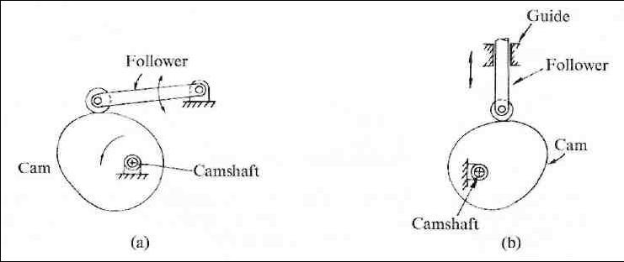

1. **Cylindrical cam:** T he cylindrical cam has a groove cut along its cylindrical surface. T he roller follows the groove, and the follower moves in a plane parallel to the axis of rotation of the cylinder.

Fig. 3.2 C ylindrical cam.

Page 26 of 65

©Einstein C ollege of Engineering

Sub C ode: ME35

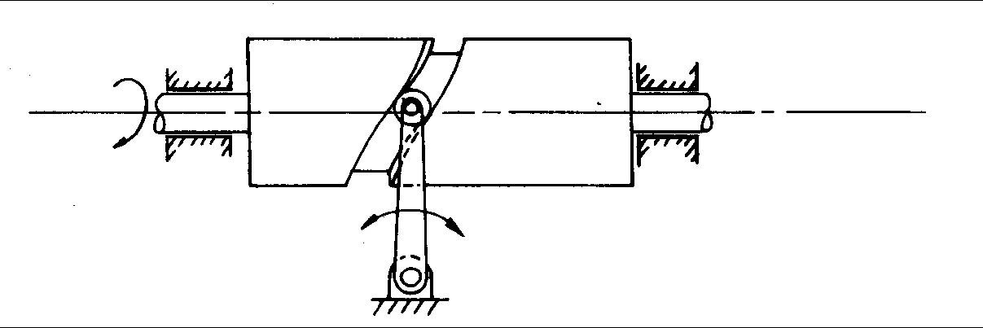

1. **Translating cam.** T he translating cam is a contoured or grooved plate sliding on a guiding surface(s). T he follower may oscillate (Fig. 3.3a) or reciprocate (Fig. 3.3b). T he contour or the shape of the groove is determined by the specified motion of the follower.

Fig. 3.3 translating cam

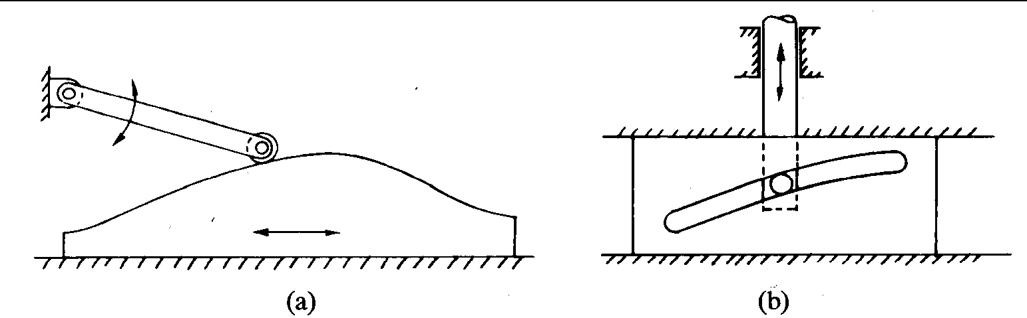

### Types of followers(Fig 3.4):

1. Based on surface in contact.
2. Knife edge follower
3. Roller follower
4. Flat faced follower
5. Spherical follower

Sub C ode: ME35

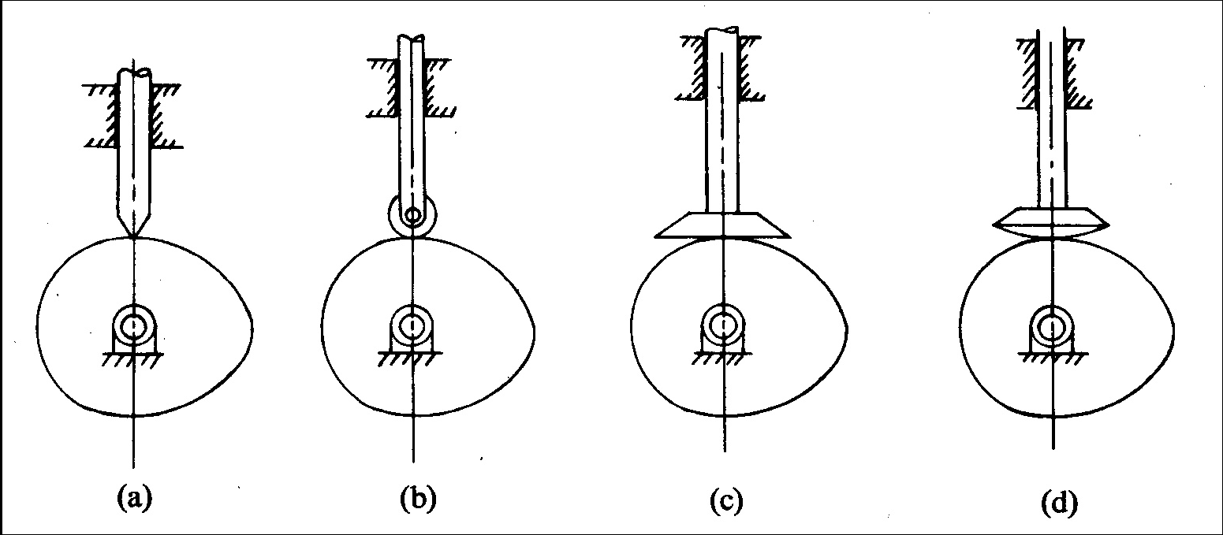

Fig 3.4

1. Based on type of motion(Fig 3.5):
2. Oscillating follower
3. T ranslating follower

Fig: 3.5

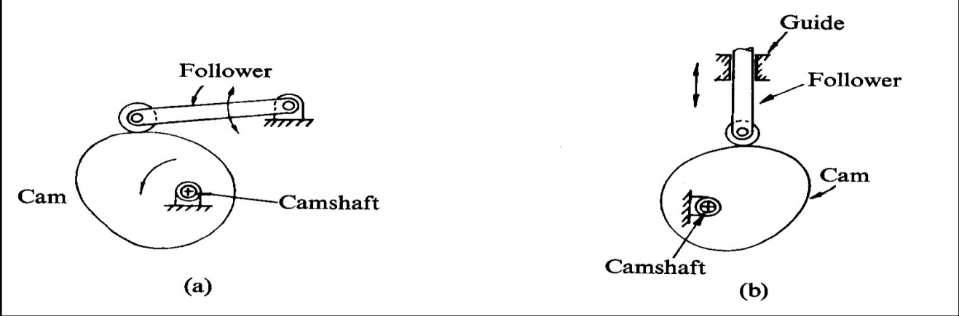

Based on line of motion (Fig 3.6):

Page 28 of 65

©Einstein C ollege of Engineering

Sub C ode: ME35

1. R adial follower: T he lines of movement of in-line cam followers pass through the centers of the camshafts
2. Off-set follower: For this type, the lines of movement are offset from the centers of the camshafts

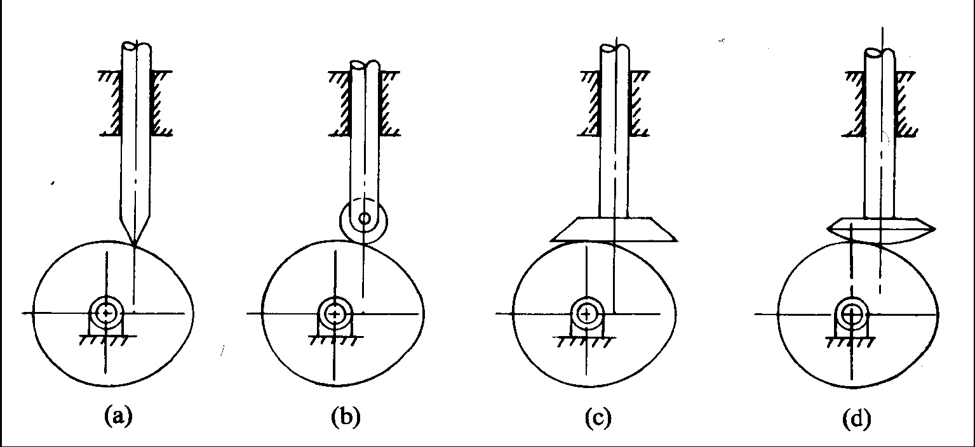Fig 3.6

### Cam

**nomenclature (Fig. 3.7):**

*Cam Profile* T he contour of the working surface of the cam.

*Tracer Point* T he point at the knife edge of a follower, or the center of a roller, or the center of a spherical face.

*Pitch Curve* T he path of the tracer point.

*Base Circle* T he smallest circle drawn, tangential to the cam profile, with its center on the axis of the camshaft. T he size of the base circle determines the size of

the cam.

*Prime Circle* T he smallest circle drawn, tangential to the pitch curve, with its center on the axis of the camshaft.

*Pressure Angle* T he angle between the normal to the pitch curve and the direction of motion of the follower at the point of contact.

Page 29 of 65

©Einstein C ollege of Engineering

Sub C ode: ME35

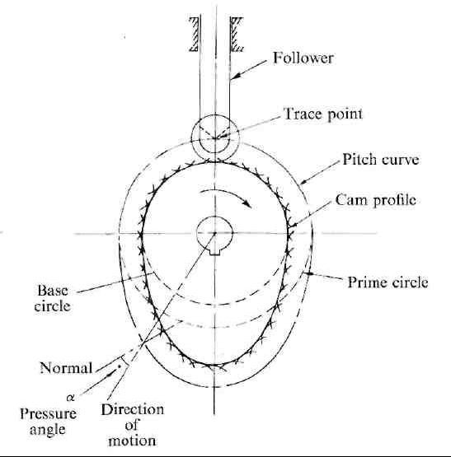

*Fig 3.7*Types of follower motion:

C am follower systems are designed to achieve a desired oscillatory motion. Appropriate displacement patterns are to be selected for this purpose, before designing the cam surface. T he cam is assumed to rotate at a constant speed and the follower raises, dwells, returns to its original position and dwells again through specified angles of rotation of the cam, during each revolution of the cam. Some of the standard follower motions are as follows:

T hey are, follower motion with,

Page 30 of 65

©Einstein C ollege of Engineering

1. Uniform velocity

Sub C ode: ME35

1. Modified uniform velocity
2. Uniform acceleration and deceleration
3. Simple harmonic motion
4. C ycloidal motion

**Displacement diagrams:** In a cam follower system, the motion of the follower is very important. Its displacement can be plotted against the angular displacement θ of the cam and it is called as the displacement diagram. T he displacement of the follower is plotted along the y-axis and angular displacement θ of the cam is plotted along x-axis. From the displacement diagram, velocity and acceleration of the follower can also be plotted for different angular displacements θ of the cam. T he displacement, velocity and acceleration diagrams are plotted for one cycle of operation i.e., one rotation of the cam. Displacement diagrams are basic requirements for the construction of cam profiles. C onstruction of displacement diagrams and calculation of velocities and accelerations of followers with different types of motions are discussed in the following sections.

### (a) Follower motion with Uniform velocity:

Fig.3.8 shows the displacement, velocity and acceleration patterns of a follower having uniform velocity type of motion. Since the follower moves with constant velocity, during rise and fall, the displacement varies linearly with θ. Also, since the velocity changes from zero to a finite value, within no time, theoretically, the acceleration becomes infinite at the beginning and end of rise and fall.

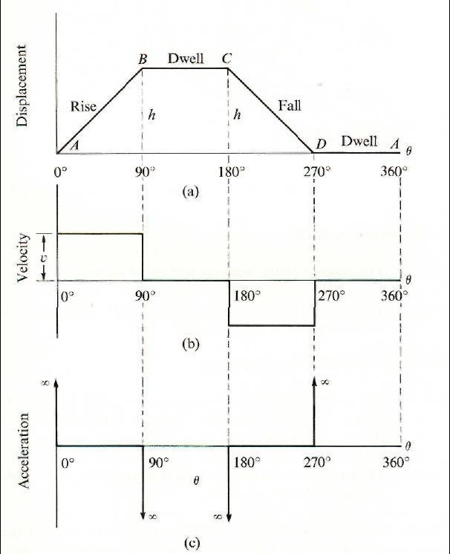

### Follower motion with modified uniform velocity:

Sub C ode: ME35

Fig 3.8

### (b)

It is observed in the displacement diagrams of the follower with uniform velocity that the acceleration of the follower becomes infinite at the beginning and ending of rise and return strokes. In order to prevent this, the displacement diagrams are slightly modified.In the modified form, the velocity of the follower changes uniformly during the beginning and end of each stroke. Accordingly, the displacement of the follower varies parabolic ally during these periods. With this modification, the acceleration becomes constant during these periods, instead of being infinite as in the uniform velocity type of motion. T he displacement, velocity and acceleration patterns shown in fig 3.9

Sub C ode: ME35

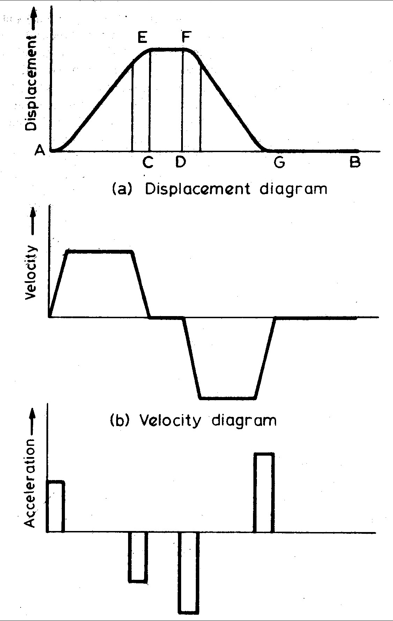

### (c) Follower motion with uniform

**acceleration and retardation (UARM):**

Here, the displacement of the follower varies parabolically with respect to angular displacement of cam. Accordingly, the velocity of the follower varies uniformly with respect to angular displacement of cam. T he acceleration/retardation of the follower becomes constant accordingly. T he displacement, velocity and acceleration patterns are shown fig 3.10

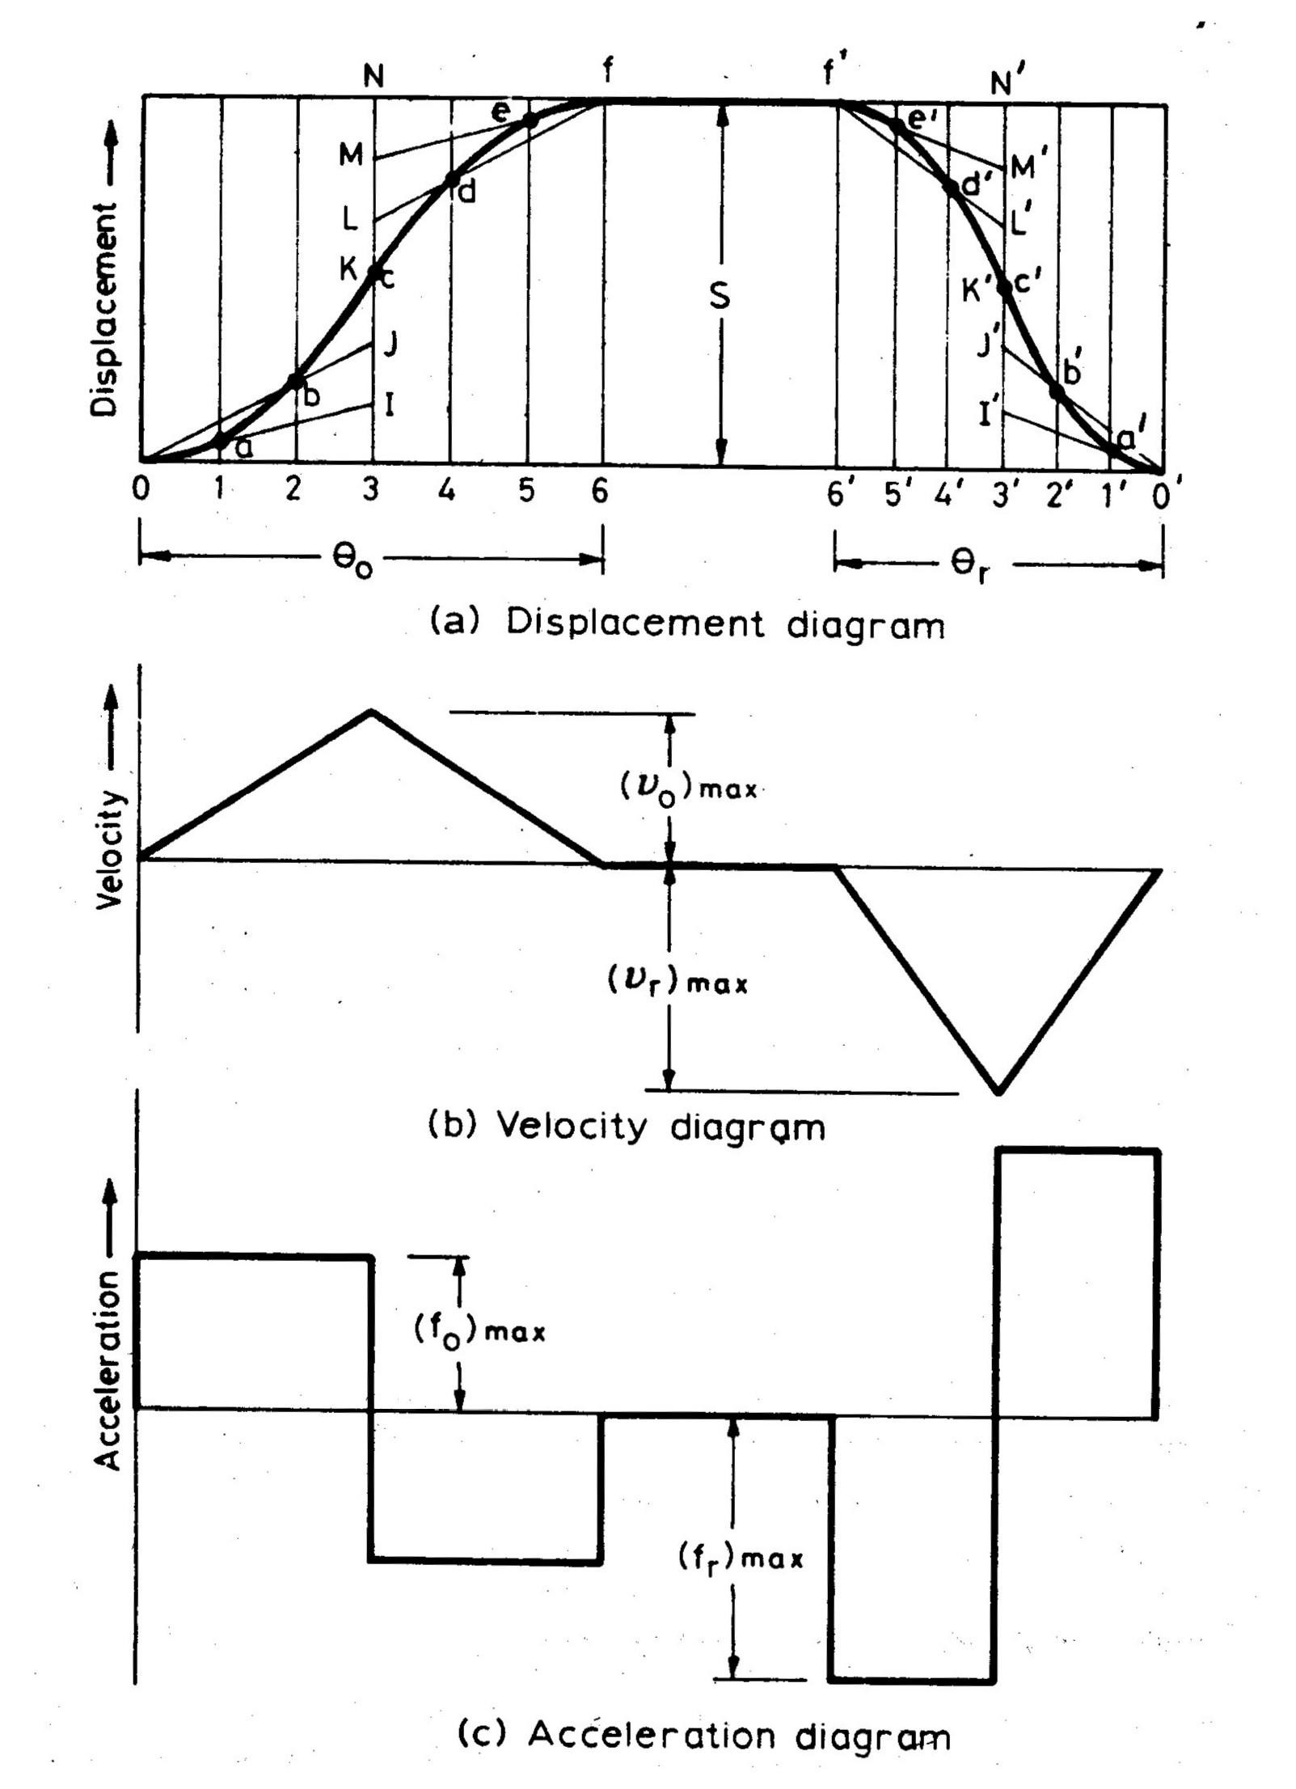

1. **Simple Harmonic Motion:** In fig3.11, the motion executed by point Pl, which is the projection of point P on the vertical diameter is called simple harmonic motion. Here, P moves with uniform angular velocity ωp, along a circle of radius r (r = s/2).

Sub C ode: ME35

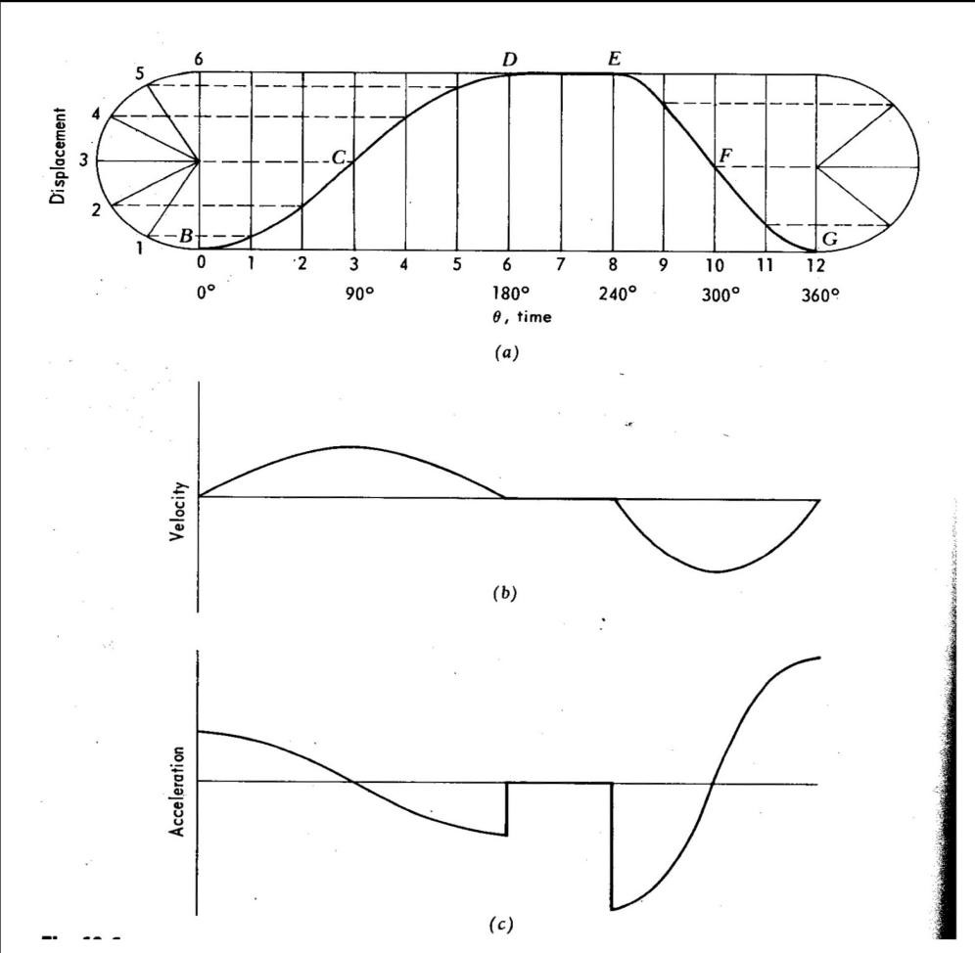

Sub C ode: ME35

**Cycloidal motion:**

C ycloid is the path generated by a point on the circumference of a circle, as the circle rolls without slipping, on a straight/flat surface. T he motion executed by the follower here, is similar to that of the projection of a point moving along a cyloidal curve on a vertical line as shown in figure 6.12.

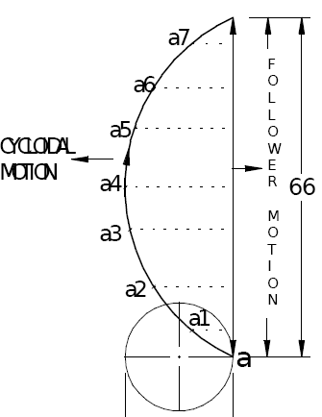

Sub C ode: ME35

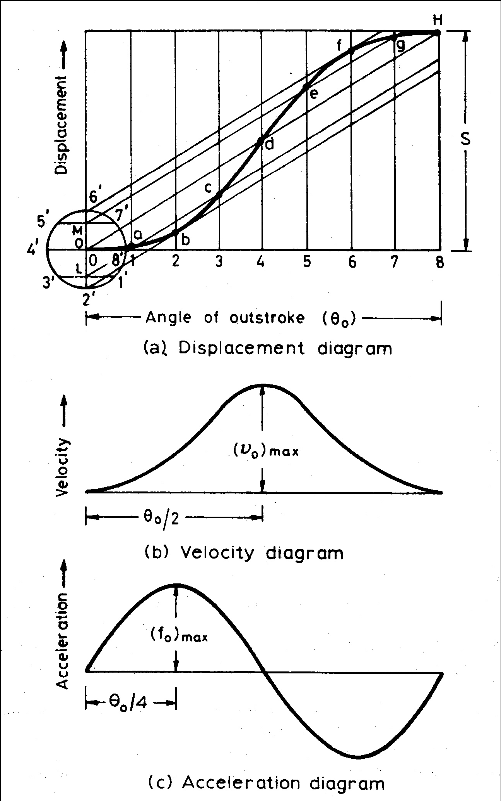

### Draw the cam profile for following conditions:

Follower type = Knife edged, in-line; lift = 50mm; base circle radius = 50mm; out stroke with SHM, for 600 cam rotation; dwell for 450cam rotation; return stroke with SHM, for 90ocam rotation; dwell for the remaining period.

* 1. Draw the cam profile for the same operating conditions of with the follower off set by 10 mm to the left of cam center**.**

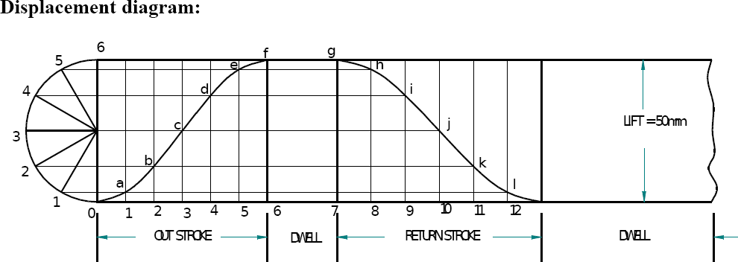

C am profile:

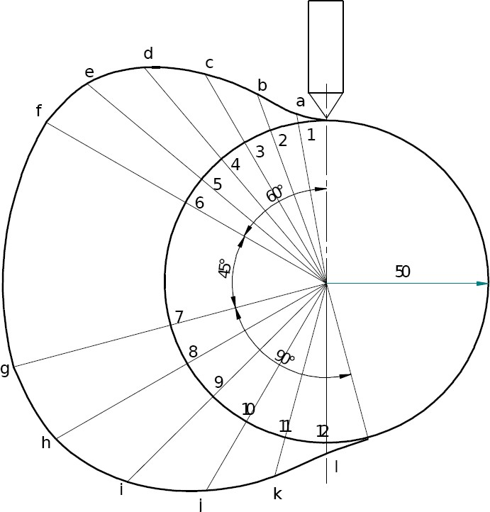

C am profile with 10 mm offset:

Sub C ode: ME35

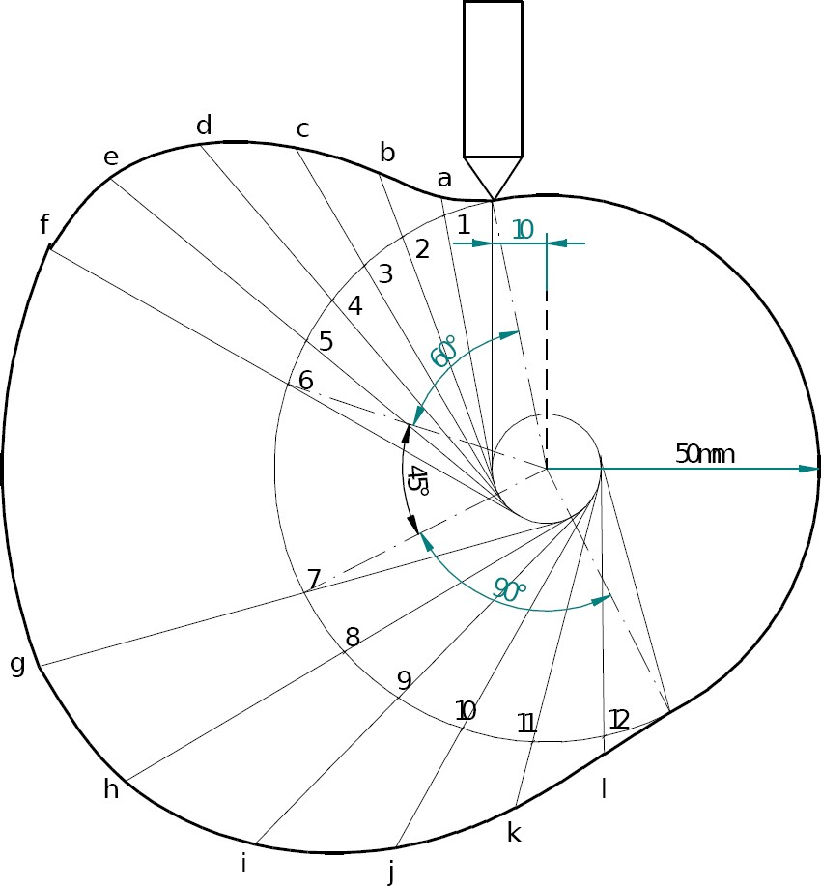

### (2) Draw the cam profile for following conditions:

Follower type = roller follower, in-line; lift = 25mm; base circle radius = 20mm; roller radius = 5mm; out stroke with Uniform acceleration and retardation, for 1200 cam rotation; dwell for 600 cam rotation; return stroke with Uniform acceleration and retardation , for 900 cam rotation; dwell for the remaining period.

(4) Draw the cam profile for conditions same with follower off set to right of cam center by 5mm and cam rotating counter clockwise.

Page 39 of 65

©Einstein C ollege of Engineering

Displacement Diagram :

Sub C ode: ME35

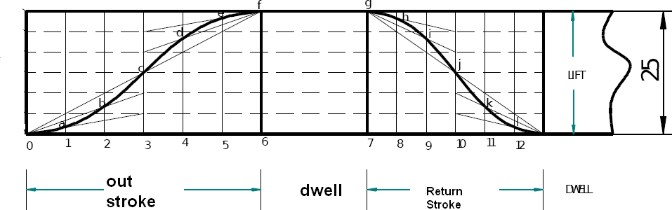

Cam profile ;

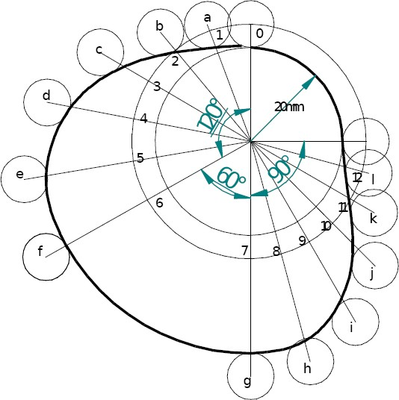

C am profile with 5 mm offset

Sub C ode: ME35

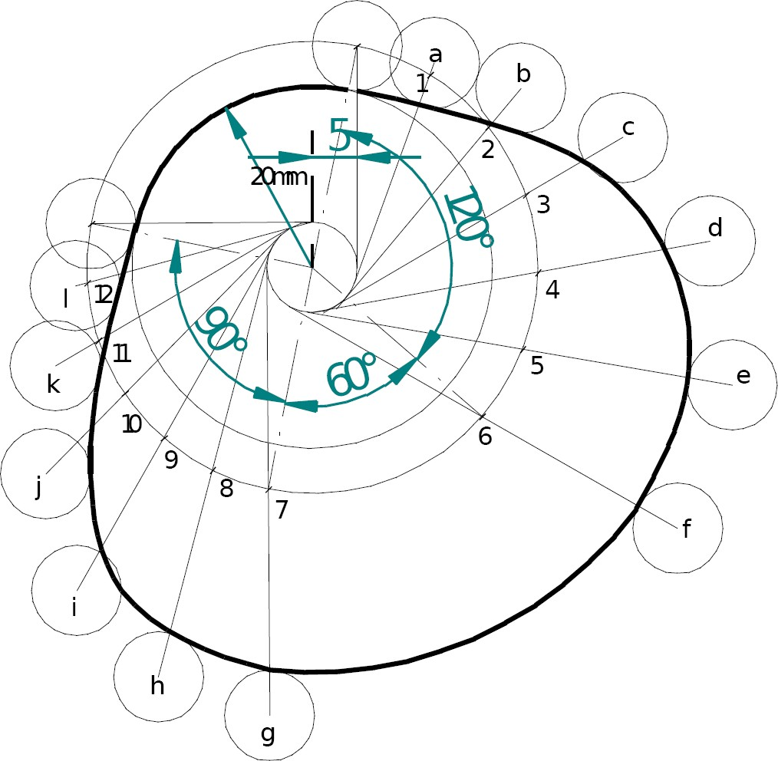

### Draw the cam profile for following conditions:

Follower type = knife edged follower, in line; lift = 30mm; base circle radius = 20mm;out stroke with uniform velocity in 1200 of cam rotation; dwell for 600; return stroke with uniform velocity, during 900 of cam rotation; dwell for the remaining period.

**Displacement Diagram**

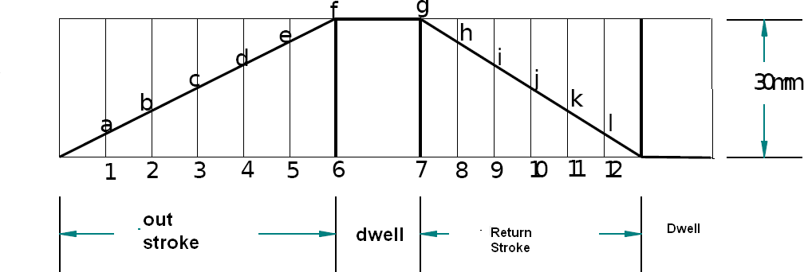

Cam profile

Page 43 of 65

©Einstein C ollege of Engineering

### Draw the cam profile for following conditions:

Sub C ode: ME35

Follower type = flat faced follower, in line; follower rises by 20mm with SHM in 1200of cam rotation, dwells for 300 of cam rotation; returns with SHM in 1200 of cam rotation and dwells during the remaining period. Base circle radius = 25mm.

Displacement Diagram:

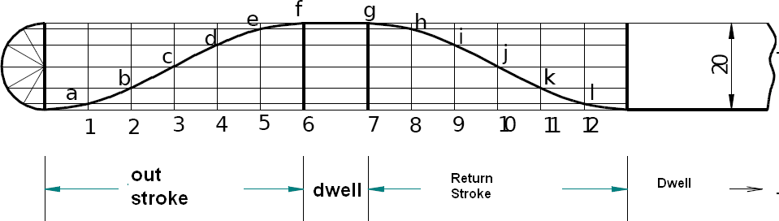

Cam profile

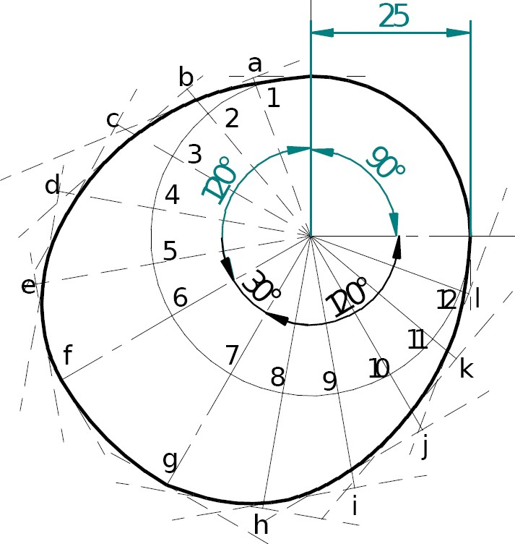

Page 44 of 65

©Einstein C ollege of Engineering

**5.Gears**

**Introduction**: T he slip and creep in the belt or rope drives is a common phenomenon, in the transmission of motion or power between two shafts. T he effect of slip is to reduce the velocity ratio of the drive. In precision machine, in which a definite velocity ratio is importance (as in watch mechanism, special purpose machines..etc), the only positive drive is by means of gears or toothed wheels.

Gears are machine elements that transmit motion by means of successively engaging teeth. T he gear teeth act like small levers. Gears are highly efficient (nearly 95%) due to primarily rolling contact between the teeth, thus the motion transmitted is considered as positive.

Gears essentially allow positive engagement between teeth so high forces can be transmitted while still undergoing essentially rolling contact. Gears do not depend on friction and do best when friction is minimized.

**4.1 Gear Classification:** Gears may be classified according to the relative position of the axes of revolution. T he axes may be

1. Gears for connecting parallel shafts,
2. Gears for connecting intersecting shafts,
3. Gears for neither parallel nor intersecting shafts.

### Gears for connecting parallel shafts

1. **Spur gears:** Spur gears are the most common type of gears. T hey have straight teeth, and are mounted on parallel shafts. Sometimes, many spur gears are used at once to create very large gear reductions. Each time a gear tooth engages a tooth on the other gear, the teeth collide, and this impact makes a noise. It also increases the stress on the gear teeth. To reduce the noise and stress in the gears, most of the gears in your car are **helical**.

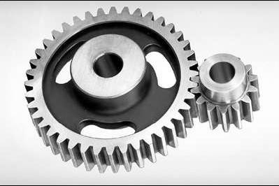

***Spur gears*** are the most commonly used gear type. T hey are characterized by teeth, which are perpendicular to the face of the gear. Spur gears are most commonly available, and are

generally the least expensive.

**Limitations:** Spur gears generally cannot be used when a direction change between the two shafts is required.

Sub C ode: ME35

**Advantages:** Spur gears are easy to find, inexpensive, and efficient.

1. 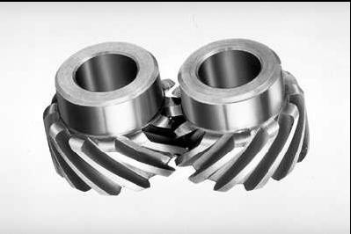**Parallel helical gears:** T he teeth on helical gears are cut at an angle to the face of the gear. When two teeth on a helical gear system engage, the contact starts at one end of the tooth and gradually spreads as the gears rotate, until the two teeth are in full engagement.

T his gradual engagement makes helical gears operate much more smoothly and quietly than spur gears. For this reason, helical gears are used in almost all car transmission. Because of the angle of the teeth on helical gears, they create a thrust load on the gear when they mesh. Devices that use helical gears have bearings that can support this thrust load.

One interesting thing about helical gears is that if the angles of the gear teeth are correct, they can be mounted on perpendicular shafts, adjusting the rotation angle by 90 degrees. Helical gears to have the following differences from spur gears of the same size:

T ooth strength is greater because the teeth are longer, Greater surface contact on the teeth allows a helical gear to carry more load than a spur gear. T he longer surface of contact reduces the efficiency of a helical gear relative to a spur gear

Rack and pinion (T he rack is like a gear whose axis is at

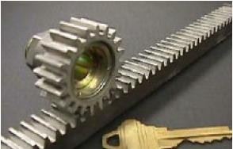infinity.): ***Racks*** are straight gears that are used to convert rotational motion to translational motion by means of a gear mesh. (T hey are in theory a gear with an infinite pitch Diameter). In theory, the torque and angular velocity of the

pinion gear are related to the Force and the velocity of the rack by the radius of the pinion gear, as is shown.Perhaps the most well-known application of a rack is the rack and pinion steering system used on many cars in the past

**Gears for connecting intersecting shafts: Bevel gears** are useful when the direction of a shaft's rotation needs to be changed. T hey are usually mounted on shafts that are 90 degrees apart, but can be designed to work at other angles as well.

Sub C ode: ME35

T he teeth on bevel gears can be straight, spiral or hypoid. Straight bevel gear teeth actually have the same problem as straight spur gear teeth, as each tooth engages; it impacts the corresponding tooth all at once. Just like with spur gears, the solution to this problem is to curve the gear teeth. T hese spiral teeth engage just like helical teeth: the contact starts at one end of the gear and progressively spreads across the whole tooth.

On straight and spiral bevel gears, the shafts must be perpendicular to each other, but they must also be in the same plane. T he hypoid gear, can engage with the axes in different planes.

**Neither parallel nor intersecting shafts**: Helical gears may be used to mesh two shafts that are not parallel, although they are still primarily use in parallel shaft applications. A special application in which helical gears are used is a crossed gear mesh, in which the two shafts are perpendicular to each other.

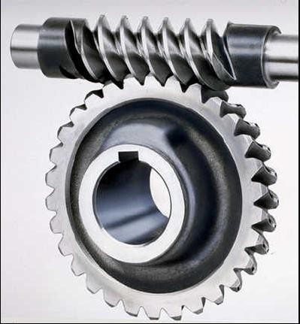***worm gear****:* Worm gears are used when large gear reductions are needed. It is common for worm gears to have reductions of 20:1, and even up

to 300:1 or greater.71

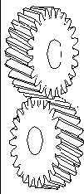

T ERMINOLOGY:

Sub C ode: ME35

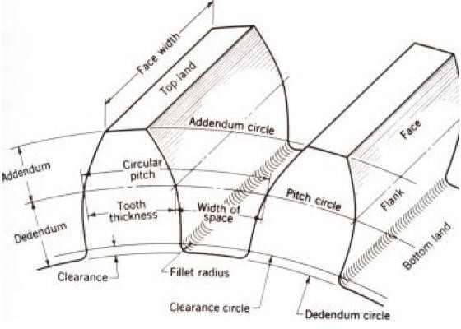

**Addendum:** T he radial distance between the Pitch C ircle and the top of the teeth.

**Arc of Action:** Is the arc of the Pitch C ircle between the beginning and the end of the engagement of a given pair of teeth.

**Arc of Approach:** Is the arc of the Pitch C ircle between the first point of contact of the gear teeth and the Pitch Point.

**Arc of Recession:** T hat arc of the Pitch C ircle between the Pitch Point and the last point of contact of the gear teeth.

**Backlash:** Play between mating teeth.

**Base Circle:** T he circle from which is generated the involute curve upon which the tooth profile is based.

**Center Distance:** T he distance between centers of two gears.

**Chordal Addendum:** T he distance between a chord, passing through the points where the Pitch C ircle crosses the tooth profile, and the tooth top.

**Chordal Thickness:** T he thickness of the tooth measured along a chord passing through the points where the Pitch C ircle crosses the tooth profile.

**Circular Pitch:** Millimeter of Pitch C ircle circumference per tooth.

**Circular Thickness:** T he thickness of the tooth measured along an arc following the Pitch C ircle

Sub C ode: ME35

**Clearance:** T he distance between the top of a tooth and the bottom of the space into which it fits on the meshing gear.

**Contact Ratio:** T he ratio of the length of the Arc of Action to the C ircular Pitch. **Dedendum:** T he radial distance between the bottom of the tooth to pitch circle. **Diametral Pitch:** T eeth per mm of diameter.

**Face:** T he working surface of a gear tooth, located between the pitch diameter and the top of the tooth.

**Face Width:** T he width of the tooth measured parallel to the gear axis.

**Flank:** T he working surface of a gear tooth, located between the pitch diameter and the bottom of the teeth

**Gear:** T he larger of two meshed gears. I f both gears are the same size, they are both called "gears".

**Land:** T he top surface of the tooth.

**Line of Action:** T hat line along which the point of contact between gear teeth travels,between the first point of contact and the last.

**Module:** Millimeter of Pitch Diameter to T eeth.

**Pinion:** T he smaller of two meshed gears.

**Pitch Circle:** T he circle, the radius of which is equal to the distance from the center of the gear to the pitch point.

**Diametral pitch:** T eeth per millimeter of pitch diameter.

**Pitch Point:** T he point of tangency of the pitch circles of two meshing gears, where the Line of C enters crosses the pitch circles.

**Pressure Angle:** Angle between the Line of Action and a line perpendicular to the Line of C enters.

**Profile Shift:** An increase in the Outer Diameter and Root Diameter of a gear, introduced to lower the practical tooth number or acheive a non-standard C enter Distance.

**Ratio:** Ratio of the numbers of teeth on mating gears.

**Root Circle:** T he circle that passes through the bottom of the tooth spaces.

**Root Diameter:** T he diameter of the Root C ircle.

**Working Depth:** T he depth to which a tooth extends into the space between teeth on the mating gear.

### Fundamental Law of Gear-Tooth

Pitch point divides the line between the line of centers and its position decides the velocity ratio of the two teeth. T he above expression is the **fundamental law of gear-tooth action**.

### Formation of teeth:

Involute teeth C ycloidal teeth

### Involute curve:

T he curve most commonly used for gear-tooth profiles is the involute of a circle. T his **involute curve** is the path traced by a point on a line as the line

rolls without slipping on the circumference of a circle. It may also be defined as a path traced by the end of a string, which is originally wrapped on a circle when the string is unwrapped from the circle. T he circle from which the involute is derived is called

the **base circle**.

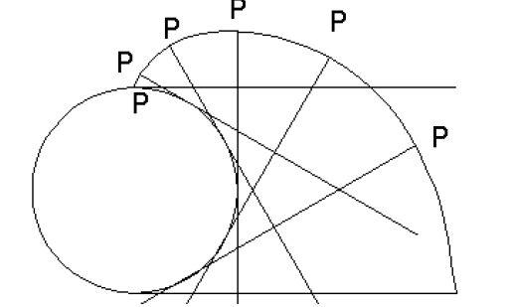

**Cycloidal Curve**

Sub C ode: ME35

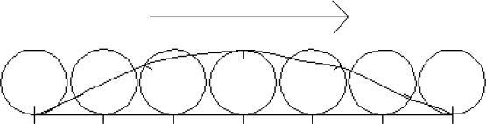

**Path of contact :**

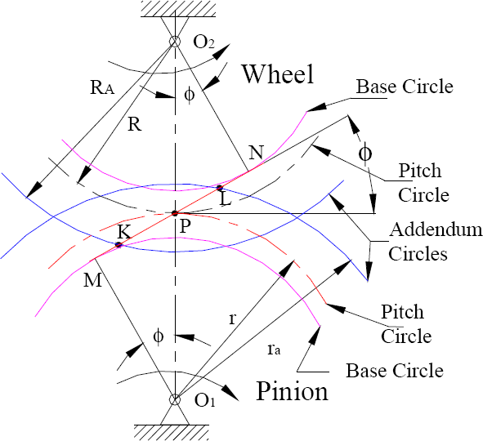

C onsider a pinion driving wheel as shown in figure. When the pinion rotates in clockwise, the contact between a pair of involute teeth begins at *K* (on the near the base circle of pinion or the outer end of the tooth face on the wheel) and ends at *L* (outer end of the tooth face on the pinion or on the flank near the base circle of wheel).

*MN* is the common normal at the point of contacts and the common tangent to the base circles. T he point *K* is the intersection of the addendum circle of wheel and the common tangent. T he point *L* is the intersection of the addendum circle of pinion and common tangent.

T he length of path of contact is the length of common normal cut-off by the addendum circles of the wheel and the pinion. T hus the length of part of contact is *KL* which is the sum of the parts of path of contacts *KP* and *PL*. C ontact length *KP* is called as **path of approach** and contact length *PL* is called as **path of recess**.

Sub C ode: ME35

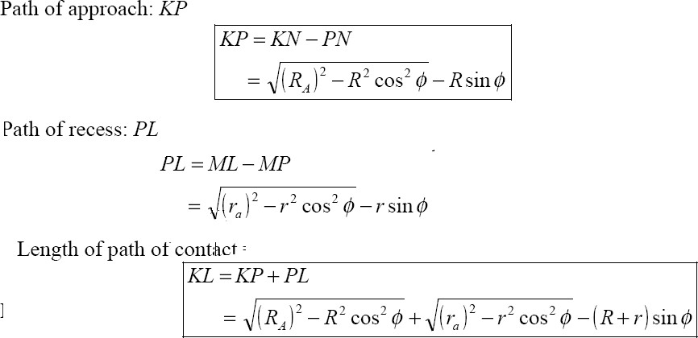

**Arc of contact:** Arc of contact is the path traced by a point on the pitch circle from the beginning to the end of engagement of a given pair of teeth. In Figure, the arc of contact is *EPF* or *GPH*.

T he arc *GP* is known as *arc of approach* and the arc *PH* is called *arc of recess*. T he angles subtended by these arcs at O1 are called *angle of approach* and *angle of recess* respectively.

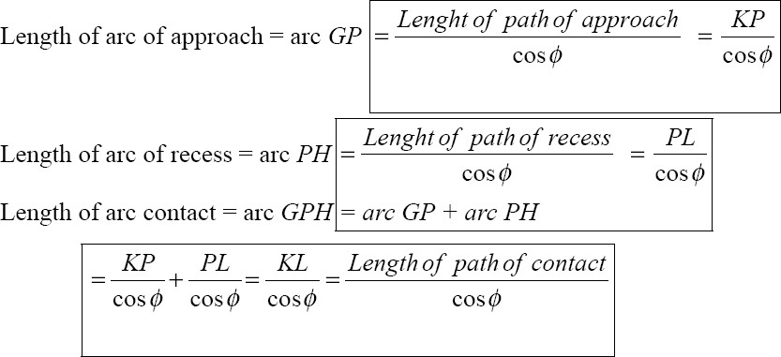

### Contact Ratio (or Number of Pairs of Teeth in Contact)

Sub C ode: ME35

T he contact ratio or the number of pairs of teeth in contact is defined as the ratio of the length of the arc of contact to the circular pitch.

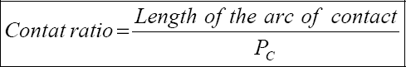



C ontinuous motion transfer requires **two pairs of teeth in contact at the ends of the path of contact**, though there is only one pair in contact in the middle of the path, as in Figure. T he average number of teeth in contact is an important parameter - if it is too low due to the use of inappropriate profile shifts or to an excessive centre distance. T he manufacturing inaccuracies may lead to loss of kinematic continuity - that is to impact, vibration and noise T he average number of teeth in contact is also a guide to load sharing between teeth; it is termed the ***contact ratio***

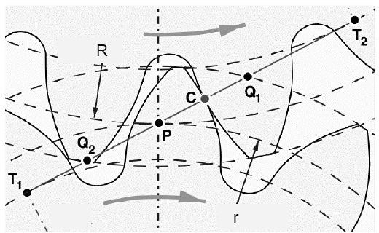

T he tooth tip of the pinion will then undercut the tooth on the wheel at the root and damages part of the involute profile. T his effect is known as

*interference*, and occurs when the teeth are being cut and weakens the tooth at its root.

In general, the phenomenon, when the tip of tooth undercuts the root on its mating gear is known as interference. Similarly, if the radius of the addendum circles of the wheel increases beyond O2M, then the tip of tooth on wheel will cause interference with the tooth on pinion. T he points M and N are called interference points.

Interference may be avoided if the path of the contact does not extend beyond interference points. T he limiting value of the radius of the addendum circle of the pinion is O1N and of the wheel is O2M.

T he interference may only be prevented, if the point of contact between the two teeth is always on the involute profiles and if the addendum circles of the two mating gears cut the common tangent to the base circles at the points of tangency.

### Methods to avoid Interference

1. Height of the teeth may be reduced.
2. under cut of the radial flank of the pinion.
3. C entre distance may be increased. It leads to increase in pressure angle.
4. By tooth correction, the pressure angle, centre distance and base circles remain unchanged, but tooth thickness of gear will be greater than the pinion tooth thickness.

### Minimum numbers of teeth on the pinion avoid Interference

T he pinion turns clockwise and drives the gear as shown in Figure.

Points M and N are called interference points. i.e., if the contact takes place beyond M and N, interference will occur.

T he limiting value of addendum circle radius of pinion is O1N and the limiting value of addendum circle radius of gear is O2M. C onsidering the critical addendum circle radius of gear, the limiting number of teeth on gear can be calculated.

T he equation gives minimum number of teeth required on the pinion to avoid interference.

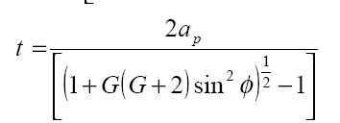

If the number of teeth on pinion and gear is same: G=1

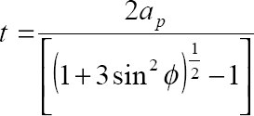

The equation gives minimum number of teeth required on the wheel to avoid interference*.*

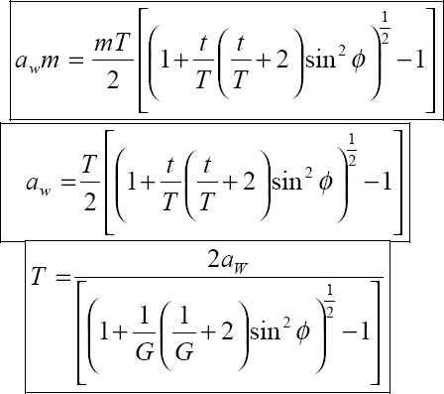

©Einstein C ollege

Page 55 of 65

of Engineering

A gear train is two or more gear working together by meshing their teeth and turning each other in a system to generate power and speed. It reduces speed and increases torque. To create large gear ratio,gears are connected together to form gear trains. T hey often consist of multiple gears in the train.T he most common of the gear train is the gear pair connecting parallel shafts. T he teeth of this type can be spur, helical or herringbone.

Sub C ode: ME35

T he angular velocity is simply the reverse of the tooth ratio.Any combination of gear wheels employed to transmit motion from one shaft to the other is called a gear train. T he meshing of two gears may be idealized as two smooth discs with their edges touching and no slip between them. T his ideal diameter is called the Pitch C ircle Diameter (PC D) of the gear.

### Simple Gear Trains

T he typical spur gears as shown in diagram. T he direction of rotation is reversed from one gear to another. It has no affect on the gear ratio. T he teeth on the gears must all be the same size so if gear A advances one tooth, so does B and C .

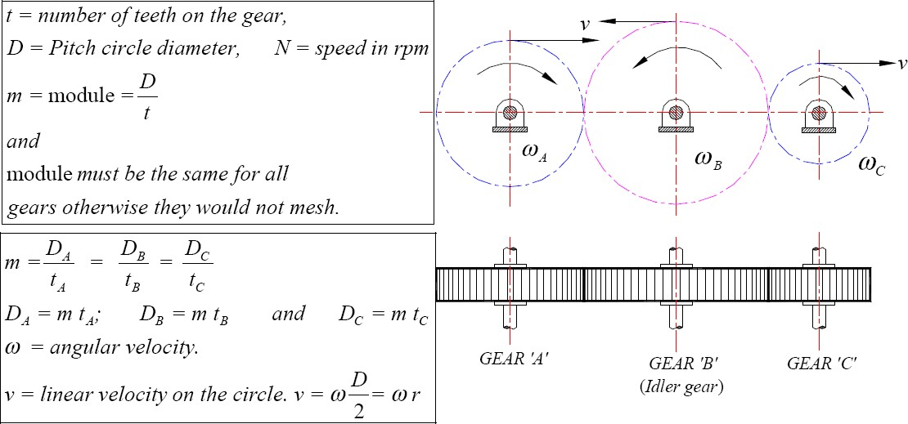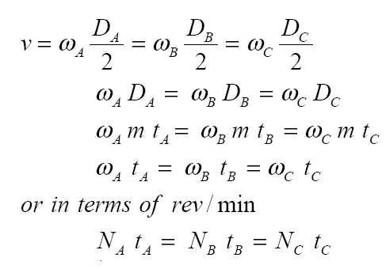

***Compound Gear train***

C ompound gears are simply a chain of simple gear trains with the input of the second being the output of the first. A chain of two pairs is shown below. Gear B is the output of the first pair and gear C is the input of the second pair. Gears B and C are locked to the same shaft and revolve at the same speed. For large velocities ratios, compound gear train arrangement is preferred.

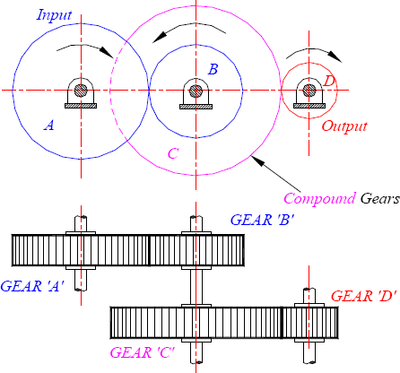

Sub C ode: ME35

Page 57 of 65

©Einstein C ollege of Engineering

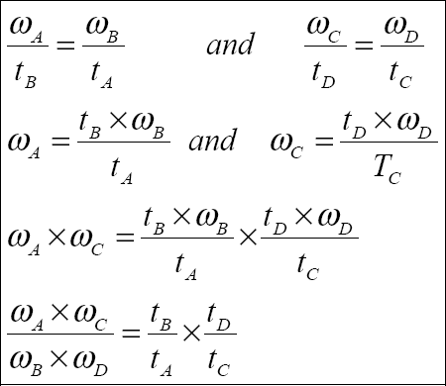

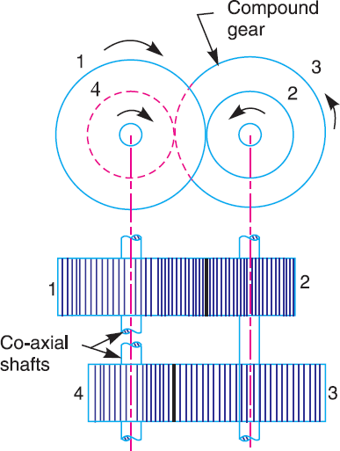Reverted gear train:

The driver and driven axes lies on the same line. These are used in speed reducers, clocks and machine tools. If *R* and *T*=Pitch circle radius & number of teeth of the gear**.**

